Shabbos Stories Anthology for
Yom tov shavuos
Printed L’illuy nishmas Nechama bas R’ Noach, a”h
A Project of the Shabbos Stories for the Parsha begun in 5770/2009

For a free copy, please forward your request to keren18@juno.com

Compiled by Daniel Keren

TABLE OF CONTENTS

Shabbos Stories for Yom Tov Shavuos 5778…………………………..Page 2
Brooklyn Torah Gazette for Yom Tov Shavuos 5778…………………Page 15
Shabbos Stories for Yom Tov Shavuos 5777……………………………Page 29
Brooklyn Torah Gazette for Yom Tov Shavuos 5777………………….Page 41
Shabbos Stories for Yom Tov Shavuos 5775……………………..…….Page 57
Shabbos Stories for Yom Tov Shavuos 5773………………………..….Page 12
Shabbos Stories for Yom Tov Shavuos 5772………………………..….Page 31
Additional Stories for Yom Tov Shavuos 577…………………….…….Page 51
Shabbos Stories for
Yom tov shavuos 5778
Volume 9, Issue 37 6-7 Sivan 5778/ May 20-21, 2018
Printed L’illuy nishmas Nechama bas R’ Noach, a”h

For a free subscription, please forward your request to keren18@juno.com

Graduate's Unconventional Valedictorian Speech
By Levi Stein

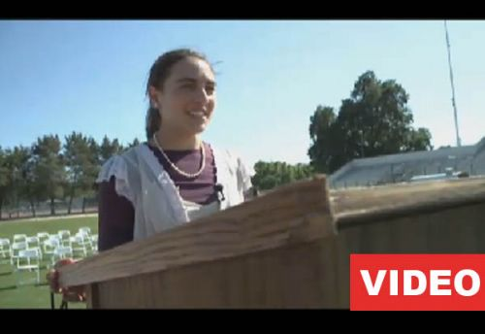
Vacaville High School valedictorian Carolyn Fine gave her speech via a recorded message due to the ceremony taking place on Shavuos.

Like the rest of her graduating class at Vacaville High School, valedictorian Carolyn Fine is preparing for the big day this week. But because commencement exercise falls out during the Jewish holiday of Shavuot, the 18-year-old is getting ready a bit differently.
In observance of the holiday – which commemorates the giving of the Torah at Mount Sinai – Fine will not deliver the traditional valedictorian’s speech through a microphone. She won’t even travel to the ceremony in a car, and will instead walk.
“I was nervous about what to do,” Fine told the Contra Costa Times. “The more I learn about the Jewish religion, the more connected I feel.”
School officials worked with Fine to make alternate arrangements.
“It’s great to see that, on her own, she’s standing by her faith,” commented Rabbi Chaim Zaklos, director of Chabad-Lubavitch of Solano County, who has been helping the young scholar.

Reprinted from the June 10, 2011 website of Chabad.org

Why Dairy on Shavuot?
By Rabbi Shraga Simmons

Seven fascinating reasons for this popular custom.

Ahhh... the sumptuous delight of blintzes and cheesecake. Eating a dairy meal on Shavuot has become an enduring tradition. But what's the source for this? Here are seven fascinating reasons:

Reason #1
When the Jewish people received the Torah at Mount Sinai, included was special instructions for how to slaughter and prepare meat for eating. Until then, the Jews had not followed these laws, thus all their meat – plus the cooking pots – were now considered "not kosher." So the only alternative was to eat dairy, which requires no advance preparation.
This raises the question, however: Why didn't the Jews simply slaughter new animals, "kasher" their pots in boiling water (hagala), and cook fresh meat?
The answer is that the revelation at Sinai occurred on Shabbat, when slaughter and cooking are prohibited.
Another point to clarify: How were the Jews able to obtain milk on Shabbat, since milking an animal falls under the prohibited activity of mefarek?
The answer is that the Jews already had milk available from before Shabbat, which they had been using to feed the various animals that accompanied their journeys in the wilderness.
Reason #2
Torah is likened to milk, as the verse says, "Like honey and milk [the Torah] lies under your tongue" (Song of Songs 4:11). Just as milk has the ability to fully sustain the body of a human being (i.e. a nursing baby), so too the Torah provides all the “spiritual nourishment” necessary for the human soul.

Reason #3
The gematria (numerical value) of the Hebrew word for milk, chalav, is 40. We eat dairy foods on Shavuot to commemorate the 40 days that Moses spent on Mount Sinai receiving instruction in the entire Torah. (Moses spent an additional 40 days on Sinai, praying for forgiveness following the Golden Calf, and then a third set of 40 days before returning with a new set of stone tablets.)
The numerical value of chalav, 40, has further significance in that there were 40 generations from Moses who recorded the Written Torah, till the generation of Ravina and Rav Ashi who wrote the final version of the Oral Torah, the Talmud.
Further, the Talmud begins with the letter mem – gematria 40 – and ends with mem as well.
Reason #4
According to the Zohar, each one of the 365 days of the year corresponds to a specific one of the Torah's 365 negative commandments. Which mitzvah corresponds to the day of Shavuot?
The Torah says: "Bring Bikkurim (first fruits) to the God's Holy Temple; don't cook a kid in its mother's milk" (Exodus 34:26). Since the first day for bringing Bikkurim is on Shavuot (in fact, the Torah calls Shavuot "the holiday of Bikkurim"), the second half of that verse – referring to milk and meat – is the negative commandment corresponding to Shavuot day. Thus on Shavuot we eat two meals, one of milk and one of meat, taking care not to mix the two.
Interestingly, we are instructed not to use the same loaf of bread for a meat meal and then later at a milk meal, lest some of the meat substance had splattered on the bread. Thus by eating two meals – one of milk and one of meat – we inevitably have two loaves. This corresponds to the special "Two Loaves" that were offered in the Temple on Shavuot.

Reason #5
An alternative name for Mount Sinai is Har Gav'nunim, the mountain of majestic peaks. The Hebrew word for cheese is gevina, etymologically related to Har Gav'nunim.
Further, the gematria of gevina (cheese) is 70, corresponding to the "70 faces of Torah."

Reason #6
Moses was born on the seventh day of Adar, and stayed at home for three months with his family, before being placed in the Nile River on the sixth of Sivan.
Moses was rescued by Pharaoh's daughter, who adopted Moses and took him to live in Pharaoh's palace. But right away a problem arose: what to feed the baby. In those days, there was no bottled baby formula, so when the birth mother wasn't available, the caretaker would have to hire a wet nurse. In the case of Moses, he kept refusing to nurse from Egyptian women. The Talmud explains that his mouth needed to be kept totally pure, as it would one day communicate directly with God. Finally Pharaoh's daughter found one woman who Moses agreed to nurse from – Yocheved, Moses' biological mother!
Appreciate the irony: Pharaoh's murderous decree against Jewish babies was specifically intended to prevent a new generation of Jewish leadership. So what happened instead? Moses, the upcoming great Jewish leader, was raised, educated and trained – right under Pharaoh's nose, in Pharaoh's own home, at Pharaoh's expense! And on top of it all, Moses' mother got paid a salary!
The eating of dairy foods on Shavuot commemorates this phenomenon in the early life of Moses, which occurred on the sixth of Sivan, the day on which Shavuot falls.
Reason #7
According to one commentator, that day at Sinai was the first time the Jews ate dairy products. There is a general prohibition of "eating a limb from a live animal" (ever min hachai), which logically should also include milk, the product of a live animal. Ever min hachai is actually one of the Seven Noahide Laws which the Jews observed prior to Sinai (and which has applied to all humanity since the days of Noah).
However, upon receiving the Torah, which refers to the Land of Israel as "flowing with milk and honey" (Exodus 3:18), dairy products became permitted to the Jews. In other words, at the same moment that their meat became prohibited, dairy became permitted. They ate dairy on that original Shavuot, and we do today, too.
If the Jews ate dairy for the first time at Mount Sinai, this raises the question how Abraham could have fed dairy products to his three guests (Genesis 18:8).
The answer requires a technical understanding of the prohibition of ever min hachai, "limb from a live animal." One way is to define a "limb" as a piece of meat which contains bones and/or sinews. It is this type of ever min hachaiwhich has always been forbidden to non-Jews. This prohibition does not include milk, because although milk comes from a live animal, it does not contains bones or sinews. Hence, Abraham was permitted to feed milk to his non-Jewish guests.
There is a second, expanded definition of ever min hachai, which encompasses all products from a live animal -- including milk. It is this definition which is prohibited to Jews. Thus it was not until the giving of the Torah, with its reference to "land of milk and honey," that dairy products became permitted to Jews.
This distinction is spelled out clearly by the great Rabbi Shlomo Kluger, in "HaElef Lecha Shlomo" (Yoreh Deah 322).
Sources:
Reason #1: Mishnah Berurah 494:12; Talmud – Bechorot 6b; Rabbi Shlomo Kluger (HaElef Lecha Shlomo – YD 322)
Reason #2: Rabbi Meir of Dzikov – Imrei Noam
Reason #3: Deut. 10:10; Rav Menachem Mendel of Ropshitz
Reason #4: Talmud – Makkot 23b; Chidushei HaRim; Rema (OC 494:3, YD 88:2)
Reason #5: Psalms 68:16; Midrash – Bamidbar Rabba 13:15; Rebbe of Ostropole;
Reb Naftali of Ropshitz; Rabbi Dovid Meisels
Reason #6: Talmud – Sotah 12b; Yalkut Yitzchak
Reason #7: Rabbi Shlomo Kluger (HaElef Lecha Shlomo – YD 322)

Reprinted from the Shavuot website of aish.com
Where Is Mount Sinai?
By Yehuda Shurpin

Why don’t the rabbis know where it is?

I’ve seen lots of theories about the location of Mount Sinai. Is there any validity to those theories? I know that Judaism reveres the Temple Mount as the site of the Holy Temple, but is there any location that Judaism reveres or at least recognizes as Mount Sinai, the place where G-d gave the Torah and where the Jewish nation was born? And if not, why?

Reply
There are lots of theories, but none of them are even close to conclusive. Why is that? Why have the Jewish sages not preserved a tradition regarding the location of the most monumental event in all of history? Why the ambivalence?
Once the Jewish people received the Torah on Mount Sinai and continued their journey to the Land of Israel, there is just one biblical mention of anyone going back to Mount Sinai.
We read in the Book of Kings¹ how, hundreds of years after the giving of the Torah, Elijah the prophet fled the wicked queen Jezebel and took refuge in a cave on “the mountain of G-d, Horeb,” which is identified as none other than Mount Sinai.
But on closer examination, this incident itself only underscores the question.
The day after Elijah took refuge, the word of G-d came to him: “What are you doing here, Elijah?”
After the prophet complained about his lot and the bad deeds of the people, G-d told him to step outside and stand on the mountainside. Elijah did so, and then, in one of the most stirring moments in Scripture, we read:
Behold! the L-rd passes, and a great and strong wind splitting mountains and shattering boulders before the L-rd—but the L-rd was not in the wind.
And after the wind, an earthquake—not in the earthquake was the L-rd.
After the earthquake, fire—not in the fire was the L-rd.
And after the fire, a still small sound.
And as Elijah heard, he wrapped his face in his mantle, and he went out and stood at the entrance to the cave, and behold a voice came to him and [again] said: “What are you doing here, Elijah?”
G-d then told him to go back to the people, with instructions on how to deal with them.

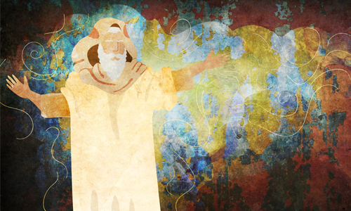

Mount Sinai was the site of great drama, but G-d told Elijah that His eternal place is not in great noises and rumbling earthquakes. Rather, He can be found in our quiet, humble day-to-day actions. His message was clear: “You don’t belong here. Go back to the people and do your work!”

Honoring the Place
Perhaps the rabbis’ attitude toward Mount Sinai can best be explained by the following piece of Talmud:
It is not the place that honors the person; rather, the person honors his place, as we found with regard to Mount Sinai, that as long as the Divine Presence rested upon it, the Torah said: “Nor let the flocks nor the herds graze before that mountain.”² Once the Divine Presence departed from the mountain, the Torah said: “When the shofar sounds long, they may come up to the mountain”³[indicating that the sanctity was not intrinsic to the place, but was due to the Divine Presence resting there].⁴
Mount Sinai itself was not inherently holy. Rather, what was done there gave honor and holiness to Sinai, so once the people received the Torah and moved on, Sinai was no longer holy.
We read a similar story from the Talmud:
Rabbah bar bar Chanah said: “Once we were traveling in the desert, and we were accompanied by a certain Arab. . . . That Arab also said to me: ‘Come, I will show you Mount Sinai.’ I went and saw that scorpions were encircling it, and they were standing as high as white donkey…
The commentaries explain that scorpions represent the forces of evil. Once the Divine Presence left the place, it became susceptible to unholiness.
Thus, though Sinai was holy during the giving of the Torah, once it had accomplished its purpose it was void of significance. At Sinai we were given a mission to learn the Torah and uplift and refine the mundane, outside world. Simply hanging around Mount Sinai would defeat the purpose.
But it does not end there.

The Return of Mount Sinai
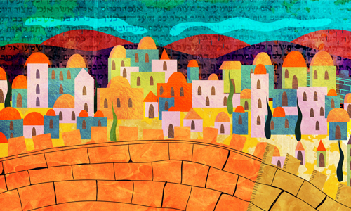

The Talmud states that in the messianic era, all of the synagogues of the diaspora will be transported to the Land of Israel:
Rabbi Elazar HaKappar says: “In the future, the synagogues and the study halls in Babylonia will be transported and reestablished in the Land of Israel, as it is stated: ‘Surely, like Tabor among the mountains, and like Carmel by the sea, so shall he come.’⁶
There is a tradition that these mountains came to Sinai at the giving of the Torah and demanded that the Torah should be given upon them. We can therefore extrapolate: Just as Tabor and Carmel, which came only momentarily to Torah, were relocated and established in Israel in reward for their actions, all the more so should the synagogues and study halls in Babylonia, in which the Torah is read and disseminated, be relocated to Israel.”⁷
Commentaries explain that this refers to all the synagogues from throughout the generations. Since the Divine Presence rested upon them, and they were considered holy places, their holiness is never entirely erased, and they will be transported to the Land of Israel.
In a fascinating talk, the Lubavitcher Rebbe explains that if this is true for all the synagogues and houses of Torah learning, then it is surely true for Mount Sinai itself, which was in a sense responsible for all the future generations’ learning of Torah and performance of mitzvahs. Thus, in the messianic era, Mount Sinai will regain its holiness and be transported to the Land of Israel.⁸
May it be speedily in our days!
FOOTNOTES
1. I Kings 19.
2. Exodus 34:3.
3. Exodus 19:13.
4. Talmud, Taanit 21b.
5. Talmud, Bava Batra 74a.
6. Jeremiah 46:18.
7. Talmud, Megillah 29a.
8. See Sefer Hasichot 5749, vol. 2, p. 464, fn. 77; Torat Menachem 5748, vol. 3, p. 354.

Reprinted from the website of Chabad.Org Rabbi Yehuda Shurpin responds to questions for Chabad.org's Ask the Rabbi service. Sefira Ross is a freelance designer and illustrator whose original creations grace many Chabad.org pages. Residing in Seattle, Washington, her days are spent between multitasking illustrations and being a mom.
Holiday Preparations
By Yerachmiel Tilles

A Tale of How a Great Kabbalist Acquired a Guest for Shavuot

All his adult life, Rabbi Chaim Toledano, the rabbi of Salé in Morocco, was careful to make sure that he hosted guests, or at least one guest, at his table for every holiday meal. After all, what is a holiday meal without a guest? “Merely a stomach celebration,” our sages say.
So dear was this mitzvah to Rabbi Toledano, who was known for his piety and holiness, that if a holiday approached and no guest was expected, he would send his attendant to search the marketplaces and the outskirts of town. The whole time he would be restless, unable to relax, until his attendant returned with a poor person, or a traveler from a different city, in tow.

There were simply no guests to be found...
One year, Shavuot eve fell on a pleasant, clear spring day. The whole morning, the Jews of Salé were busy preparing everything they needed for the two-day festival. Although he did not yet have a guest, Rabbi Toledano was confident that G-d Almighty would provide one for him. Noontime arrived, but still there was no guest. As he usually did in such cases, he requested of his attendant to go out to search for a traveler in need of hospitality.
The rabbi’s attendant circulated throughout the entire town, but he was unable to find a single Jew who didn’t have a place to be for the holiday. With upturned palms, he ruefully informed his master that he had returned emptyhanded—there were simply no guests to be found.
“Go search again, please,” Rabbi Chaim commanded. Then he paused for a moment. “You can even look in the Jewish cemetery, if you don’t succeed elsewhere. Perhaps someone will be wandering there.”
The attendant hurried to do the rabbi’s bidding. When he again was unable to find anybody appropriate in the streets, he reluctantly walked over to the cemetery. There, almost immediately he saw a Jewish man, bearded and wearing a Moroccan-style jalabiya, whom he didn’t recognize. The man was sitting on the ground between two graves, hunched over with his face in his hands, crying bitterly, his whole body wracked by grief.

The man continued to cry uncontrollably,
and never uttered a word in response...
The attendant did his best to comfort him and to invite him to come to the rabbi’s home, but to no avail. It was if he wasn’t even there. No matter what he said, the man continued to cry uncontrollably, and never uttered a word in response or even acknowledged his presence.
The attendant rushed back to the rabbi, and told him about the strange man he had found in the cemetery, sitting on the ground crying, and how he refused to say a single word—not to identify himself, and not to explain his tears.
Rabbi Toledano immediately rose, put on his white festive cloak, took his walking cane in hand, and set out at a brisk pace for the cemetery. Usually, when the townspeople would see him in the street, they would eagerly dart over to kiss his hand and receive a blessing, which he was always happy to bestow. This time, seeing he was hurrying so, they didn’t dare to interrupt him.
When he and his attendant reached the cemetery, they found the man lying on his back next to one of the graves, still crying his heart out. After much effort, Rabbi Toledano was able to calm him down somewhat, but when he invited him to be at his house for Shavuot, the man refused. Out of respect for the rabbi, who was clearly a holy person, he broke his silence, but he said he was much too unhappy and upset to be anyone’s guest. Rabbi Chaim pleaded with him to tell what was causing him so much grief, saying that, with G-d’s help, he would do everything in his power to help him. But still the forlorn man refused to reveal his thoughts.
In the end, feeling he had no alternative, Rabbi Toledano declared, “Look, our holy sages of blessed memory have said, ‘One must never despair of G-d’s mercy, even if a sword is poised at his throat.’ I swear to you that I will rescue you from whatever terrible plight has befallen you. Now, just get up and come with me to be my guest for the Shavuot holiday.”
I put all my accumulated wealth…into a
small wooden chest, and set sail for home...
The distraught man took encouragement from the rabbi’s sincere concern and forceful promise. He humbly accepted Rabbi Chaim’s invitation, and climbed to his feet. As they walked together, he unburdened himself of his story to his exalted host.
“I am a resident of Salé, but I left my family here several years ago in order to go overseas to seek prosperity. After many sea voyages and struggling in a number of different countries, finally, with G-d’s help, I succeeded to amass a very large sum. I put all my accumulated wealth—gold, silver and assorted jewels—into a small wooden chest, and set sail for home.
“When the ship arrived in the harbor here, a small raft pulled alongside, to ferry the few disembarking passengers through the shallow water to the shore. As I was transferring my things to the raft, somehow I lost my grip on the heavy box and it fell into the water. It sank immediately. All my wealth! Everything that I slaved and suffered for all of these years! All wasted! Lost in a single moment!
“Truly, I wish I were dead. Anyway, ‘a poor person is considered as dead,’ our sages stated. I can’t bear the idea of being a pauper again!” Finishing his sad tale, he broke down once more, burying his face in his hands and weeping bitterly.

Rabbi Toledano girded himself...
uttering a series of holy names...
Rabbi Toledano pondered what to do. He thought about turning over all of his money and everything he possessed to this unfortunate victim of fate. After all, he had promised to rescue him. But he quickly realized that even if he were to do so, it wouldn’t make up even half the value of what had disappeared into the ocean’s vaults.
He meditated on the matter more, standing deep in thought for many minutes. At last, he seemed to make up his mind, accepting the extreme measures necessary to fulfill his word and rescue his cherished guest from his desperate situation. Turning to his groaning companion, he said, “Come, my son. Let’s go back to the port. There you can point out to me exactly where your treasure fell into the sea.”
When they got to the shore, the guest estimated to the rabbi where he thought his box had sunk. Rabbi Toledano girded himself and, uttering a series of holy names known to masters of Kabbalah, adjured with a binding oath the heavenly officer appointed over the ocean.
After just a few moments, an assortment of items could be seen floating on the surface of the water, all things that had been lost at sea. The waves became stronger—their white frothy crests rising high above the chilly blue surface—and a huge number of different objects, seemingly dredged from the ocean bottom, were now riding the powerful current towards the shore.
The rabbi’s features were cast in seriousness. “Don’t dare touch anything that is not yours!” he solemnly warned his guest. The latter stood frozen to his spot, too terrified by the vision taking place in front of his eyes to even think of responding. Suddenly he saw his precious wooden chest, being pushed by the waxing tide directly towards him. He snatched it up instinctively, and then hugged it in great joy and excitement.
Turning to Rabbi Toledano, he began to thank him profusely. The rabbi himself was very happy that he had been able to keep his promise, save a Jew in tragic need, and acquire a guest who would be able to enjoy with him the special Shavuot holiday meals in a proper festive spirit.
“Come, my son,” he said once more, this time with a wide smile. “Let us hurry home and get ready to receive the Torah.”

Translated/adapted from Echyeh v’Asaper.
Biographical note: Rabbi Chaim Toledano (c. 1700–1783) was the rabbi of Salé, Morocco, in the generation after the Ohr HaChaim left for Israel. In the book Tehillah le-David he is described as being “the glorious adornment of the sages... pleasing to G-d and man.”
Copyright 2003 by KabbalaOnline.org. All rights reserved, including the right to reproduce this work or portions thereof, in any form, unless with permission, in writing, from Kabbalah Online.

Yerachmiel Tilles is the co-founder of Ascent-of-Safed, and was its educational director for 18 years. He is the creator of www.ascentofsafed.com and www.kabbalaonline.org and currently the director of both sites. He is also a well-known storyteller, a columnist for numerous chassidic publications, and a staff rabbi on AskMoses.com, as well as and the author of "Saturday Night, Full Moon": Intriguing Stories of Kabbalah Sages, Chasidic Masters and other Jewish Heroes.

Reprinted from the website of KabbalaOnline.org
Brooklyn torah gazette
For yom tov shavuos 5778

Volume 2, Issue 37 (Whole Number 80) 6-7 Sivan 5778/ May 20-21, 2018
Printed L’illuy nishmas Nechama bas R’ Noach, a”h

Decisions
By Rabbi Eli J. Mansour

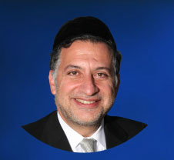

It is customary on Shabuot to read Megilat Rut, which tells the extrardinary story of Rut, a Moabite woman who converted to Judaism and moved to Eretz Yisrael. The story began when a famine struck Eretz Yisrael, prompting Elimelech, one of the wealthiest men among Beneh Yisrael, to leave the country and settle in Moab. He feared that as poverty became widespread, more and more Jews would be knocking on his door asking forassistance, and so he left. In Moab, his two sons, Mahlon and Kilyon, married Moabite women.
Gd punished Elimelech for abandoning his people during their time of crisis, and he lost his entire fortune. Shortly thereafter he died, as did his two sons.
His wife, Naomi, who had previously been a wealthy, prominent woman, was now left as a poor, penniless widow. She decided to return home to Bet Lehem, and her two Moabit daughters-in law, who were named Rut and Orpa, expressed their desire to join her.
Naomi pleaded with them to stay in their homeland, Moab, rather than move with her to what was for them a foreign country. After all, she was penniless, and they would not find anyone in Eretz Yisrael willing to marry them.
Orpa heeded her mother-in law’s advice and went home, but Rut insisted on accompanying Naomi to Eretz Yisrael. Ultimately, she ended up meeting and marrying a wealthy landowner named Boaz, with whom she had a child, Obed, who was the grandfather of David Hamelech.
One of the many meaningful lessons we can learn from this story is the impact of the decisions we make in life. When Naomi urged Rut to stay in Moab, but she insisted on accompanying her to Bet Lehem, she could not possibly have imagined what kind of longterm impact this decision would have, and how it would change world history forever. From her perspective, this was simply a matter of performing kindness for a family member in need to whom she was very devoted.
But at that moment, when she told Naomi that she was joining her regardless of what she said and what happened, she laid the groundwork for the birth of David Hamelech who would establish the eternal Jewish dynasty from which Mashiah will emerge.
It is frightening to consider how even the small decisions we make in life – not to mention the larger decisions – can have such far-reaching effects. This is not to suggest that everyone should fret and panic when planning what to eat for dinner or choosing a shirt to wear. It does mean, however, that we must exercise care and patience when making the significant decisions in our lives.
We never know which decision we make can change the entire direction of our and our families’ lives. I still recall several occasions when as a student I had to decide whether or not to attend a certain Shiur. There were various considerations that had to be taken into account, and ultimately I decided to go.
In those Shiurim, I heard ideas and insights that literally changed my life and profoundly impacted upon the direction I took. At the time I had to make the decision, it seemed like a relatively trivial and minor matter. But in the end, this decision altered the direction of my life.
We
must not be flippant when it comes to making decisions in life. This is certainly true when it comes to larger decisions such as where to live and where to send our children for schooling, but also with regard to the seemingly small decisions, such as whether to attend a Shiur, whether to go to the synagogue, whether to make the humorous, not-so-nice remark that we want to make, or whether to share a Devar Torah with a friend. The implications of these decisions can often be far more profound than we think, and they therefore must be made carefully and responsibly, after serious thought and consideration.

Reprinted from this week’s website of the Edmond J. Safra Synagogue of Brooklyn (NY) where Rabbi Mansour serves as the spiritual leader.

Shavout Reflections
As Heard from Rabbi Avigdor Miller, Zt”l

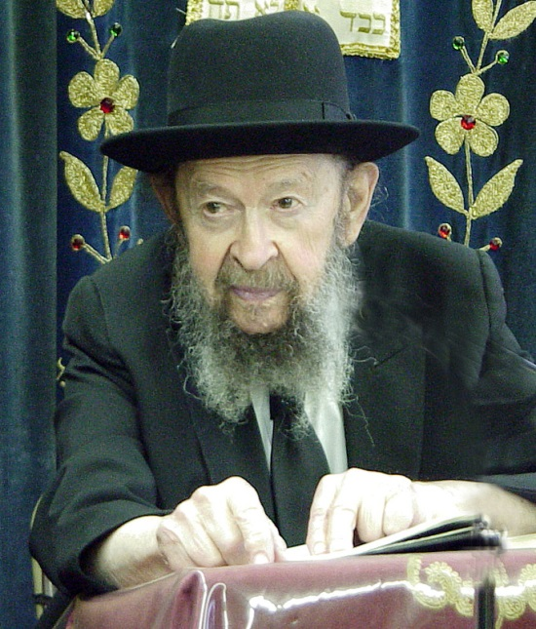

As we approach the subject of the Dor Hamidbar (the generation of the Wilderness), also known as the Dor Deah (the generation of True Knowledge), let us keep constantly before our eyes that this era was the time when Hashem’s love was strongest.
These men were chosen as witnesses of the most wondrous spectacles and demonstrations of Hashem’s Presence among His people. At the same time, they were subject to the most severe chastisement, because “The one that Hashem loves, He rebukes, as a father to the son that He favors” (Mishle 3:12).
The harshest punishments were bestowed upon this generation, as well as the greatest expressions of Hashem’s love and the most sublime encomium and encouragement. All the chastisements and castigations of this period were because of Hashem’s especial love: “to afflict you in order to test (or, to elevate) you, to do benefit to you in your end” (Devarim 8:16).
Rabbi Yochanan (Sanhedrin 110B) upholds the opinion of Rabbi Eliezer that the generation of the Wilderness is very highly regarded by Hashem, who declared: “I remember for you the kindness of your youth, the love of your bridal days, when you followed me into the wilderness, a land unsown. (Therefore) Israel is holy to Hashem” (Yirmiyah 2:2-3)
“Gedolah Deah!” “How great is True Knowledge!” (Berachot 33A).
The greatest revelation of Hashem for all time was at Har Sinai. And we can look back and see that the purpose of Yosef being sold by the brothers was to bring Jacob and his family to Egypt.
The exile in Egypt and the Nation’s witnessing of the 10 Plagues and the splitting of Yam Suf were all to prepare us for the great and fearsome day when we were going to meet and hear Hashem. In fact the purpose of the Creation of heaven and earth was only to bestow theTorah upon the Nation of Yisrael.
The Rambam says, regarding the Revelation at Har Sinai, “We must Exhalt it over all others” (Igerret Teman). This means that we must build this scene in the edifice of our minds. Picture that there were 600,000 men between the ages of 20 and 60, along with women, children and converts. Total over 2 million people. The thick cloud of Shechina was on the top of Har Sinai. Thunder and lightning and the strong sound of Shofar.
The Voice is heard, “Anochi Hashem Elokecha”, speaking directly to the Nation. The Nation was overwhelmed with the very greatest fear and the greatest love.
The revelation at Har Sinai was the greatest injection of ‘Deah”, the acquiring of True Knowledge combined with actual sensory perception, which has remained an intregal part of the Jewish Nation until today.

Adapted from “Journey into Greatness” by Rabbi Miller ZT’L
Reprinted from this week’s email “As Heard from Rabbi Avigdor Miller,”
The Holy Writ
By Rabbi Yirmiyahu Ullman

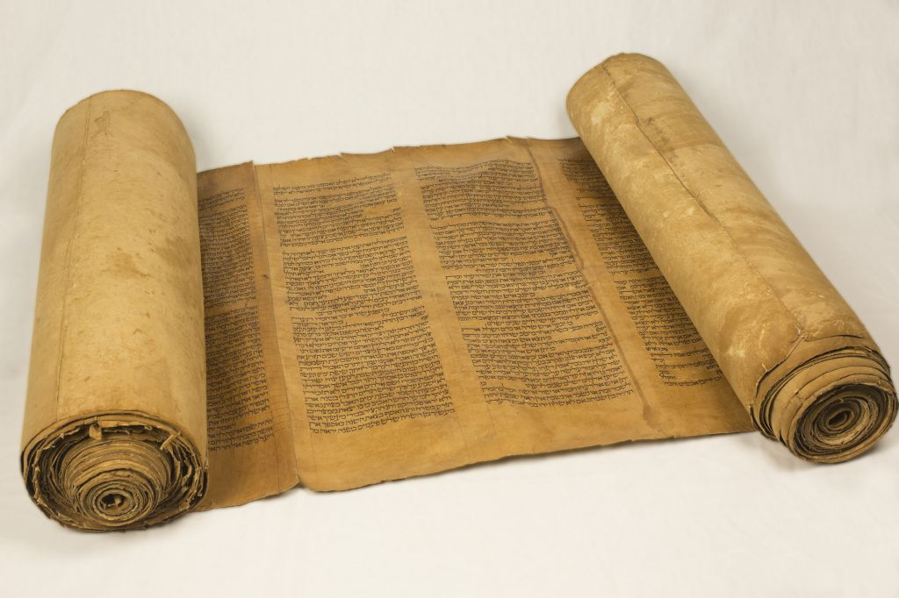

From: Vicky

Dear Rabbi, As we approach the holiday of Shavuot commemorating the receiving of the Torah, would you please explain how and when the first Torah scroll was actually written?

Dear Vicky, The Talmudic Sages actually differ about this point. According to one opinion, the Torah was written on separate parchments in separate installments throughout the sojourn in the wilderness. These segments were then assembled at the end of the forty years, before crossing into the Land of Israel. Accordingly, immediately after Sinai, G-d dictated to Moses the entire book of Genesis, and the book of Exodus until the portion of Yitro that recounts the giving of the Torah. As further events occurred and further precepts were given, G-d dictated to Moses how to record these events and precepts in additional parchments.
The book of Deuteronomy was dictated as a type of summary at the end of the fortieth year. The other view expressed by the Sages is that the entire Torah was dictated by G-d to Moses at one time, and not in installments of separate scrolls.
Accordingly, the Torah was written at the end of the fortieth year in the wilderness, just prior to the death of Moses. In fact, the concluding eight verses of the Torah which describe the death of Moses raise an additional difference of opinions as to who actually wrote these final verses.
The Talmud states (Bava Batra 15): “‘And Moses the servant of the L-rd died there’. Can it be that while Moses was still alive he could have written, ‘And Moses died there’? Rather, until these verses describing his death, Moses wrote. From here on, after the death of Moses, Joshua wrote.
Rabbi Shimon said, ‘Is it possible that the Torah should be lacking a single letter (i.e., Is it possible that Moses did not write the entire Torah?). Rather, we must conclude that until the account of Moses’ death, G-d dictated and Moses wrote. From here on, G-d dictated and Moses wrote with tears.”
One explanation of the above is that because of the truth of the Torah, Moses could not have formally written about his death in the Torah: In order to write he’d have to be alive, and could not write that he died. Conversely, if he wrote about his death, he would necessarily die.
Thus, the first opinion concludes that Joshua wrote these last eight verses. However, since this negates the integrity of the Torah, the second opinion posits that Moses actually wrote the entire Torah to the very end, including his death. But these last eight verses were informally stenciled by Moses using the tears he shed over his death. Joshua then later filled in the tear-stenciled verses with proper ink. In this way, Joshua literally filled the void left by Moses’ death and continued the story where Moses left off.
The Gaon of Vilna, however, offers another explanation. He notes that the Hebrew term used in the Talmud for Moses’ concluding the final eight verses of the Torah in tears is dema. He writes that dema also connotes something that is mixed. Thus, he explains that when the Talmud states that Moses concluded the Torah with dema, this means that the concluding letters, words and verses of the Torah were written without interrupting spaces.
In this way, the concluding section of the Torah describing Moses’ death was dictated to him by G-d in a cryptic way, where many possible “readings” of the text were mixed together in various letter combinations. Therefore, the final words, “And Moses died there,” were not explicitly apparent in the Torah that Moses wrote. Rather, these words emerged from the mixture of possible readings only as a result of the “space” left by his death.

Reprinted from this week’s email of OHRNET, the Ohr Somayach Torah Magazine of the Internet.

Eleven Shavuot Facts

Every Jew Should Know
By Yossi Feller
The holiday of Shavuot is a two-day holiday, beginning at sundown of the 5th of Sivan and lasting until nightfall of the 7th of Sivan. (In Israel it is a one-day holiday, ending at nightfall of the 6th of Sivan.) Every year on Shavuot we renew our acceptance of the Torah, and G-d “re-gives” it to us anew.
Here are 11 things you should know about Shavuot:

1. The festival has five names.
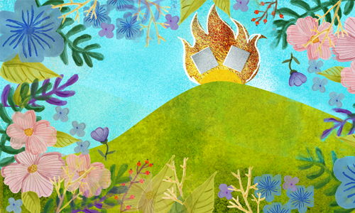
Shavuot—The word Shavuot means “weeks.” It marks the completion of the seven-week Omer counting period between Passover and Shavuot.
Yom HaBikkurim—“The day of First Fruits.” Shavuot is also the celebration of the wheat harvest and the ripening of the first fruits, which is the reason for this name as well as the following one.
Chag HaKatzir—the “Harvest Festival.”
Atzeret—In the Talmud, Shavuot is also called Atzeret, which means “The Stoppage,” a reference to the prohibition against work on this holiday.
Zeman Matan Torahteinu—In the holiday prayer service, we refer to it as the "Time of the Giving of Our Torah."
2. Women and girls light candles to usher
in the holiday on both of its evenings.

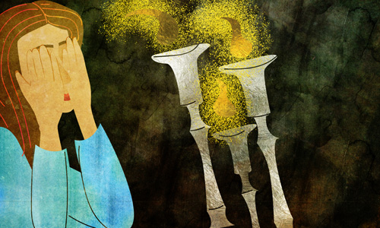
Candles are kindled on most Jewish holidays of biblical origin. They are: Rosh Hashanah, Yom Kippur, Sukkot, Shemini Atzeret, Passover (first and last days) and Shavuot. (Holiday candles are not lit on Chanukah or Purim.)
Holiday candle-lighting follows a procedure similar to that of the Shabbat candle lighting.
The basic difference between the two is that while it is forbidden to create a flame on a holiday, it is permitted to light a candle using a pre-existing flame, such as another candle that was kindled before the holiday, a gas range which has been left on, or a pilot flame. Note that it is also forbidden to extinguish a flame on the holiday, so make sure you have a place to put down the candle or match that you used to kindle your holiday candles.

3. It is customary to stay up and learn Torah on the first night of Shavuot.
The Midrash relates that on the night before the giving of the Torah, the Jewish people did what anybody does before an important event—they turned in early for a good night’s sleep. This seemingly innocent decision, however, led to embarrassing consequences. The next morning, when it came time for the Torah to be given, the place was empty. The entire Jewish people had slept in. The Midrash even recounts that Moses had to wake them—causing G-d to later lament, “Why have I come and no one is here to receive Me?”
Credit: Gify

In order to rectify our forefathers’ mistake, we stay up late every Shavuot night to show that our enthusiasm isn’t lacking at all.

4. All men, women and children should hear the reading of the Ten Commandments on the first day of Shavuot.
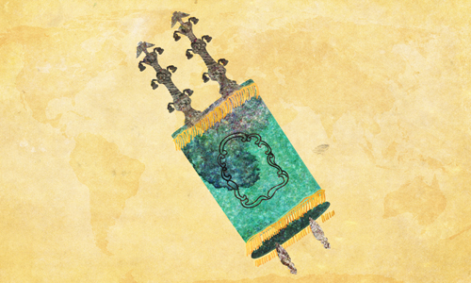
The holiday of Shavuot is the day on which we celebrate the great revelation of the giving of the Torah at Mount Sinai, more than 3,300 years ago. You stood at the foot of the mountain. Your grandparents and great-grandparents before them. The souls of all Jews, from all times, came together to hear the Ten Commandments from G-d Himself.
Since we all stood at Mount Sinai, we must all reaffirm our commitment. Babies, young children, the elderly, all that are able, should attend Torah reading on the first day of Shavuot.

5. Children play a special role in this holiday.
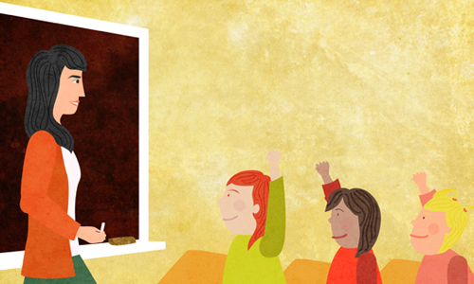
Before G-d gave the Torah to the Jewish people, He demanded guarantors. The Jews made a number of suggestions, all rejected by G-d, until they declared, “Our children will be our guarantors that we will cherish and observe the Torah.” G-d immediately accepted them and agreed to give the Torah.
There is therefore special significance to bringing children, even the youngest of infants, to hear the Ten Commandments.
Let us make sure to bring along all our “guarantors” to the synagogue on the first day of Shavuot.

6. As on other holidays, special meals are eaten, and no “work” may be performed.

Just as there are sacred places, portals in space through which a certain transcendence shines, so too there are sacred times, luminescent points in the yearly cycle, times when we are lifted beyond time, far above the mundane world and all its cares.
Shabbat is the day on which the weekly cycle transcends itself. Then there is Yom Tov, literally “a good day”; each Yom Tov is the highest point in the year in its particular way, with its particular meaning, message and flavor.

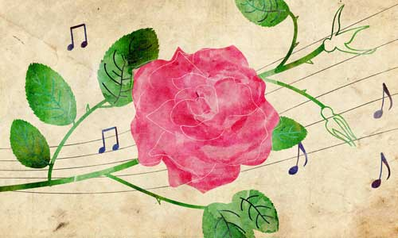
On these days, the Torah prohibits work. At a sacred time, work or any involvement in the mundanities of the week will subvert that sacredness and block its light. But “work” is defined somewhat differently for Yom Tov than it is for Shabbat.

7. It is customary to eat dairy foods on Shavuot.
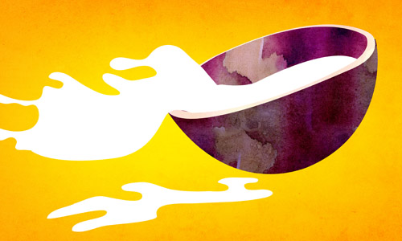
There are a number of reasons for this custom. Here are a few:
On the holiday of Shavuot, a two-loaf bread offering was brought in the Temple. To commemorate this, we eat two meals on Shavuot—first a dairy meal, and then, after a short break, we eat the traditional holiday meat meal. Learn more about waiting between dairy and meat.
With the giving of the Torah, the Jews became obligated to observe the kosher laws. As the Torah was given on Shabbat, no cattle could be slaughtered nor could utensils be koshered, and thus on that day they ate dairy. Read more about the koshering process.
The Torah is likened to nourishing milk. Also, the Hebrew word for milk is chalav, and when the numerical values of each of the letters in the word chalav are added together—8 + 30 + 2—the total is 40. Forty is the number of days Moses spent on Mount Sinai when receiving the Torah. Read more about what happened when Moses was up on Sinai.
When Moses ascended Mount Sinai, the angels urged G-d to reconsider His decision to give His most precious Torah to earthly beings. “Bestow Your majesty upon the heavens . . . What is man that You should remember him, and the son of man that You should be mindful of him?” (Psalms 8:5–7) One of the reasons why the angels’ request went unheeded is because of the Jews’ meticulous adherence to the laws of the Torah—including the kosher laws. Not so the angels, who when visiting Abrahamconsumed butter and milk together with meat (Genesis 18:8). On Shavuot we therefore eat dairy products and then take a break before eating meat—in order to demonstrate our commitment to this mitzvah. Read more about whether Abraham served the angels non-kosher food.

8. On the second day of Shavuot, the Yizkor memorial service is recited.
Yizkor, a special memorial prayer for the departed, is recited in the synagogue four times a year, following the Torah reading on the last day of Passover, on the second day of Shavuot, on Shemini Atzeret and on Yom Kippur.

9. Three famous Jewish personalities have a special connection to Shavuot.
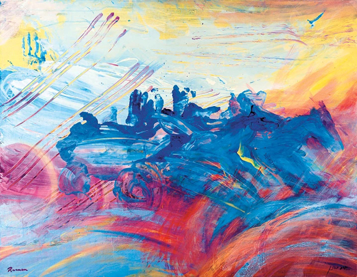
© Yoram Raanan

Moses—he received the Torah from G-d at Mount Sinai on this day.
King David—the second Jewish king passed away on this day.
The Baal Shem Tov—the founder of the chassidic movement also passed away on this day.

10. Some communities read the Book of Ruth.
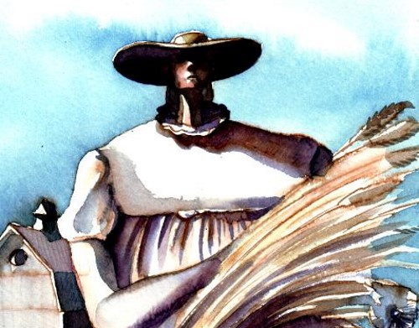
Credit: Sarah Kranz
King David—whose passing occurred on this day—was a descendant of Ruth the Moabite. It is therefore customary in some communities to read the book of Ruth in the synagogue.

11. Some have the custom to decorate their homes and synagogues with flowers and sweet-smelling plants in advance of Shavuot.

Many reasons are given for this custom. Here are a few:
G-d warned the Jews at Sinai that “the sheep and the cattle shall not graze facing that mountain [Sinai].” Now, the Torah was given in a desert. This indicates that a miracle occurred, temporarily turning that area into fertile land with an abundance of greenery. In commemoration of this miracle, it became the custom to celebrate the holiday of Shavuot with greenery.
Expounding on the verse “His cheeks are as a bed of spices, as banks of sweet herbs; his lips are lilies dripping with flowing myrrh” (Song of Songs 5:13), the Talmud explains that “from each and every utterance [of the Ten Commandments] that emerged from the mouth of the Holy One, Blessed be He, the entire world was filled with fragrant spices.” Accordingly, on Shavuot we decorate with fragrant flowers and greenery.
The Mishnah states that on the holiday of Shavuot, G-d judges the earth and determines the abundance of the fruits of the trees for the coming year. Therefore, trees are placed in the synagogue to remind us to pray for the trees and their fruits.

Reprinted from this week’s website of Chabad.Org

Shabbos Stories for
Yom tov shavuos 5777
Volume 8, Issue 40 6 Sivan 5777/ May 31, 2017
Printed L’illuy nishmas Nechama bas R’ Noach, a”h

For a free subscription, please forward your request to keren18@juno.com

Tithing Time

The Tiferes Shlomo zt'l was a great chassidic leader, the Rebbe of Rodomsk. Yet one year, he traveled to Radishitz to be with the Rebbe of Radishitz zt’l for Shavuos. The Rebbe of Radishitz was from the oldest and most revered tzaddikim of that generation, and the Tiferes Shlomo wanted to be in his presence for Shavuos.
The Rebbe of Radishitz however wasn't pleased that the Tiferes Shlomo came to him. "You have your own congregation," the Rebbe of Radishitz said. "That's true, but I came for Shavuos."
The Rebbe of Radishitz replied, "In reference to the preparation for Mattan Torah, it states, 'Moshe went down from the mountain to the nation' (Shemos 19:14). Rashi writes, 'This teaches us that Moshe didn’t go to his business . He went from the mountain straight to the nation.'
What business is Rashi referring to? Moshe Rabbeinu wasn't a businessman. Certainly, his business, is referring to Moshe Rabbeinu's desire and occupation to prepare himself spiritually for Mattan Torah.
The passuk praises Moshe Rabbeinu for forgoing his personal growth to help the Jewish nation. He didn’t take care of his personal needs, he went to the nation. Their needs came first…" In this manner, the Rebbe of Radishitz impressed on the Tiferes Shlomo that a leader must be ready to make spiritual sacrifices for the sake of his people.
This rule also applies to Torah study. Reb Moshe Feinstein zt’l taught that just as one tithes his money, Torah scholars should tithe a tenth of their learning hours, to teach weaker students.
The Torah scholar thinks he’s losing out when he teaches a weaker student, since he can learn quicker and better by himself. But one mustn’t solely think about himself. He must have other people in mind.

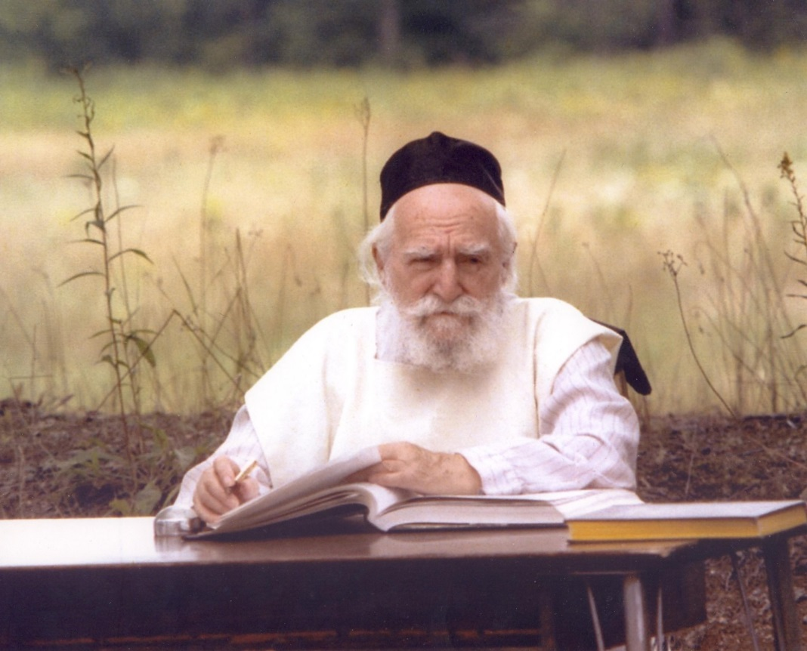
Rav Moshe Feinstein, zt”l

After World War Two, a bachur came to a yeshiva in London to learn Torah. He admits that he was the weakest student in the school, since he missed many years of Torah study, struggling to survive the war.
However, he said, there were two people who helped him, and set aside time to learn Torah with him. They were Moshe and Tuvya. (He was referring to Reb Moshe Shternbuch Shlita and Reb Tuvya Weiss Shlita, the Gaavad and the Raavad of the Edah Chareidis of Yerushalayim, respectively.)

Reprinted from the Shemini 5777 email of Torah Wellsprings: Collected Thoughts from Rabbi Elimelech Biderman as compiled by Rabbi Boruch Twersky.

The Hidden Tract,
The Grave, and the Tree
By Menachem Posner

In the old cemetery in Cracow, right near the burial place of Rabbi MosheIsserles, stood a great tree. Its large branches seemed to have borne the weight of centuries, and were laden with the heaviness of time.
Come listen, and I will tell you the story of that tree, as it was told on Lag BaOmer, the day when Rabbi Moshe, known by all as the Ramah, passed away in the year 1572 (5332).

Rabbi Yaakov ben Asher was a great Talmudist who flourished in the 13th and 14th centuries. His most lasting contribution to Jewish life may have been his book Arba Turim (Four Towers), an encompassing compendium of Jewish law and tradition as applied to all areas of life in his day.
As the centuries wore on, more questions were asked and more answers were provided. Circumstances continued to evolve, and scholars dug yet deeper into the well of Torah.
Two great scholars took it upon themselves to compose commentaries on the Arba Turim. In Poland, Rabbi Moshe Isserles wrote a commentary known as the Darkei Moshe (Ways of Moses). Faraway in the mystical city of Tzfat, nestled in the hills of northern Israel, Rabbi Yosef Karo wrote a commentary, which he named the Beit Yosef (House of Joseph).
The commentaries were well-received, but Rabbi Moshe felt there was room to do even more. The time had come for a new work, a text that would provide guidance for Jewish people all over, encompassing the works of Rabbi Yaakov, but incorporating other voices and traditions as well, all in a concise and clear manner, eliminating the meandering conversation that sometimes obscured the Arba Turim and its commentaries.
Without fanfare, Rabbi Moshe set to work on the monumental text.
One day, after the work had neared completion, he received a prized visitor: a messenger of the Jewish community in the Holy Land.
In those days, there was precious little industry in Israel, and the Jews there relied on their brethren in the diaspora for crucial financial support.
Only the most special individuals were entrusted with the task of raising funds. The roads and waterways were fraught with danger, and the traveler needed to be resourceful and hardy. In addition, as a representative of the residents of the holiest place on earth, he needed to be learned and pious, a stellar example for all. And last but not least, he needed to be trustworthy and honest.
As soon as Rabbi Moshe learned of his guest, he called for a sumptuous feast to be prepared for him, and the two men soon found themselves deep in Torah discussions.
“Since you have set out such a fine table for me,” said the visitor after the meal was concluded, “I wish to leave you with a ‘set table’ as well. Here is a set of Shulchan Aruch (literally “Set Table”), which was recently completed by Rabbi Yosef Karo.”
Rabbi Moshe eagerly perused the books. He could hardly contain his emotions as he realized that his peer from the Holy Land had done almost exactly what he had set out to do, creating a terse and easily applicable code of Jewish law.
He spent the entire night poring over the work. By morning he concluded that although it was similar to his work, there were many critical differences. While Rabbi Yosef relied chiefly on the great Sephardic decisors of previous generations, he did not cite the more recent rulings, particularly those of the leaders of Ashkenazic Jewry.
What was he to do? Should he publish his work, competing directly with the already-published treatise by the sage from Tzfat? That would not do. No, he would need to hide his work, ensuring that it would never see the light of day.
The following night, after the town was asleep, Rabbi Moshe crept out of his house and made his way to the Jewish cemetery, which was not far away. There, under a tree, he buried his manuscript, and stole back to bed.
No one knew of his noble deed, except for the caretaker of the cemetery, who had seen the rabbi bury the manuscript.
Rabbi Moshe then began a new task, writing glosses that would accompany the Shulchan Aruch, allowing all of Israel to study a single, unified code, which he called the Mappah (Tablecloth). The Sephardim could rely on the words of the original author, and Ashkenazim could study the glosses that Rabbi Moshe artfully inserted.
Years later, the same visitor from the Holy Land once again visited Cracow. This time, Rabbi Moshe joyously presented him with his latest work.
“Please take this back with you to Tzfat and present it to Rabbi Yosef Karo,” he asked the guest. “Tell him that the tablecloth had been prepared before the table, but it was then tailored to fit after the table had been crafted.”
When the unified work made its way to the holy city of Tzfat, Rabbi Yosef Karo, who was then elderly, was pleased by what had been done. Full of gratitude to his humble, junior peer in farway Poland, he purchased 100 dinars worth of parchment and wrote a Torah scroll to be given as a gift to Rabbi Moshe.

Meanwhile, the tree under which the manuscript was buried continued to grow. Its strong arms spread in all directions, and it produced lush leaves year after year.
Before he passed away, Rabbi Moshe asked that he be buried under the tree’s ample branches. And so it was.
Years passed, and the tree grew ever bigger, and closer to the grave. One year, on Lag BaOmer, when thousands of pilgrims would stream to the resting place of Rabbi Moshe, the shoving got so bad, that there was talk of uprooting the tree to create more room for visitors.
Despite the caretaker’s objections, the men arrived with their tools and were about to set to work. Suddenly, a great storm began brewing, and the men felt themselves being blown in all directions. It was then clear to all that the tree was special, and no one dared touch it again.
Years turned into centuries, and the Nazis swept into Poland, bringing destruction and devastation in their wake. In the ancient Jewish cemetery of Cracow, the Nazis tore down the walls and hauled away tombstones to be used as paving stones.
The tombstone of the Rabbi Moshe was one of the few that remained undisturbed. It’s said that the tree’s boughs bent down to shelter the tomb from the Nazis and their henchmen.
When the city’s few, broken survivors returned home from the camps, they made their way to the desolate cemetery, and there they were greeted by a lone tombstone, that of Rabbi Moshe Isserles, sheltered by the tree that had borne witness to the rabbi’s magnanimity and sacrifice.
Adapted from Sichat Hashavuah.

Reprinted from the Parshas Behar-Bechukosai 5777 email of Chabad.Org Magazine.

Shavuot Night in Salonika:
16th Century Kabbalists are Inspired By a Voice from the Spiritual Worlds

By Rabbi Shlomo HaLevi Alkabetz
[Adapted by Mrs. Chaya Bracha Leiter
from a letter by the great Kabbalist.]

The pious one [Rabbi Yosef Caro] and I agreed to make a mighty effort on Shavuot night to keep sleep from our eyes, and not to stop learning for even one second. Thank G-d we were successful. When you hear what transpired, it will enliven your souls.
For the night of Shavuot, this is the order of study I prepared…. [Verses from Scripture *] All this we did in a spirit of great fear and awe, with melody and trepidation. But what will be told next won't be believed.
After all the verses, we recited aloud all the Mishna's of Zera'im (the first of the Six Orders), and then we started again, learning it in the way of true learning, and we completed two tractates.
At that moment, the Creator graced us and we heard a great voice coming from Rabbi Caro, the words unintelligible. The people nearby heard but could not understand. The voice was very pleasing but at the same time was growing continually stronger, and we fell on our faces from the great awe. No one dared to lift his eyes and face to see.
The voice spoke:
Fortunate are you...because you took it upon yourselves to crown Me…"Listen my beloved, those who most glorify the Creator, My loved ones, peace to you. Fortunate are you and fortunate are those that bore you. Fortunate are you in This World and fortunate you will be in the World to Come, because you took it upon yourselves to crown Me on this night. It has been many years since My crown has fallen, and there has been no one to comfort Me. I had been cast to the dust embracing the filth, but now you have restored the crown.
"Strengthen yourselves my dear ones; forge ahead my beloved; be happy and joyous, and know that you are among the exalted. You merited to be in the King's palace. The voice of your Torah and breath of your mouths arose before G-d and pierced through the surroundings and many firmaments, until the messenger-angels on high were quieted, and the fire-angels hushed and all G-d's lofty army listened to your voices.
"I am the Mishna that admonishes mankind. I have come to speak to you. If only there were ten of you, you would have ascended higher. Even so, you have elevated yourselves and those who bore you. You are fortunate, my dear ones, for because of you, sleep passed from the eyes of those who bore you. I have been summoned this night through those gathered in this great and prestigious city. You are not like those lying on their beds, sleeping a sleep that is one-sixtieth of death, besmirching their beds. You bound to the One and have pleased Him. Therefore, my children, strengthen yourselves and strive forth in my love, my Torah, and my fear.
"If you could imagine even one thousandth myriad of my pain, no joy could enter your hearts, no laughter could escape your mouths, considering that on your account I have been cast to the dust. Therefore, strengthen and fortify yourselves my children, my dear ones who glorify Me. Do not halt your efforts, for the thread of kindness is drawn to you, and your Torah is sweet before Him. Therefore, stand my sons, my dear ones, on your feet and elevate me. With a loud voice, as on Yom Kippur, declare, 'Blessed is the name of his glorious kingdom for ever and ever.'" Move to the Land of Israel…Do not value your belongings, for you will partake of the best of the supernal levels…
Standing on our feet, we recited aloud, as bidden. The voice then resumed:
"Fortunate are you, my children. Return to your learning and do not stop one minute. Move to the Land of Israel, because not all times are equal, and there is no preventing salvation, whether by much or by a little. Do not value your belongings, for you will partake of the best of the supernal levels.
And if you desire and will obey, the choicest of that land you will consume. Therefore, hurry and travel there for I am the cause that sustains you, and will continue to sustain you. Peace to you in your houses, and peace in all there is to you. Eternal G-d gives strength to His people and blesses them with peace'."
All these things were spoken to us, and our ears did hear. Additional matters of wisdom were shared, and great were the promises that brought us all to tears from so much joy. We also heard of the Shechina's suffering, due to our sins, and the voice was as a sick person imploring us. Then we strengthened ourselves until daybreak, reciting verses unceasingly with joy and trembling.
When morning came, we went to immerse, as we did the two previous days, and there we met the three others that had been absent the night before. We reprimanded them and told them the favor G-d had wrought us. Their hearts melted and they turned their faces and wept, as did we. At the same time, we maintained a harsh façade, since it was because of them that we had not merited greater revelations. If permission were granted, your eyes would behold the fire surrounding this house…
The lack of a quorum had imposed a severe limitation, as we were told. They answered that they would afford us this opportunity on the second night (of Shavuot): we would join and be ten. We consented even though we had slept not a wink the first night. During the day, we also had not rested because after the Mincha prayer, Rabbi Caro had delivered a sermon. Still, we girded our loins, performing the same rites as the night before, and did do with much joy because now we were ten.
On this occasion, however, the voice did not wait until we started to recite the Mishna. Nor did it wait until midnight (as it had the night before, when it began exactly at midnight), but it made itself heard immediately. As we were reading the verses of Shema, the voice of our cherished one knocked and began, "Listen my dear ones, those most glorifying G-d. Arise! And raise those who are lying in dust, through the mystical secret "of the dust from Above".
Many matters of wisdom He taught, and afterwards said:
"Happy are you, my dear ones that raise me. How high you have been elevated now that you are ten, as is proper in all matters of holiness. Happy are you in the future world. Fear not the reproach of man or his goading because you elevate all of Israel. Know that you are among the exalted, that glory rinses your hands and that the thread of kindness is drawn to you. If permission were granted, your eyes would behold the fire surrounding this house. Therefore, strengthen yourselves and do not break the bond with Above. Say aloud, 'Hear, oh Israel…Blessed is the name of his glorious kingdom'."
After another half an hour, we returned to studying the secrets of Torah. Exactly at midnight, the Voice returned a second time, teaching for over an hour and a half. It praised the learning and said:
"See and hear this voice speaking? Ask your elders and know that for hundreds of years you are the only ones to merit such an experience. Therefore, from now on, be alert to help each other, and to strengthen the weak. Hold yourselves as leaders, for you are the princes of the King's palace, and you have merited to enter the hallway. Now strive to enter the inner chamber, but do not forsake the entry, for he who leaves the gate - his blood is on his head.
"Wake up my sons and understand what I am explaining to you. Wake up, my dear ones, and strive to be sons of valor... Behold the day is coming when men will remove their silver and worldly pleasures, and gods of gold, and desires of wealth, and travel to the Holy Land. It is possible, except that you are sinking in the mire of worldly vanities... Behold! You have merited what others, for many generations, have not."
These matters continued at great length. All who were present, resolved to turn to G-d with all their might.
~~~~~~~~~~~~~~~~~~~~~
Rabbi Alkabetz also wrote that the following Shabbat, the voice again came to Rabbi Caro, whereupon he again gathered the ten together to warn them and to urge them to enter the "inner place". They agreed to set aside every desire, to refrain from meat and wine, and to mourn the exile of the Divine Presence, and the causes of Exile. Rabbi Alkabetz left immediately for Israel, and soon afterwards both Rabbi Caro and he established residence in Safed.
Editor’s notes: The Shelah copied this story from the writing of Rabbi Shlomo Alkabetz and concluded, "It is apparent in his writing that there was much more that he was not allowed to reveal. We must learn from this story the importance of behaving with extra spiritual refinement on this night."
on second paragraph:
* A long list of verses (without chapter numbers) in Torah, Prophets and Writings, including all the verses depicting the Mt. Sinai experience, and the beginnings and ends of all the main divisions in Scripture. All these together comprise the root of "Tikun Layil Shavuot" — the published collection of verses and teachings which many Jews recite throughout the (first) night of Shavuot, a custom based on the Salonica experience recounted above.

Biographical notes: Rabbi Yosef Caro (1488-1575) was the chief rabbi of Zefat from 1546. Author of several major works, including Shulchan Aruch ("The Prepared Table"/Code of Jewish Law), a compendium of the laws of the Torah governing a Jew's entire life: personal, social, family, business, and religious. Notwithstanding subsequent revisions, it remains the foremost authoritative work on Jewish law and practice and is universally accepted by Jews the world over.
Rabbi Shlomo Alkabetz (1508-1593), is best known as the author of the famous liturgical poem "Lecha Dodi" (Come My Beloved"), sung by Jews worldwide to welcome the Shabbat. He was the Kabbala teacher of Rabbi Caro and of his brother-in-law, Rabbi Moshe Cordevero, as well as the author of many works.
Mrs. Chaya-Brocha Leiter is a tour guide and Torah teacher at Ascent-of-Safed.

Reprinted from the archives of KabbalaOnline.com

Everyone Had a Chance

The day drew near when G-d desired to give the Torah to His chosen people, the children of Israel, whom He saw now cleansed of the impurities that had filled their lives in the slavery of Egypt.
But G-d decided that it would only be fair to offer the Torah to the other nations of the earth (although He knew that they would reject it) before offering it to the children of Israel. And so He first approached the Edomites, descendants of Esau, and offered them the Torah with these inviting words:
"Ye, Edomites, sons of Esau, I bring you a gift - My holy Torah. Accept it and ye shall be blessed with long life, you and your children also."
"What is written in Your Torah?" questioned the Edomites.
"It is written in My Torah: `You shall not murder!' "
"But that is ridiculous!" protested the Edomites.
"We are soldiers, men of war who live by the sword! How do you expect us to accept a Torah that preaches against our chosen way of life? No, thank you. Your Torah is no use to us at all."
G-d then took the Torah to the children of Ishmael and offered it to them:
"Children of Ishmael, accept the Torah which I bring you this day, and if you keep its commandments you shall be blessed with all good!"
"What does Your Torah demand of us?" the Ishmaelites asked cautiously.
"My Torah says 'You shall not steal!' " replied the Almighty.
"That wouldn't suit us at all," replied the sons of Ishmael. We are men of commerce, and such a law would interfere with our business transactions. We are sorry, but we have no use for Your Torah."
The next people that G-d approached were the inhabitants of Tyre and Sidon and all the people of Canaan, to whom He said
"I bring you a most precious gift - My Torah. Take it and you shall all be blessed with many days upon your land!"
The Canaanites spoke up, saying: "First tell us what is written in Your Torah."
"In My Torah it is written: 'You shall have fair scales, correct weights, and give full measure,' " replied the Almighty.
"We do not want to accept Your Torah which is so finicky about such matters. Your Torah is not for us!" answered the Canaanites emphatically.
And thus, after G-d had taken the Torah to all the other nations of the world, who lacked sufficient understanding to estimate its worth, He went to the children of Israel. He was confident that His chosen people would appreciate the Torah and accept it eagerly.

Reprinted from the current website of Chabad.Org

Rav Pinchas Chaim Sheinberg’s Shavuos Custom of Davening Vasikin at the Kosel
By Rabbi Yisroel Reisman

Let me share with you a story with a little Mussar that I heard regarding the Chag Hashavuos in Eretz Yisrael. Rav Pinchas Chaim Sheinberg had the custom of staying up in his Yeshiva, Torah Ohr on Shavuos night and then accompanying the boys of his Yeshiva and walking to the Kosel to Daven Vasikin.
As many of you know, it is quite a long walk. As Rav Scheinberg got older he started to question whether he should make the walk. One Shavuos or Erev Shavuos his wife told him you know that it is a long walk and afterwards you have been up all night, to walk back, I don’t think you have the strength for it.
Rav Scheinberg disagreed and said I can do it and his Rebbetzin said no I don’t want you to do it. Rav Scheinberg decided to do the Gorel HaGra. To do that very special Gorel that great people can do with a Sefer and opening it up and finding a Posuk. Rav Scheinberg used a Tanach for the Gorel HaGra because he came to the Posuk that is found in Tehillim 29:1.

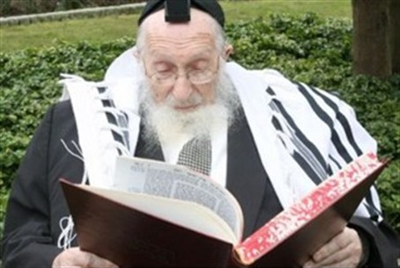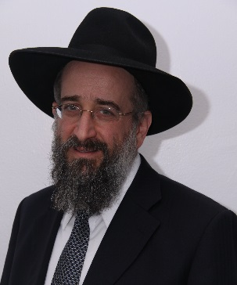
Rabbi Pinchas Chaim Sheinberg, zt”l Rabbi Yisroel Reisman

(He understood that the Gorel HaGra was telling him (that Hashem gives strength and you can do it, you can walk to the Kosel. A Talmid later asked him I don’t understand, the end of the Posuk.(You came to that Posuk, maybe the Posuk was telling you to watch out for your Sholom Bayis and listen to your wife.
It is not [a] Sholom Bayis [problem] when my wife and I disagree. People can disagree, it is not personal. We had a disagreement and we did a Gorel HaGra. Whatever it is we are B’sholom. Whether the Gorel goes my way or her way is totally irrelevant.
What a basic and important thought in Sholom Bayis. When there are disagreements, normal intelligent people can disagree over things. It doesn’t become personal. It is not a question of Sholom. A Geshmake thought.

Reprinted from the Parshat Bamidbar/Shavuous 5776 email of Rabbi Yisroel Reisman’s weekly Torah Divrei Torah.

Brooklyn torah gazette
Yom Tov Shavuos 5777
Volume 1, Issue 27 (Whole Number 27) 6 Sivan 5777/ May 31, 2017
Printed L’illuy nishmas Nechama bas R’ Noach, a”h

For a free subscription, please forward your request to keren18@juno.com

The Connection of Shavuos
And Hashgacha Pratis

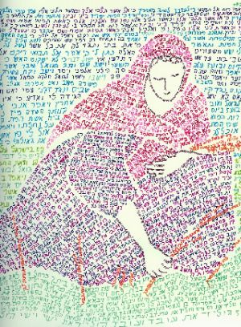

The Aseres HaDibros begins with "I am Hashem your G-d… who took you out of Mitzrayim." The commentaries ask, shouldn’t the Ten Commandments begin with "I am Hashem your G-d… Who created heaven and earth"? Isn't creation a greater miracle than yetzias Mitzrayim?
The meforshim answer that yetzias Mitzrayim has a unique edge, because it teaches us hashgachah pratis. It proves that even after creation, Hashem continues to lead the world. One might claim that Hashem created the world and then left it for the rules of nature (as many nations of the world think).
The miracles of yetzias Mitzrayim verify that Hashem continues to lead the world, and especially the Jewish nation, with hashgachah pratis. This is the reason the Ten Commandments begin with, "I am Hashem your G-d… who took you out of Mitzrayim."
The Rosh writes, "Trust in Hashem with all your heart, and believe in His hashgachah…. Believe that He sees everything that happens on earth, and He knows the deeds of man… He knows their thoughts… If one doesn’t believe in [in the hashgachah pratis that we learn from yetzias Mitzrayim] he doesn’t believe in “Anochi Hashem Elokecha/I am the L-rd Your G-d” either.
This is the central pillar of the entire Torah." (Orchos HaRosh 1:26) When one believes in hashgachah pratis, he knows that everything is for the good. There are hard moments; times when Hashem's hashgachah seems to be concealed from us, but we believe that even then Hashem is with us, and His continence is shining on us. When we look back, we can often see the wonders of Hashem's providence, and we discover that even in the hardest times, Hashem was always there with us. The Chasam Sofer zy'a (II Droshos p.299) says that Megilas Rus (which we read on Shavuos) teaches us this lesson. Megilas Rus tells that Naomi returned to Eretz Yisrael after her husband and two sons died. She was alone in the world, besides for her daughter-in-law Rus. She felt helpless. She felt that her only hope was her wealthy relative, Boaz, who should help her. This is the reason Noami and Rus traveled from Moav to Beis Lechem. She wanted to be near where Boaz lived.
Because of Naomi's extraordinary tznius [modesty], she never planned to speak directly with Boaz, to ask him for help. (Indeed, there is no reference in the pesukim that Noami ever spoke with Boaz.) Her intention was to speak with Boaz's wife, tell her about her poverty and plight, and Boaz's wife would relay the message to her husband.
However, just when Naomi came to Beis Lechem, Boaz's wife died. As the Gemara (Bava Basra 91) teaches from the passuk "when they came to Beis Lechem, the entire city was in an uproar." The Gemara explains, "The city was in a tumult, because everyone came to bury Boaz's wife, who was niftar that day." When Noami saw this, she felt her last hope was shattered. Therefore, when people greeted her, she said "Don’t call me Noami. Call me bitter, because Hashem made me very bitter" (Rus 1:20).
But everything proved to be for the good, because this situation resulted in Rus marrying Boaz. Now Noami was Boaz's mother-in-law; all her needs would be taken care of. Furthermore, from this marriage, Rus gave birth to a boy who would support Noami in her old age. As the women said to Naomi "[this child] will revive you and he will support you in your old age" (4:15).
From this child, Dovid Hamelech, Shlomo HaMelech, and even Moshiach will come. So what appeared to be a grave problem, proved to be for her benefit. The roshei teivos of Noami's Hebrew words, [heh – lamed – shin – mem] "Hashem made it very bitter for me," spell Shlomo, because what appeared to be bitter was actually setting the way for Shlomo HaMelech's birth who would build the Beis HaMikdash. Everything turned out being for the good, as Hashem's hashgachah stands behind everything that occurs in life.

Reprinted from the Shavuos 5776 email of Torah Wellsprings: Collected Thoughts from Rabbi Elimelech Biderman as compiled by Rabbi Boruch Twersky.

Do You Really Believe that The Torah is Historical?
By Aron Moss

Do you still hold on to the belief that the Torah is Divine? Literary experts and historians have compared the Bible to other writings of 3,000 years ago (when the Torah was supposedly given by G-d) and say that its style doesn't fit into the literature of that time frame, and must have been written much later. How can you ignore a fact that has been scientifically proven?

Answer:
Did you hear the joke about the recent study on frogs? Scientists took a sample of over 100 frogs of various species and did the following test:
They placed each frog on a table, crept up behind it and shouted, "Jump!" The frog jumped.
Then they cut off one leg, and again shouted jump. It jumped, although not as far.
They then cut off a second leg and told it to jump, and then a third, each time observing that the frog responded, but jumped smaller distances.
Finally they cut off the fourth leg and again shouted "Jump!" They were amazed to find that in every case the result was the same. The frog did not move at all.
The conclusion: When you cut off a frog's legs, it goes deaf. It is scientifically proven.
We all come to the conclusions that we want to believe. When the experts find that the Torah is too advanced for its time, they conclude it must have been written later than claimed. When I study Torah, I conclude that it is still ahead of its time, because it was written by G-d for all times and all places. Even the parts that seem archaic and outdated, when explained on a deeper level, have powerful messages that I often feel are speaking directly to me. They are relevant and inspiring to me, right here, right now.
Many have tried to either prove or disprove the Torah's divinity. Neither attempt will be successful. G-d wants us to have free choice. If we listen to His word, it is not by force. To maintain balance, there will always be valid arguments to discredit Him and His Torah. We can choose to buy those arguments, or see beyond them. Then, when we open ourselves to the Torah's message, the choice to do so is coming from within.
G-d has given you a mission. How you respond is totally up to you. You can be as deaf as a legless frog, or you can take a leap in response to your higher calling.

Reprinted from the current Chabad.Org website.
Shavuot and the Unity
Of the Jewish People
Adapted from a letter of Rabbi Menachem Mendel Schneerson, the Lubavitcher Rebbe, zt”l

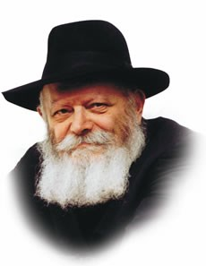
Torah from Sinai begins with the Ten Commandments, of which the first two: "I am G-d, your G-d" (the root and foundation of all positive mitzvot) and "You shall have no other gods" (the root and foundation of all prohibitions) proclaim the Unity of G-d.
A precondition to the Giving of the Torah was the unity of the Jewish people (as it is written, "And Israel encamped there facing the Mountain"-- in the singular form, indicating, as our Sages explain, "as one person with one heart").
The essence of the Giving of the Torah is to realize in the material world the Unity of G-d, through the "one nation on earth," the Jewish people, fulfilling the 613 mitzvot of the one Torah.
At first glance it is difficult to understand how such unity can be achieved, considering that G-d Himself created mankind as diverse individuals, differing in their opinions ("as they differ in their faces so they differ in their minds"), living in a world which He likewise created variegated as to climate and physical features. How can a whole nation attain true unity within itself and bring unity into such a diversified world?
The explanation is to be found in the verse, "And they stood themselves under the Mountain (Mount Sinai)"--all of the 600,000 adult men, their wives, sons and daughters. This means that, as they were about to receive the Torah, all submitted themselves to it so completely, that mundane matters ceased to exist for them, as it were; their self-effacement (bitul) and joy of receiving the Torah left room for nothing else. And since the "Mountain" was the same for all, and all were permeated with the same feeling of self-effacement and joy, this brought true unity to all the individual Jews, and also unity into the world, through the one Torah.
The Jewish people began with one family, that of our ancestors Abraham and Sara, and ever since then the Jewish family has been the foundation of our people. In the family, too, each member is a separate individual, with a particular function and purpose in life assigned to him and her by Divine Providence.
Unless there is unity in the family, there can be no unity of the Jewish people. How is family unity achieved? In the same way as mentioned above: When all the members of the family accept the One Torah from the One G-d in such a way that the Torah and mitzvot are the only essential thing, and all other things are merely secondary, and have a significance only insofar as they are related to the essence--then there is true unity in the family.
In attaining this family unity--bearing in mind also that Jewish families are the component parts of the Jewish people, hence the basis of the unity of the Jewish people, as mentioned above--the Jewish mother and daughter have a most important part, being the Foundation of the Home, as has been underscored on previous occasions.
Needless to say, the said unity must be a constant one, without interruptions; this is to say, it must be expressed not only on certain days of the year, or certain hours of the day, but in every day of the year and in every hour of the day. This means that a Jewish home must be wholly based on the foundations of the Torah and mitzvot, and so permeated with the spirit of Torah dedication and the joy of mitzva that this should be reflected also in the conduct outside the home, in the street, and in the entire environment.
Herein lies the essence of the "integrity" and unity of the Jewish family and of Jewish family life.
It is hoped that this point will be brought out with the proper clarity and forcefulness, together with its aim and purpose--its realization in daily life, in keeping with the basic principle of our Sages of blessed memory: The essential thing is the deed.

Reprinted from Issue #219 of L’Chaim Weekly for Parshat Bamidbar 5752/1992.

Shavuos – an Overview
By Rabbi Yair Hoffman

PREPARING FOR SHAVUOS
Shavuos is called Z’man Matan Toraseinu. Originally, this event occurred in the Hebrew year 2448 (3324 years ago). As we know, Rav Dessler in his Michtav M’Eliyahu explains that time does not flow as a straight line, but rather as a circle. The day of Shavuos which is the 6th of Sivan is, therefore, the very day that we received the Torah.
Similarly, the Nesivos Shalom explains that just as the Torah is eternal, so too is Kabalas HaTorah eternal. Each and every year there is a new Kabalas HaTorah. In other words, Shavuos is not just a commemoration of our receiving the Torah – it is receiving it once again.
Receiving the Torah is monumental. The entire essence of the nation of Israel is only for Torah (Sefer HaChinuch 273). The entire universe, heavens and earth, were only created for the sake of the Torah (ibid). Receiving the Torah, therefore, requires much preparation. Indeed, the Torah tells us in Parshas Yisro that we needed to prepare for three days – “Heyu nechonim l’shloshes yamim (Shmos 19:15).”
One of the preparations that we make for receiving the Torah is that we learn Pirkei Avos on every Shabbos between Pesach and Shavuos. The Midrash Shmuel explains, “One who will be learning Torah must first know its method of study and how to treat Torah. Therefore, so that the heart of each member of Klal Yisroel will be ready to accept Torah with a complete heart and to properly observe it, they enacted the learning of Pirkei Avos.”

ZENITH OF OUR GROWTH
Let us also recall that Shavuos represents the zenith of our spiritual growth. When we left Mitzrayim we were on the lowest level of Tumah – impurity. In a matter of 49 days we experienced record spiritual growth to the point where the nation of Israel at the time was greatest generation that ever lived.

NO LIMIT TO OUR MITZVOS
We should also be aware that there is no limit to the heights and growth we can accomplish in our ruchniyus – indeed in any Mitzvah. This can be seen from a passage of the Targum Yonasan on Sefer Rus. Boaz tells Rus that he is aware of both how she came and joined up the nation of Israel, and also of all the Chessed that she had performed with her mother-in-law. The Targum Yonasan on this Pasuk explains that because they were written next to each other and said in the same breath, these two Mitzvos were equal to each other.

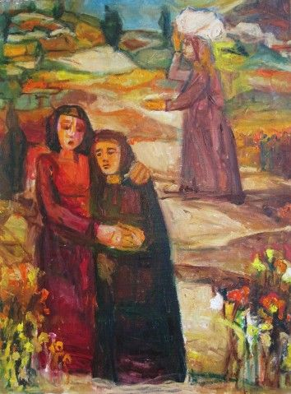

This is somewhat mind-boggling. Rus was a princess of Moav, a very powerful nation. It is a remarkable notion that one of the top women in society would give it all up to become a lowly member of the Jewish nation that must take Tzedakah. Is this lofty Mitzvah equal to the mere Chessed that she does with her mother-in-law?
The answer, according to Rav Henoch Leibowitz zt”l. is that there is no spiritual limit to any Mitzvah that we perform. If we do a Chessed, any Chessed, with the right intentions and Kavannah – it can be equal to the greatest of Mitzvos.

EREV ROSH CHODESH IS PREPARATION TIME
The Shla HaKadosh explains that Erev Rosh Chodesh Sivan (Monday Before Shavuos this year) is a special time of preparation in terms of Teshuvah, Tefillah and Tzedakah. This may be based upon the Rashi in Parshas Yisro (19:1-2) that the nation of Israel did Teshuvah on this day when they travelled from Refidim.
The Psukim in the Torah give us the pre-history of Matan Torah:
On Rosh Chodesh Sivan itself Klal Yisroel entered Midbar Sinai, a place wherein Har Sinai is located.
On the second of Sivan Moshe was told and gave over to Klal Yisroel the two Parshios of “Atem Ra’isem” and “You shall be for Me a nation of priests and a holy nation.” This was when they answered, “Everything that Hashem spoke – we shall do.”
On the third of Sivan Moshe related to Hashem the words of the nation. Moshe was then told of the Mitzvah of separating.
On the fourth of Sivan Moshe was told to go to the nation and sanctify them. He then told them to prepare themselves for three days.
The Mechilta (Parshas Yisro) explains that part of the preparations involved the utter unity of the nation – VaYachon Sham Yisroel –b’lev echad k’ish echad – with one heart, like one man. It is clear from this Mechilta that there are levels of Dveikus and holiness that cannot be achieved alone but only through a joint and communal effort. We achieved this level at that time. It was through this unique achdus that we merited to say “Naaseh v’Nishmah – we will do and then we will listen.”
Ultimately Hashem placed the very mountain above them like a barrel. The verse tells us that they stood under the mountain – “vayetzatzvu betachtis hahar” (Shmos 19:17) Rashi explains– “Kafah aleihem har k’gigis.”

THE THREE DAYS OF HAGBALLAH
“The essence of these days,” according to the Shaar HaMelech, “is to separate ourselves from all the vanities of this world to be prepared to greet Hashem. In each and every year we should look at ourselves as if we are preparing ourselves for Kabalas HaTorah on the mountain of Sinai.”
The separation means to focus on things spiritual, and avoid an emphasis on aspects of the physical world that take us away from concentrating on Hashem and upon our relationship with Him. Our brachos should therefore be recited with more intensity and concentration, we should avoid unnecessary window shopping and looking at catalogues. Rather, our focus should be on three more important things: 1] improving on Davening, 2] on focusing more on the life lessons inherent in our Torah studies, and 3] upon Chessed. Each of these three brings us ever closer to Hashem Yisbarach.

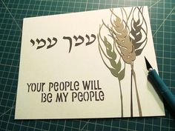

OTHER NAMES OF SHAVUOS
Another name for the Yom Tov of Shavuos is Atzeres. There are actually two Yomim Tovim with this name. Both of them have a unique and special quality to them that no other Yom Tov has. Shavuos is achieving a state of being alone with Hashem. The Bais Avrohom explains in terms of the Dveikus that can be achieved through the Yomim Tovim that Pesach is considered like the period of engagement and Shavuos is like the very wedding itself. When the mountain was placed upon the nation of Israel like a barrel – it was likened to a Chuppah.
The closeness to Hashem that we achieve at Matan Torah makes Shavuos the ideal time to celebrate the first fruits of the Seven Species with which Eretz Yisroel is blessed. During this time the first fruits were harvested and brought in decorated baskets to the Beis HaMikdash. Thus, another name for Shavuos is Chag HaBikkurim (the Festival of the First Fruits).
Shavuos is also the time when we celebrate the abundant wheat harvest that Hashem has given us. This is why it is called Chag HaKatzir (the Feast of Harvest). It is because Shavuos is also the beginning of the wheat harvest that we bring the shtei haLechem (two loaves) as a meal-offering in the Beis HaMikdash.

SHAVUOS CUSTOMS

No Bloodletting or Testing
The Talmud (Shabbos 129b) tells us that a celestial damager was sent out against the nation of Israel on the day before Shavuos. It’s name was T’voach. By virtue of Klal Yisroel having accepted the Torah, they saved themselves from the destructive fate of T’voach. On the eve of Shavuos we do not engage in any form of bloodletting because of the dangers involved. Indeed, the sages forbade doing so on every Erev Yom Tov on account of Shavuos. The Minhag is cited by the commentators (Darchei Moshe CM 468:3) and the custom in Klal Yisroel is to avoid it unless there is medical need.
Some people have the custom to sleep on Erev Shavuos in order to be able to stay up the entire night on Shavuos. The Mogain Avrohom (OC 290) quotes the Sefer Chasidim that when Erev Shavuos falls on Shabbos, it is forbidden to say that one is resting so that he or she can be awake for the night of Shavuos.
The Minhag of Grass and Trees in Shul
There is a Minhag mentioned by the Ramah in Shulchan Aruch (OC 494) to place grass, flowers, and trees in Shul on Shavuos. One explanation for this is found in the words of the Levush (Rabbi Mordechai Yaffe):
It commemorates the grass that surrounded Har Sinai at the time of Matan Torah. As the verse states, “the sheep and flocks may not graze..” The indication is that grass grew there. It is a worthwhile Minhag to continue because it helps us relive the experience at Har Sinai – an experience that we actually go through once again.
Another explanation is that it commemorates the bringing of the Bikkurim the first fruits, which were made from baskets woven and decorated from and with grasses and flowers (Ziv HaMinhagim).
Another explanation is that Moshe Rabbeinu was saved on the banks of the Ye’or which had grassy knolls (Chiddushei HaRim – the Gerrer Rebbe).
The Brisker Rav explained that the decorations are a minimum form of decoration and show us that the only means in which one can acquire Torah is if we are satisified with the minimum and not pursue luxuries and other forms of consumption. Grasses are mentioned in this vein in the Gemorah Eiruvin 22a by Rabbi Adda Bar Ahava ( Moadim L’Simcha p. 402).

The Minhag of Milchigs
The Ramah mentions that it is the custom to split the meal on Shavuos, where the first half of the meal is comprised of dairy foods and the second half is comprised of meat foods. Although it is no longer the custom to split the meal, we do have the custom to eat dairy foods on Shavuos. The reason for this custom is to remind us that when we received the Torah we were taught the laws of preparing the meat in the proper, kosher manner. Since we were unable to this immediately, we consumed only dairy foods at the time.

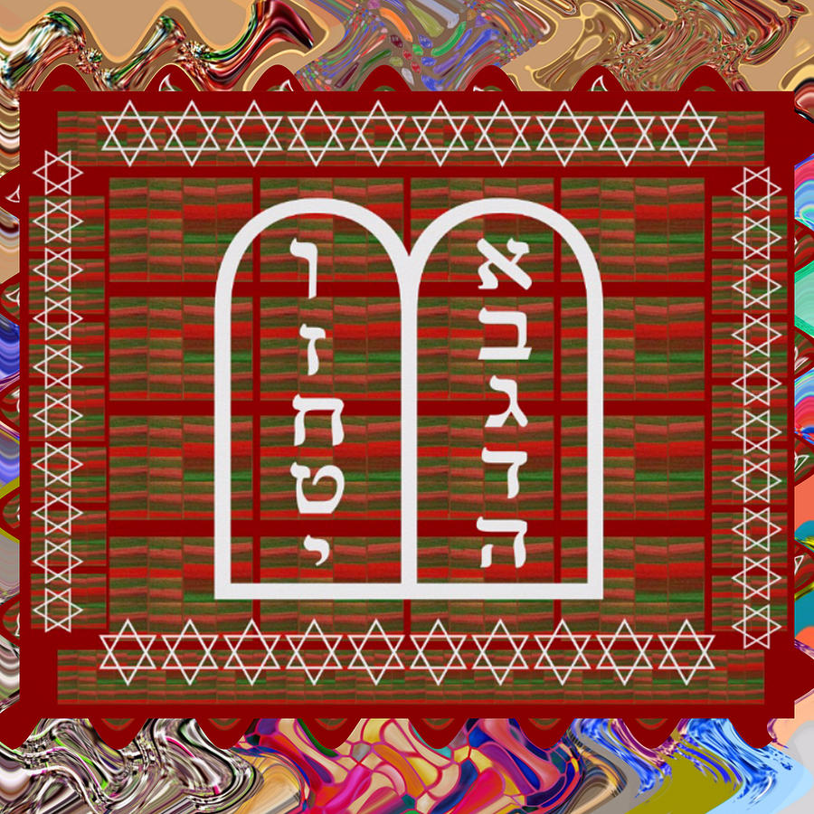

Waiting for Nightfall
Although generally we are permitted to bring in Shabbos or Yom Tov slightly earlier than is required, in regard to Shavuos the custom is not to pray immediately but to wait for nightfall. The reason is that we want to count the Omer completely and perfectly. Doing so would entail making sure that the last day is complete.

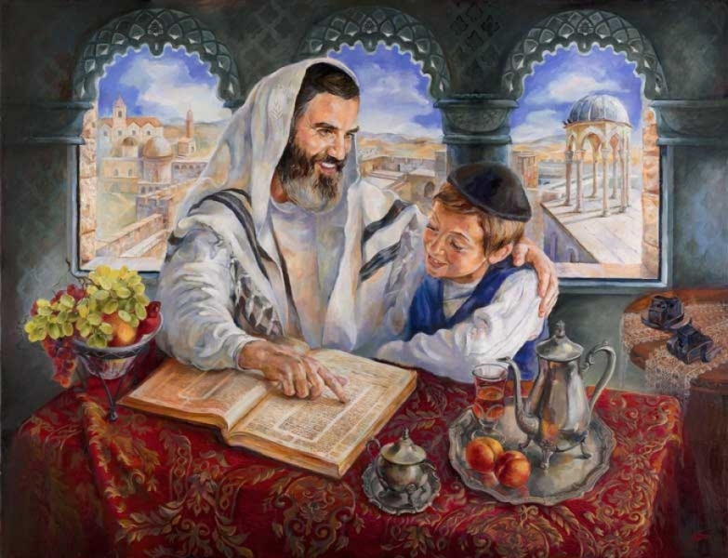

The Minhag to Stay Up All Night
Although the custom is not mentioned in the Talmud nor in the Shulchan Aruch, the custom has developed in Klal Yisroel to remain awake the entire night of Shavuos and to study Torah. The Seforim HaKedoshim explain that one who stays up all night studying Torah merits “Gilui Shechina” revelation of Hashem’s Divine Presence on that night.
The Kaf HaChaim (OC 494) writes that women who have the custom of counting the Omer can indeed partake in perfecting the Tikkunim involved in the Mitzvah of Sfiras haOmer by learning at night as well. Other Poskim explain that there was no Minhag for the women to stay up as well.

Shavuos Davening
The Shacharis and full Hallel of Yom Tov are recited. The reading of the Aseres HaDibros takes place on the first day of Shavuos. This is followed with Mussaf and the Birkas Kohanim. On the second day Megilas Rus is read before the reading of the Torah. It is preceded with the Piut of Akdamus.

Why We Read Megilas Rus
There is a debate among the Poskim as to whether our custom to read the Megillah of Rus on Shavuos is a full-fledged obligation or a Minhag. The reason why we read the book of Rus is to teach us that Torah is only given through hardship and poverty (Yallkut Shimoni 596). Another reason is that the entire episode took place during the Zman HaKatzir – and Shavuos is known as Chag HaKatzir too. A third reason is so that we will have read all three parts of the TaNaCh on the day of Matan Torah (Otzer HaMinhagim).

The Piut of Akdamus
The Piut (supplication poem) was written by Rav Meir Ben Yitzchok Shliachtzibbur, a Rishon that is often quoted by Rashi and Tosfos (See, for example, Rashi on Tehillim 73:12 and Tosfos RH 11a). It is a double Aleph Bais poem that describes the greatness of the Creator of the world, the nature of Malachim, and the loftier stature that the nation of Israel has above the angels themselves. One section of it describes how, kavyachol, Hashem is longingly desirous of Klal Yisroel learning Torah and desires their prayers. It ends with the statement that who hear (and absorb the depth and meaning of the piut) will merit to be among that group that will merit fantastic miracles on the great day.
The Piut is recited in Aramaic so that the Malachim will not understand it, hear it and take it for their own use. It should remain special for the Jewish people alone. It is the only Piut which is recited while the Sefer Torah itself is lying on the Bima. This demonstrates how very special it is.
Yizkor
On the second day of Yom Tov (the first day in Eretz Yisroel) after the Torah is read, a special prayer of Yizkor is recited as is done on all second day Yomim Tovim. We daven for and pledge Tzedakah in the merit of those in our family who have passed on. It is the custom in Klal Yisroel for everyone who still has both parents to leave the shul during the recitation of Yizkor.

YOM TOV HALACHOS
Like on Shabbos, there exists a prohibition of performing Malacha on Yom Tov. The admonition against certain Malachos should be used as a means of coming closer to Hashem as well. What is Malacha exactly, and how can it be used as a tool for greater closeness to G-d?
Malacha is not defined as work, necessarily. Malacha is defined as a certain, specific type of creative act. More precisely, Malacha is defined as the specific creative acts that were necessary to create the Mishkan, the resting place for Hashem’s concentration of the Shechina Presence here on earth.
Our refraining from such creative acts on Shabbos and Yom Tov is the collective flag of the Jewish people. Just as any nation is proud and salutes its national flag, so too is the observance of Shabbos and the holidays the flag of the Jewish people. The flag symbolizes and embodies our belief that the world was created for a purpose by a kind and benevolent Being who rewards good and punishes evil. A focus on this idea will cause us to become ever closer to Him. Mere contemplation of it when we refrain from Malacha achieves this end.

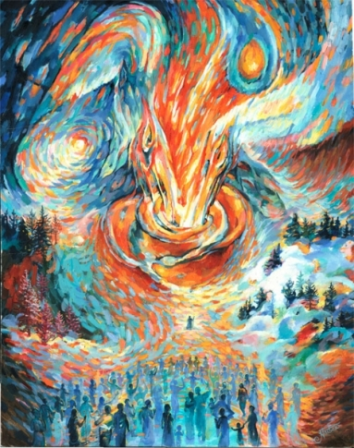

While the definition of Malacha is the same for both Shabbos and Yom Tov, the Torah made some exceptions for Yom Tov. The Torah states that actions that are necessary for people to eat are permitted on Yom Tov. This is called “Ochel Nefesh.” Not all actions, however, are permitted for Ochel Nefesh purposes. If the food preparation could have been done with equal freshness and results before Yom Tov, and one had the time opportunity to do it then, then it may only be done with a shinui on Yom Tov itself. There are some Malachos on Yom Tov that are forbidden or very different even when it comes to food preparation.
It is also important to know that one may never do Malacha on Yom Tov during a Bain HaSh’mashos – twilight that immediately followed a Yom Tov. Why is this so? Because we do not know exactly when the day changes from one to the other. It is forbidden to do Malacha on Yom Tov for another day. Thus we might be doing Malacha on Yom Tov for another day which is forbidden.
One is also, of course, not permitted to perform any Malacha on the first day of Yom Tov for the second day of Yom Tov – even if the preparations involve no Malacha. This is called Hachana and something in which we must be very careful. The Yom Tov is very special and acts performed on it must be limited only to the needs of that Yom Tov.
May it be Hashem’s will that we merit a complete and full Kabalas HaTorah this year!

Reprinted from the June 10, 2016 website of Yeshiva World News. Originally published in the 5 Town Jewish Times.

Shabbos Stories for
Yom tov shavuos 5775
Volume 6, Issue 37 6 Sivan 5775/ May 24, 2015
Printed L’illuy nishmas Nechama bas R’ Noach, a”h

For a free subscription, please forward your request to keren18@juno.com

A Shavuot Baal
Shem Tov Story

The holiday of Shavuot, where we mark the Giving of the Torah at Mt. Sinai, begins this Tuesday evening (May 14, 2013), and continues until Thursday evening. Shavuot is also the yahrtzeit (anniversary of passing) of the Baal Shem Tov, the founder of the Chassidic movement.
In honor of the Baal Shem Tov, I share with you the following story, which I hope you will enjoy.
Moshe was an inkeeper in a village belonging to a Polish nobleman, Count Tadeush Vissotzky. He was one of many Jews who rented various properties from the Count. Before Moshe, his father had rented the inn from the Count’s father. He was, in a sense, grandfathered in.
As with any business, some years were better than others. His income depended largely on the weather; during harsh winters he had fewer travelers, and dry summers were no more favorable.
When it was hard to pay the annual rent, the Count’s father was always understanding, and would graciously extend an extension to Moshe’s father. Not only was the Count’s son and current landlord not so accommodating, but he also enjoyed hosting opulent parties and would frequently spend way beyond his means.
One year, when time came to pay the rent, Moshe arrived at the Count’s home and requested an extension. Begrudgingly, the Count gave him six months to pay in full.
Six months came and went, but the flow of travelers to Moshe’s inn was sparse, and he still did not have the means to pay. Another year passed, and he now owed the Count two years’ rent.
Moshe came to the Count and pleaded for another extension. The Count was enraged, and warned Moshe that if he didn’t pay up the entire debt on the first day of the next year, he would kick him out, jail his family, and take the inn away from him forever.
Moshe returned home and told his wife the sad story.
“Do you recall when we once hosted a traveler who told us about a very holy man who lives in the nearby Mezibuzh?”
“Yes, I believe so. Are you referring to Rabbi Israel Baal Shem Tov?” inquired Moshe.
“That’s him! Remember the miracle stories the traveler told us about him? How he has helped so many people? You should go see him, I bet he can help us!” said his wife.
Now, Moshe didn’t believe half of the miracle stories he had heard about the Baal Shem Tov; he was not convinced that he should make the journey to Mezibuzh. Despite his hesitations, his wife continued to urge him to go to the Baal Shem Tov.
Realizing that he had nothing to lose, he finally obliged.
As soon as he arrived in the Baal Shem Tov’s presence, he felt a certain calming effect. He began to cry profusely and unburdened himself to the great Baal Shem Tov.
“Trust in the Almighty G-d,” said the Baal Shem Tov. Handing him a silver coin, he continued, “At the next market day in your home town, a peasant will approach you and offer his wares for sale. Buy it immediately and then come back to me for further instructions.”
Moshe arrived back home, already having lost the sense of comfort he felt while in the presence of the holy rabbi. How could the Baal Shem Tov possibly help? he wondered.
His wife said, “Do what the Baal Shem Tov said! What have you got to lose?”
The next week, Moshe went to the market. A young peasant approached him and offered him a lambskin in exchange for one silver coin. Moshe handed over the coin he had received from the Baal Shem Tov, and took the lambskin.
He returned home and after telling his wife of what had transpired, he set out to journey to the Baal Shem Tov, as he had been instructed.
When he arrived, he showed the Baal Shem Tov the lambskin he had purchased. Running his fingers over it, the Baal Shem Tov exclaimed, “Remarkable! A good purchase, indeed. Listen carefully: next week, Count Vissotzky is making a large birthday party for himself; many people will bring him gifts. Give him this lambskin as a birthday present.”
Arriving home, Moshe’s sad demeanor was apparent. “A lambskin for a birthday gift? The Count is sure to receive many lavish gifts… my gift will look paltry in comparison! The Baal Shem Tov said this was a remarkable lambskin, but it looks quite plain to me. It is not even large enough to make a fur coat!”
“Didn’t everything the Baal Shem Tov say happen exactly as he said?” said his wife. “Who are we to question this holy man? Bring the lambskin as a birthday gift to the Count!”
When the day arrived, people from all over began arriving for the party. Observing the steady flow of people and their gifts, Moshe became discouraged.
He nevertheless set out for the castle, lambskin in hand. When he arrived, a guard said, “Moshe, you brought a gift?! Let’s see what it is!” Upon seeing the lambskin, the guard grabbed it from Moshe’s hands, and instructed Moshe to wait.
Bringing the lambskin to the Count, the guard said, “This is a birthday gift from Moshe the Inkeeper!”
“What a shameless gift from this miserable Jew!” said the Count. Embarrassed in front of his guests, he told the guard to throw Moshe into the cellar, to be dealt with later.
Some of the Count’s guests — having already had a few drinks of alcohol — began to mock him. One of the guests was looking closely at the lambskin and suddenly proclaimed, “Remarkable!”
Gathering around him, the guests took a closer look, and they saw the most amazing thing: In the middle of the lambskin, there was a beautiful pattern which spelled out the Count’s name, his father’s name, his date of birth and his family coat-of-arms.
“Incredible!” one of them said. “I’ve never seen anything like it!” said another.
After gazing at the wondrous lambskin, the Count ordered that they bring Moshe before him. Not knowing what they had discovered, Moshe was petrified of what the Count had in store for him.
Moshe began pleading for mercy.
“Where did you get this lambskin?!” shouted the Count.
“Please have mercy, I didn’t mean any harm!” responded Moshe.
The Count assured him that he would not harm him or his family, and that he merely wanted to know which artist had made such a stunning pattern on the lambskin.
“Artist? I don’t know what you mean,” responded Moshe. He then proceeded to tell the Count the entire story of how he had visited the Baal Shem Tov, received a silver coin, purchased the first thing that came his way in the market, and finally how he had brought the lamb skin to the Count.
Everyone realized that the Baal Shem Tov was behind this. They gave Moshe gifts to bring to the Baal Shem Tov so they could receive his blessings. The Count annulled Moshe’s debt, and declared that he would never have to pay rent again.
Brandishing the lambskin, he said “This will make a beautiful fur hat!”
Since Moshe had now received so many gifts, the Count ordered his carriage to take him home, telling his servants to do whatever Moshe would request.
Arriving home, he told his wife the miraculous story, then continued straight on his way to see the Baal Shem Tov.
Shabbat Shalom, and this Shavuot, may we all receive the Torah with joy — and internalize it!

Reprinted from the website of Chabad on Campus/Queens.

ABCs of Shavuot:
Celebrating our receiving the
Torah at Mount Sinai.
By Rabbi Shraga Simmons

It is ironic that Shavuot is such a little-known holiday, given that it commemorates the single most important event in Jewish history – the giving of the Torah at Mount Sinai.
Shavuot occurs on the 6th of Sivan, the culmination of a seven-week period, "counting of the Omer," that occurs following Passover. The very name "Shavuot" means "weeks," in recognition of the weeks of preparation and anticipation leading up to the Sinai experience. Since Shavuot occurs 50 days after the first day of Passover, it is sometimes known as "Pentecost," a Greek word meaning "the holiday of 50 days." (Shavuot, however, has no connection to the Christian Pentecost holiday.)
Three millennia ago, after leaving Egypt on the day of Passover, the Jews traveled into the Sinai desert. There, the entire Jewish nation – 3 million men, women and children – directly experienced divine revelation:
G-d spoke to you from the midst of the fire; you were hearing the sound of words, but you were not seeing a form, only a sound. He told you of His covenant, instructing you to keep the Ten Commandments, and He inscribed them on two stone tablets. (Deut. 4:12-13)
The giving of the Torah was an event of awesome proportions that indelibly stamped the Jewish nation with a unique character, faith and destiny. And in the 3,300 years since, the Torah’s ideals – monotheism, justice, responsibility – have become the moral basis for Western civilization. In the words of U.S. President Calvin Coolidge, "The Hebraic mortars cemented the foundations of American democracy."

How to Celebrate
Shavuot is a full-fledged Yom Tov, and as such carries most of the same restrictions as on Shabbat – no driving, no writing, etc. The exception is that food preparation (e.g. cooking) is permitted. In Israel, Shavuot lasts one day; outside of Israel it is two days.
Perhaps the reason for the relative obscurity of Shavuot is because this holiday has no obvious "symbols" of the day – i.e. no Shofar, no Sukkah, no Chanukah Menorah.
On Shavuot, there are no symbols to distract us from the central focus of Jewish life: the Torah. So how do we commemorate Shavuot? It is a widespread custom to stay up the entire night learning Torah. And since Torah is the way to self-perfection, the Shavuot night learning is called Tikkun Leil Shavuot, which means "an act of self-perfection on the night of Shavuot."
Those who study all night then say the morning prayers at the earliest permitted time – thus expressing the enthusiasm of the Jewish people to receive the Torah. Most synagogues and yeshivot will organize special classes and lectures throughout the night of Shavuot.
At synagogue services on Shavuot morning, we read the biblical book of Ruth. Ruth was a non-Jewish woman whose love for God and Torah led her to convert to Judaism. The Torah intimates that the souls of eventual converts were also present at Sinai, as it says: "I am making [the covenant] both with those here today before the Lord our God, and also with those not here today." (Deut. 29:13)
Ruth has a further connection to Shavuot, in that she became the ancestor of King David, who was born on Shavuot, and died on Shavuot.
On Shavuot, it is customary to decorate the synagogue with branches and flowers. This is because Mount Sinai blossomed with flowers on the day the Torah was given. The Bible also associates Shavuot with the harvest of wheat and fruits, and marks the bringing of the first fruits to the Holy Temple as an expression of thanksgiving. (see Exodus 23:16, 34:22, Numbers 28:26)
On Shavuot morning, the Yizkor memorial prayer for the departed is also said.

Dairy Foods
There is a universal Jewish tradition of eating dairy foods on Shavuot. Various reasons have been suggested, among them:
The Biblical book Song of Songs (4:11) refers to the sweet nourishing value of Torah by saying: "It drips from your lips, like honey and milk under your tongue."
The verse in Exodus 23:19 juxtaposes the holiday of Shavuot with the prohibition of mixing milk and meat. On Shavuot, we therefore eat separate meals – one of milk and one of meat.
Upon receiving the Torah at Mount Sinai, the Jews immediately became obligated in the laws of Sh'chita – slaughter of animals. Since they did not have time to prepare kosher meat, they ate dairy instead.
The numerical value of milk – chalav – is 40. This hints to the 40 days that Moses spent atop Mount Sinai, and the 40 years the Jews spent wandering the desert.

Pilgrimage to the Western Wall
In 1967, the Six Day War ended just a few days before Shavuot. Israel had reclaimed the Western Wall, and for the first time in 19 years Jews had access to the area surrounding the Temple Mount, Judaism's holy site. On Shavuot itself, the Western Wall first became open to visitors, and on that memorable day over 200,000 Jews journeyed by foot to the Western Wall. (In Jerusalem, no cars or buses run on Jewish holidays.)
In subsequent years, this "pedestrian pilgrimage" has become a recurring tradition. Early on Shavuot morning – after a full night of Torah learning – the streets of Jerusalem are filled with tens of thousands of Jews walking to the Western Wall.
This tradition has biblical precedence. Shavuot is one of Judaism's three main pilgrimage festivals, where the entire nation would gather in Jerusalem for celebration and study.

Reprinted from the website of Aish.com
Moses Receives the Torah
By Isaac Jacobs
Published and copyrighted
By Kehot Publication Society

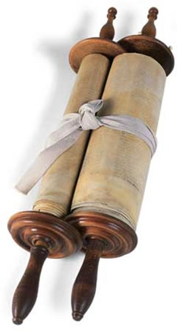
Courtesy Farbrengen Magazine
The entire people heard the words of G-d, and they became frightened. They begged Moses to be the intermediary between G-d and them, for if G-d Himself would continue to give them the entire Torah, they would surely die. Moses told them not to be afraid, for G-d had revealed Himself to them so that they would fear Him and not sin.
Then G-d asked Moses to ascend the mountain; for he alone was able to stand in the presence of G-d. There Moses was to receive the two tablets containing the Ten Commandments and the entire Torah, to teach it to the children of Israel.
Moses went up the mountain and stayed there forty days and forty nights, without food or sleep, for he had become like an angel. During this time, G-d revealed to Moses the entire Torah, with all its laws and the interpretations thereof.
Finally, G-d gave Moses the two stone Tables of Testimony, containing the Ten Commandments, written by G-d Himself.

Reprinted with permission from Kehot Publication Society

Shavuos

Kindness Leads to Torah
By Simcha Groffman

Avi, I sure am excited about Shavuos.
So am I, Chaim. I stay up late into the night learning Torah with my father.
Me too. It is really something to see the Beis HaMidrash (study hall) packed at that hour.
My father will be giving a class Shavuos night.
Really, Avi? What will he be speaking about?
He will talk about the connection between the Megilla of Ruth, which we read on Shavuos and the holiday itself.
I always wanted to know what the story of Ruth had in common with the giving of the Torah on Shavuos.
Why don't you come to the class, Chaim?
I think I will.
Later that night, Avi's father begins the class.
I am happy that all of you could join us this evening. Tonight we will be discussing the connection between the Megilla of Ruth and the holiday of Shavuos.
Our story begins with a famine in the Land of Israel. Elimelech was one of the wealthy men of the time, a supporter of many people. Due to the famine, poverty became rampant, and Elimelech did not want to support the many needy people who would beg for his help. He decided to leave his homeland, along with his family, and stay in the land of Moab. After a while he decided to live there. That is when the problems began. Elimelech passed away. His sons married non-Jewish women. They too passed away, leaving his wife, Naomi, a widow with no children. She became poverty stricken and heartbroken. Naomi decided to return to her homeland, the Land of Israel.
Her daughters-in-law, Ruth and Orpah, were Moabite women. Moab was the son of Lot, the nephew of Avraham Avinu, our father Abraham. Ruth and Orpah had Jewish ancestry. We know that Avraham Avinu was a man whose very essence was kindness. He spent his entire life doing acts of kindness for others. That is why he was fitting to be the father of the Jewish nation. His descendants also had this character trait of kindness. However, Lot, his nephew went to live in Sodom, a place where kindness was against the law. The trait of kindness became hidden, covered up, and eventually almost forgotten. Until it surfaced generations later in the person of Ruth, the Moabite.
Ruth was a beautiful woman, the daughter of Eglon, King of Moab. She could have stayed in Moab and married a wealthy young man. Instead, she clung to her mother-in-law, Naomi, and returned with her to the land of Israel. Why did she do this? She saw Naomi's plight and empathized with her. She saw the truth of the Torah and was drawn to it. The trait of loving kindness, which had lain dormant for generations, was coming out. She later performed an even bigger act of kindness. She married an elderly man, Boaz, for the sake of Naomi's family. These two acts of self-sacrifice earned her a place in Jewish history.
Now, what does this have to do with receiving the Torah on Mount Sinai? The very essence of the Torah is kindness. The mitzvos are one act of kindness after another. In order to receive the Torah, one must prepare himself. What sort of preparation is necessary? Being kind to others. Becoming a compassionate, selfless, empathetic person. Only such a person can receive the Torah.
The story of Ruth can be an inspiration to all of us in our day and age. All Jews have that spark of kindness in their hearts. They are exiled throughout the world, far and wide. Sometimes that spark of Jewishness is covered by many layers of the foreign culture in which they are living. We should not be discouraged, however. The spark is always there. It just needs to be uncovered and brought back to its source. There it will grow into a flame of Jewishness, loving G-d, Torah, and all Jews.

Back to our friends, Avi and Chaim.

Avi, that was so inspiring. I am ready to go help anyone that I can come closer to Judaism.
Chaim, it is also a self-inspiration. Our own hearts also want to do more acts of kindness. When we help others, we are also helping ourselves, and preparing ourselves to receive the Torah in its entirety this Shavuos.
Avi, we should all be successful.
Amen.

Reprinted from the website of Ohr Somayach – ohr.edu

Shabbos Stories for
Yom Tov Shavuos 5773
Volume 4, Issue 36 6 Sivan 5773/ May 15, 2013
For a free subscription, please forward your request to keren18@juno.com
Day of Days

Those were solemn days in the camp of Israel in the desert of Sinai. Walking among the tents, one saw no idlers. Everyone was busy washing clothes, cleaning the camp, and preparing for the great event. No idle conversation or vain laughter was to be heard. Young and old alike were preoccupied with the great event about to take place.
Day of all days! Never has the sun risen so gloriously! Never has the sky been so blue or the air so fresh! A holy light filled the whole world, as Moses led his people out of camp, while G-d raised Mount Sinai, its peak lost in the heavens.
Moses Fearlessly Ascended the Mountain
As the people stood below respectfully at a distance, Moses fearlessly ascended the mountain until he too was engulfed by the heavens, and could no longer be seen. Then G-d said to Moses:
"Now I will give Israel the Torah. Today, the wonders of Heaven shall be revealed to My chosen people. But since you are here on the mountain with Me, how will the people know it is I who speak and not you? Therefore, go down and join the people!"

The Glories of Heaven Were Revealed
At that instant, just as Moses turned to descend once again, the heavens opened for the children of Israel, and the glories of Heaven were revealed to a spellbound Israel for one unforgettable and awe-inspiring moment.
Then Moses brought G-d's words to the people:
"I am not like earthly kings, the rulers and princes of the nations. I need no servants to clear the way for Me nor attendants to lay carpets for Me to tread upon. I need no candles to brighten My palace, nor purple tapestries to hang over My walls!
"I have spread the blue heaven under Me, and the entire world is My palace, brightened by My own brilliant light. The green grass and fragrant flowers are My royal carpet, and the sun is but one of My torches. The world is Mine, and I am its King!"Now, therefore, if you will listen to My voice and obey My commandments, I will make you a kingdom of priests and a holy nation - worthy subjects of the King of Kings!"

G-d is All Powerful, His Wisdom
Boundless and His Mercy Unending
And Israel knew that true indeed were the words of G-d; that upon this earth never breathed a king who could compare with Him, for G-d is all-powerful, His wisdom boundless, and His mercy unending.
When Moses had concluded delivering the Divine message to his people, Israel replied as one man: "We will do and learn!"
At that moment, six hundred thousand angels descended from Heaven, addressing each Jew: "You have made a wise choice. G-d rejoices that you are prepared to obey His every command, the smallest as well as the greatest. And because you have chosen to do so, behold the beautiful gifts we bring unto you!"
Then the angels gave each Jew two beautiful crowns of glory. One for promising "to do," and the other for promising "to learn" the words of G-d.

A Great Silence Descended
Upon the Earth
The dawn of the sixth day of Sivan found all Jews assembled around Sinai, expectantly trembling with the excitement. A great silence descended upon the earth. All movement ceased and everything stood still. No birds twittered and no ox lowed in the meadow. The waters of the seas lay still, not a wave rose or fell. No leaf fluttered in the wind, for no wind blew. The whole world was breathless with suspense. Bird, beast, and man - all were under the spell of the great event about to take place.
And then in the midst of this unbroken silence, the words of G-d burst forth like thunder:
"I AM G-D YOUR G-D."
How these words shook the world to its very foundation! They completely filled the universe and resounded throughut the earth. The smallest child and the oldest of men trembled alike before so much glory and holiness. The mountains trembled and the sea rumbled. Lightning flashed in the heavens and thunder rang out.
And the words G-d had spoken became burning flames that floated in the air. The flame issuing from G-d's words grew brighter and brighter, blinding the people with its brilliance and filling their hearts with terror. When the Torah looked down and saw them standing nearly lifeless with terror, she turned to G-d and said, "What good will it do to give me to lifeless corpses? I am to be a source of life for them, not the cause of their death! Revive them, O G-d, so that they be able to rejoice with Your great gift."

Revived by a Sweet Dew
Then a sweet dew fell upon the people, reviving them and giving them courage and strength to hear the rest of G-d's word. As the people of Israel stood in awe before Mount Sinai, the angels descended from Heaven, bearing G-d's Commandments. As one lovingly presents precious jewels, the angels presented the Commandments to the Jewish people, showing them the beauty of every law, the reward for keeping it, and the punishment if it be disobeyed.

Reprinted from the Tzivos Hashem website.

Jewish Shavuot Celebrates Gift of the Torah
By Joseph Walker ,

For observant Jews, nothing is more definitive of their life and faith than the Torah. So it stands to reason that Shavuot, the second of the three scripturally mandated Jewish pilgrimage festivals — Passover, Shavuot and Sukkot — celebrates the giving of the Torah from G-d to man.
Shavuot, which will be celebrated this year on Sunday and Monday, May 27 and 28, comes exactly 50 days after Passover, the first Jewish festival of the year. According to Rabbi Adin Steinsaltz, a noted Jewish scholar with more than 60 books to his credit, the proximity of Shavuot to Passover on the calendar is hardly coincidental.
"The relationship of Passover and Shavuot," he said, "is like the relationship between a question and an answer. Passover is the question, as reflected in the most famous question asked on the Seder night: Now that we have our freedom, what do we do with it? And the holiday of Shavuot, the festival of the giving of the Torah, is the answer."

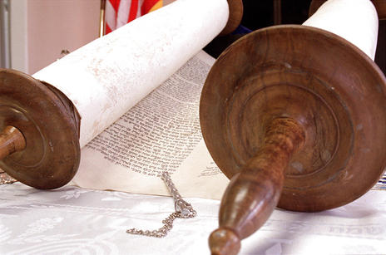
"The written Torah contains the Five Books of Moses, the Prophets and the Writings," says Rabbi Benny Zipple of Chabad Lubavitch. (Scott G. Winterton)
Indeed, Rabbi Steinsaltz said, Shavuot is more than an answer. It is also "the creation of a nation that becomes the vehicle for holding, safeguarding and transmitting the Torah. Thus these two holidays, which are joined together by the counting of those 50 days, form a full metaphysical sentence that is made up of a question and an answer."

A Reawakening and Strengthening of
Our Special Relationship with G-d
Rabbi Benny Zippel of Chabad Lubavitch of Utah said, "Shavuot is the special time for us to re-awaken and strengthen our special relationship with G-d."
Jews do that, he said, "by re-dedicating ourselves to the observance and study of the Torah — our most precious heritage."
According to Rabbi Zippel, the Torah is composed of two parts: the written law and the oral law.
"The written Torah contains the Five Books of Moses, the Prophets and the Writings," he said. "Together with the written Torah, Moses was also given the oral law, which explains and clarifies the written law. It was transmitted orally from generation to generation and eventually transcribed in the Talmud and Midrash."
Through the years Jews have studied and drawn strength, courage, instruction and inspiration from the complete Torah. It is the foundation upon which Jewish identity is built, representing "a continuous chain of tradition extended throughout the generations, connecting the scholars of the present day to the revelation at Mt. Sinai," Rabbi Zippel said.

Shavuot is a Wedding Anniversary
In a sense, he says, Shavuot is a wedding anniversary.
"On the day of the giving of the Torah to the Jewish people," he said, "G-d Himself was the groom and the Jewish people were the eager — if slightly overwhelmed — bride."
The Torah was the wedding contract. "It served as the reciprocal agreement of devotion and love between 'husband' and 'wife' — each giving, each receiving," Rabbi Zippel said. "Our assent to the Torah was unconditional and enthusiastic. After all, it was the purpose of liberation from the slavery of Egypt. We were being chosen, being wanted. We were the desired ones of G-d's plan for a just world, a world of law, that would be both spiritual and practical for us and for mankind."
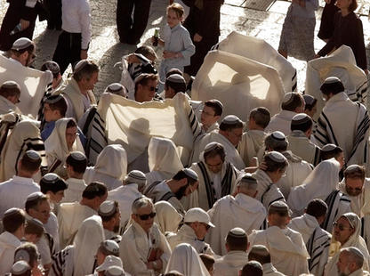
Jews gather to pray at the Western Wall in Jerusalem Old City marking the holiday of Shavuot. (Alexander Zemlianichenko, Associated Press)

With such reverence for the Torah and its teachings, it is no surprise that Torah reading — specifically, the reading of the Ten Commandments — is an important part of the Shavuot tradition. ("Every man, woman and child, including infants, should attend services on the first day of Shavuot and hear the Torah reading of the Ten Commandments," Rabbi Zippel stressed.) So is eating dairy foods, such as cheesecake and cheese blintzes; decorating homes and synagogues with fruits, flowers and greenery; the reading of the Book of Ruth; and engaging in all-night Torah study.
"Shavuot entails taking a look at ourselves and making an effort to make a real change for the better," Rabbi Zippel said. "Regardless of a person's spiritual status, he or she has the potential — and the obligation — to reveal their inner connection (to the Torah) and express that bond ... within the context of everyday life."

Reprinted from last year’s May 27, 2012 edition of the Deseret News, a newspaper published in the predominantly Mormon statue of Utah.

The Ten Commandments:
What Makes Them Special?
By Rabbi Yosef Bitton

As a preparation for the festival of shabu'ot, less than three weeks away, I will begin today a review of the Ten commandments.
The Ten commandments were given to the Jewish people at the climax of the covenant celebrated between the Children of Israel and God (Ex. Ch. 19, 20). The Ten Commandments represent a sample of the entire Tora.
While Christian tradition stresses the importance of the Ten Commandments to the exclusion of the other commandments of the Hebrew Bible, for Jewish tradition the Ten commandments are obviously an essential part of the Tora but every other Biblical precept is of no less importance.
To emphasizes this concept and express the Jewish belief on the uniformity of the Tora, Maimonides forbade to stand up while the Ten commandments are read in public in the Synagogue. Lest we will be led to believe that the other 603 precepts belong to a lower category.
What is it special about the Ten commandments then?
First, that while all other Mitzvot were given to the people of Israel through the mediation of Moshe Rabbenu, the Ten Commandments were meant to be given by God Himself. At the end, as the Tora explains, only the first two commandments were given directly by God. Why?
The people of Israel explicitly requested to hear the Commandments from Moshe because the experience of God's revelation resulted overwhelming. Ex. 20:19 "And they said to Moses, 'Speak to us yourself and we will listen. But do not have God speak to us or we will die'."
According to Jewish tradition the Children of israel requested Moshe's mediation after the first two commandments were given. This is why only the first two commandants are formulated on the first person ("I'm HaShem your God"... "You shall not have any other gods before Me") but from the third commandment Moshe is addressing the people of Israel and refers to HaShem in the third person ("You shall not take the name of God in vain").

Reprinted from the April 26, 2013 email of the Shehebar Sephardic Center.

College Graduation
Conflicts with Shavuot
West Orange Woman Asks Temple University to Reschedule Ceremony
By Robert Wiener

Sharon Litwinoff

Like most college seniors, Sharon Litwinoff is eager to attend her graduation ceremony.
But because Temple University’s commencement is scheduled for May 16 – the second day of Shavuot – she may not be able to.
The West Orange High School graduate has begun a campaign of online petitions and emails to university administrators, urging that the date be changed to accommodate those who observe the Jewish holy day.
“If they do not change the date, I cannot go to graduation,” she told NJ Jewish News.
Beyond the petition drive, Litwinoff has reached out to Jewish members of Temple’s board of trustees, as well as the campus Hillel chapter and the Philadelphia chapter of the Anti-Defamation League.
Litwinoff, who describes herself as an observant Conservative Jew, attended the Prozdor high school program at the Jewish Theological Seminary. She became bat mitzva at Congregation Beth El in South Orange.
A theater major, she discovered the conflict last August. For Conservative and Orthodox Jews, the second day of Shavuot is considered a “yom tov,” with requirements for prayer and restrictions on work, travel, and secular activities.

Created a Petition Asking Temple
University to Change the Date
“Temple needs to provide its students and faculty with a reasonable option to participate in May Commencement ceremonies without compromising their religious beliefs,” according to the petition she created. “By ignoring the scheduling conflict, Temple is forcing the Jewish members of its community to choose which is more important: religious observance or the celebration of their achievements in higher education.”
By January 4, the petition had received more than 300 signatures.
Litwinoff recognizes the university faces “a major hassle to change the date, but I don’t think they have another option. This is not a small issue. I don’t know if you can use a legal term like discrimination, but it certainly doesn’t speak well for the university.”
She said the university should consider the public relations fallout.
“For alumni who feel strongly about this, they may be cutting off donations. For prospective students it could cause a lot of bad publicity. I don't see how they could want to risk that,” she said.

Father Thinks University’s
Action was Inadvertent
Sharon’s father, Phil Litwinoff, who supports her position, suggests the scheduling conflict was inadvertent.
“When they scheduled the graduation I don’t think anybody looked at a calendar to see when Shavuos was,” said Litwinoff, an accountant and president of the NJ Jewish News board of trustees. “I think it was ignorance. They were not paying attention.”
Not so, said a spokesperson for the university.
“For years Temple has set its commencement date for the Thursday immediately following final exams,” said Hillel Hoffmann, assistant director of news communications at the university. “That academic calendar is published at least two years in advance, so people can make travel plans.”
In a Jan 3 phone interview, Hoffmann told NJJN, “Temple’s official academic calendar does not recognize Jewish holidays or any other religious holidays. We have classes on Good Friday, which is a holy day to many students. This has been known for a long time. Despite that, Temple totally respects the right or faculty, students, and staff to observe. Families who are unable to participate can work with their deans to make alternative arrangements. It happens all the time.
“Is there any chance Temple will move the ceremony?” he said. “As far as I know it is still going to go ahead with its plan.”

Reaction of Hillel Organization
To Graduation Date
Phil Nordlinger, director of Temple University Hillel, said his organization is looking at options if the graduation is not rescheduled.
“It looks pretty clear the administration can’t change the date of commencement, but we are working with them,” he said. “We are offering services for Shavuot on campus and there are synagogues in walking distance of campus.”
Nancy Baron-Baer, associate regional director of Philadelphia’s ADL chapter, also seemed resigned to the graduation going ahead on the holiday.
“We are in the process of conversations with the university about some steps they are taking to make accommodations to her and other students who may be celebrating the holiday,” she said.

Reflection on Behavior of Other Colleges
Towards Accommodating Jewish Students
Baron-Baer could not recall any examples of a college graduation being changed to accommodate Jewish students’ religious needs.
“In the last two years I can remember a high graduation scheduled on Shavuos, and the school was able to move the graduation day to another date and time,” she said. “But in a university it is a much more complicated event.”
Rutgers University changed the date of its 2010 commencement, which originally coincided with Shavuot, following a 2009 recommendation by the university Senate.

Reprinted from the January 4, 2013 edition of the New Jersey Jewish News.

The Story of Shavuot

Dawn of the sixth day of Sivan, in the year 2448 after the creation of the world.
Thunder and lightning rent the air, and the sound of the shofar was heard growing strangely louder and louder. All the people in the camp of Israel trembled.
Then all was quiet again. The air was very still. Not a sound was to be heard. No bird twittered, no donkey brayed, no ox lowed. Every living thing held its breath. Even the angels interrupted their heavenly praises. Everybody and everything kept silent . . . waiting.

Heard from One Corner
Of the Earth to the Other
Suddenly G-d's mighty words were heard from one corner of the earth to the other:
"I AM G-D, YOUR G-D!"
One after another, G-d proclaimed the Ten Commandments.
During the next forty days and nights, Moses was G-d's disciple, learning all the Commandments, along with the proper meaning of the Torah which was to be handed down by word of mouth from generation to generation. Afterwards Moses wrote down on parchment all the five books of the Torah, word for word, from the "Bet" of Bereshit to the "Lamed" of Yisrael (the last word of the Pentateuch), as it was dictated to him by G-d Himself.

Millions of Witnesses
G-d gave the Torah in the presence of all Israel - six hundred thousand male adults, aged 20 to 60, many more older men, and, of course, women and children, together with a multitude of other peoples (erev rav). In all there were several million living witnesses who saw the giving of the Torah on Mount Sinai!
Present also were all the Jewish souls who were ever to come down to live upon this earth. Every one of us then solemnly proclaimed naaseh v'nishma - we shall do and learn. Each one of us was made a party to that sacred covenant between G-d and His people Israel.
The Midrash tells us:
Said Rabbi Yitzchak: The children of Israel should have received the Torah immediately upon their departure from Egypt, but G-d said, "My children have had no convalescence after their bondage in Egypt from which they have just been freed, and cannot receive the Torah so soon." It is like a king whose son had just recovered from a serious illness, and his tutor said,

Response of the King
"Send your son to school." To which the king retorted, "My son has not convalesced at all, and you want him to immediately return to school? No, let him be on a healthy and plentiful diet for two or three months, recover his color and strength, and then he will return to school."
So said the Holy One, blessed be He: "My children have not recovered yet their color and strength from their bondage. Let them convalesce for a few weeks with the manna, the well and the quails, And then I shall give them the Torah."
Here is a beautiful parable telling us of the tender mercies of our Father our G-d who cared for us tenderly as a king cares for his only son recuperating from an illness.

Not Our Physical Condition,
But Rather Our Spiritual State
But there is something more than that in this beautiful parable. It wasn't so much our physical condition that had to be considered as our spiritual state. Hundreds of years of Egyptian bondage, enslaved to a people that, despite their architectural prowess and military might, had no feelings, no consideration for human beings, no true ethical teachings or morals - such slavery must have made a deep scar upon our ancestors' moral standards. They had to be cleansed from the "bricks and mortar" of Egypt before they could receive the holy Torah.
The children of Israel understood their situation. They had been told that fifty days after their departure from Egypt they would receive the holy Torah and they knew they had to become worthy of that Divine gift -the most wonderful thing in the world. So they impatiently counted each day, trying to better themselves every day, to improve their conduct and moral standards, to rise higher and higher as the time of the giving of the Torah drew closer.
And G-d Himself helped them to better themselves, as He always does. G-d gave them a wonderful diet that was both a physical and spiritual diet. He rained bread from Heaven in the form of manna. He opened a fountain in the hard rock. He rained meat from the skies - the quails, and He showed them many other miracles any wonders. The children of Israel learned to recognize G-d they saw that He can alter the course of nature for their sake; they realized that they were the chosen people to receive that wonderful gift - the Torah.
For forty nine days, or seven weeks, the children of Israel eagerly prepared themselves for that great event But the last three days before the giving of the Torah were days of the most careful self-examination and preparation. When the great moment of the giving of the Torah finally came, they were clean, pure and holy is body and soul, and ready to receive the Torah. Unanimously they proclaimed: "naaseh v'nishma! - We shall do and we shall hear!"
So must we be pure and clean, in body and soul, if we are to be worthy of the Torah, if we are to appreciate it's sacredness and live up to our name - "a kingdom of priests (G-d's servants) and a holy nation."

Reprinted from the website of Chabad.Org

Why Jews Learn
All Night on Shavuos

On the first night of Shavuot (this year, Tuesday night, May 14, 2013), Jews throughout the world observe the centuries-old custom of conducting an all-night vigil dedicated to Torah learning and preparation for receiving the Torah anew the next morning.
One explanation for this tradition is that the Jewish people did not rise early on the day G-d gave the Torah, and it was necessary for G-d Himself to awaken them. To compensate for their behavior, Jews have accepted upon themselves the custom of remaining awake all night.

Everyone Had a Chance
The day drew near when G-d desired to give the Torah to His chosen people, the children of Israel, whom He saw now cleansed of the impurities that had filled their lives in the slavery of Egypt.
But G-d decided that it would only be fair to offer the Torah to the other nations of the earth (although He knew that they would reject it) before offering it to the children of Israel. And so He first approached the Edomites, descendants of Esau, and offered them the Torah with these inviting words:
"Ye, Edomites, sons of Esau, I bring you a gift - My holy Torah. Accept it and ye shall be blessed with long life, you and your children also."
"What is written in Your Torah?" questioned the Edomites.
"It is written in My Torah: `You shall not murder!' "

Edomites Protest Why They
Can’t Accept the Torah
"But that is ridiculous!" protested the Edomites.
"We are soldiers, men of war who live by the sword! How do you expect us to accept a Torah that preaches against our chosen way of life? No, thank you. Your Torah is no use to us at all."
G-d then took the Torah to the children of Ishmael and offered it to them:
"Children of Ishmael, accept the Torah which I bring you this day, and if you keep its commandments you shall be blessed with all good!"
"What does Your Torah demand of us?" the Ishmaelites asked cautiously.
"My Torah says 'You shall not steal!' " replied the Almighty.

Ismaélites Also Have to Decline
Committing Themselves to the Torah
"That wouldn't suit us at all," replied the sons of Ishmael. We are men of commerce, and such a law would interfere with our business transactions. We are sorry, but we have no use for Your Torah."
The next people that G-d approached were the inhabitants of Tyre and Sidon and all the people of Canaan, to whom He said
"I bring you a most precious gift - My Torah. Take it and you shall all be blessed with many days upon your land!"
The Canaanites spoke up, saying: "First tell us what is written in Your Torah."
"In My Torah it is written: 'You shall have fair scales, correct weights, and give full measure,' " replied the Almighty.
"We do not want to accept Your Torah which is so finicky about such matters. Your Torah is not for us!" answered the Canaanites emphatically.
And thus, after G-d had taken the Torah to all the other nations of the world, who lacked sufficient understanding to estimate its worth, He went to the children of Israel. He was confident that His chosen people would appreciate the Torah and accept it eagerly.

Reprinted from the website of Chabad.Org

Thoughts that Count

Shavuot

G-d gave His three-part Torah (the Five Books of Moses, the Prophets and the Writings) to a three-part nation (the Jewish people, who are divided into Priests, Levites and Israelites) in the third month (Sivan, the third month of the year when counting from Nisan, the "first month" according to the Bible).

No Sin Offering Required on This Festival
Rabbi Levi Yitzchak of Berditchev used to say: Shavuot is the only Biblical festival in connection with which the Torah does not command that a "sin offering" be brought. For on Shavuot, the day on which the Torah was received, every Jew is in the category of a convert, who is considered to be "a young child who is just born." Just as a newborn infant is without sin, so too is the Jewish people without sin on Shavuot.
And Israel camped opposite the mountain [Mount Sinai]
The word the Torah uses for "camped" is in the singular tense, for the Jewish people stood at Mount Sinai "like one man, with one heart," with perfect unity and love for one another. This feeling of unity constituted the most appropriate preparation for receiving the Torah, for when Jews are united, they merit G-d's blessing.
(Likutei Sichot, Vol. 2)

The Obligation to Love Even the Simplest Jew
The Baal Shem Tov taught that we must love every Jew, the simplest person as well as the greatest Torah scholar. Jews are G-d's "tefilin," as it were, the Baal Shem Tov explained.
Scholarly Jews, those with great intellectual abilities, are the tefilin that are worn on the head. Simple Jews, those who perform G-d's mitzvot with joy and gladness, are the tefilin that are worn on the arm.
Just as when putting on tefilin the hand precedes the head, so too must we demonstrate love for the simple Jews first.
(Maayan Chai)

Reprinted from the archives of “L’Chaim,” a publication of the Lubavitch Youth Organization in Brooklyn, NY.
Eggplant Lasagna

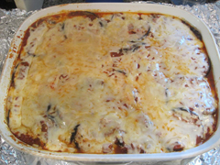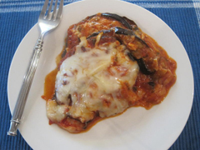

Eggplant Lasagna is one of my family’s favorite recipes (Yay! We’re having Eggplant Lasagna for dinner!!). This lasagna substitutes baked unpeeled eggplant slices for lasagna noodles resulting in a lighter, healthier main dish (and I don’t have to make another vegetable! Yay again!).
4-5 medium eggplants (around 5 pounds), washed and sliced into thin ½ inch slices
16 ounces shredded part skim mozzarella cheese or pizza cheese
2 26 ounce jars pasta sauce
non-stick vegetable spray
additional chopped vegetables or sliced mushrooms, optional
Preheat oven to 350° F, or 325° F convection mode ovens. Spray a 9x13 inch casserole or baking dish with non-stick spray. Set aside.
Line several cookie sheets with aluminum foil, and spray with non-stick vegetable spray. Place the eggplant slices in a single layer on the prepared baking sheets. Spray the slices with non-stick vegetable spray. Bake for 30 minutes until slices are soft and slightly browned.
Spoon several tablespoons of sauce onto the bottom of the prepared casserole pan. Place a single layer of baked eggplant on the sauce, completely covering the bottom of the pan. Spoon a layer of sauce on the eggplant until lightly covered with sauce. If adding additional vegetables or mushrooms place a layer over the sauce. Sprinkle a layer of shredded cheese on the sauce or additional vegetables. Repeat with remaining eggplant, sauce, and cheese. Tightly cover and bake for 60 minutes. To brown the cheese, bake uncovered for the last 10 minutes. Serve warm with garlic bread or pasta.

Note:
1. For a less cheesy version omit the cheese in between the layers and only use the cheese on the top of the lasagna.
2. For a crispier version of this recipe, dip the eggplant slices in beaten egg, then coat with corn flake crumbs or bread crumbs. Place in a single layer on the baking sheets, spray with non-stick vegetable spray and bake as indicated above.
3. You can add broccoli, zucchini, shredded carrots, sliced onions or any of your other favorite vegetables to this dish. You can even add some cubed tofu in between the layers for another delicious version.
4. Another easy way to get additional vegetables into this lasagna is to use a pasta sauce that has them already built in, such as a garden vegetable sauce or mushroom marinara.
5. Spray non-stick vegetable spray on the foil you are covering the lasagna with. It will keep the cheese from sticking to the foil.
Reprinted from the Aish.com website.

It Once Happened

The Story of Ruth
Hard times had hit the land of Israel; famine stalked the land and the people looked to the heavens for respite from their troubles. The leaders of the people, the descendants of the house of Judah, lived in Beit Lechem and at their head was Elimelech, a leader of the generation.
As members of the elite of their people, he and his wife and two sons lived in comfort, possessing vast fields, animals and a store of gold and silver. But Elimelech committed a fatal sin. For, just when the eyes of his troubled brethren focused on him for help and guidance, he left and abandoned them to their fate.
Taking his wife Naomi and his two sons, he settled in the land of Moab where he was received in a manner fitting a man of his exalted station. And there he lived, a prosperous and respected member of the aristocracy of that alien land, the plight of his suffering people conveniently forgotten.

Naomi is Relentlessly Struck by Major Tragedies
For ten years life went on until tragedy struck--Elimelech died. His sons--who had married into the royal family of Moab--soon met the same fate, leaving Naomi, a grieving mother, and Ruth and Orpah, childless widows. Naomi was now finally free to act as her heart desired, as it had desired these ten long years in this foreign land.
Though alone and broken, she decided to return home, to live out her life among her own people. She gave her loving blessings to her two young daughters-in-law and prepared to set out on her return journey. But their love for her was strong and deep, and they refused to part from her.
Only after many entreaties and tears did Orpah kiss Naomi a final goodbye and return to her family. But Ruth, from whom Moshiach was destined to descend, staunchly refused to budge from her mother-in-law's side: "Don't tell me to leave you," Ruth implored. "Where you go, I will go; where you stay I will stay; your people will be my people; and your G-d will be my G-d. Where you die I will die and there will I be buried; only death will part us."

Ruth Inherited Her Forefather’s
Trait of Loving-Kindness
Of all the Moabites, only Ruth had inherited from her forefather, Lot--Abraham's nephew--the trait of loving-kindness. When Naomi realized at last that Ruth wouldn't be dissuaded, she stopped speaking about it, and the two women began their long journey back to Beit Lechem.
"Is this Naomi?" exclaimed the townspeople in their amazement. How should they greet her? Should they disdain the former aristocrat who turned her back on them in their time of trouble, or pity the suffering widow who now stood before them? No one made a move.
Poor and homeless, Ruth went out to gather the fallen sheaves in the field, those designated for the destitute. Unknowingly she went to gather wheat in a field which belonged to Boaz, a wealthy relative of Naomi. While other women who gathered wheat talked and flirted with the workers, Ruth conducted herself modestly, her eyes fixed on her work.
As he passed through the fields Boaz noticed her, and discovering that she was the daughter-in-law of his relative, encouraged her to gather the wheat with his own maidservants. Boaz had heard of Ruth's incredible devotion to Naomi, and he resolved to take her under his wing.
When Ruth returned home that night Naomi marvelled at her successful gleaning. "Whose field did you work in?" she asked, excitedly. Ruth told her mother-in-law the whole story, how Boaz showered her with kindness and allowed her to gather as much as she could and even eat together with his workers. "

Heart Filled with a Strong and Secret Wish
Of course, he is one of our close kinsmen," said Naomi, smiling. Boaz was one of her closest relatives, and he was finally taking notice of their plight. In Naomi's heart was the strong and secret wish that Boaz would take Ruth for his wife, thereby providing a successor to the family of Elimelech. Could it be that G-d's mercy was beginning to shine on them once again?
Boaz, the closest near relative married Ruth in fulfillment of the mitzva of Levirite marriage, and they were blessed with a son, who was called Oved--"the servant of G-d." Naomi was exalted! Oved was the grandfather of David of whom we say, "David, the King of Israel, who lives forever." He was the forerunner of the Eternal Monarchy of Israel--and Moshiach will be descended from him.

Reprinted from the archives of “L’Chaim,” a publication of the Lubavitch Youth Organization in Brooklyn, NY (Issue #218 – Parshas Bamidbar 5752, June 12, 1992.

Shabbos Stories for
Shavuous 5772
Volume 3, Issue #36 5 Sivan 5772/May 26, 2012
For a free subscription, please forward your request to keren18@juno.com

Saved by the Coffee Cups

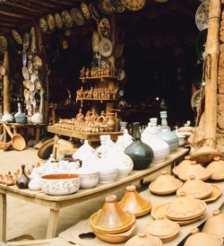
Many years ago there lived in Tunis a worthy Jew named Matzliach. He was a great lover of Torah, though not an outstanding Torah scholar. He was not very rich, but generous in his charity contributions, and he was a G-d-fearing man.
Matzliach the Antique Dealer, as he was known, for he was a dealer in old wares and antiques, was well respected in the community.
Staying Up All Night on Shavuos
To Recite Tikkun and Study torah
He was particularly praised for his special custom in connection with Shavuot, the Festival of the Giving of the Torah. Every year he would invite ten Torah scholars to his home on the first night of Shavuot, for whom he prepared a fine feast. After the feast they would all recite tikkun and study Torah all night, in honor of the great festival that celebrates the Jewish people’s receiving the Torah at Mount Sinai.
It all started many years before, when Matzliach learned for the first time about the origin of the Jewish custom to stay awake on the first night of Shavuot. He was greatly surprised to learn that on the night before that great day when G-d was to give the Torah to the Jewish people, they did not stay awake. Indeed, they slept soundly, so that when G-d descended on the mountain early in the morning to give the Torah to His chosen people, they were not there!
So G-d let loose thunder and lightning, which woke them up and sent them hurrying to the mountain.
Not that the people were not eager to receive the Torah. On the contrary, they had been counting the days—forty-nine days, seven full weeks—from the day after they departed from Egypt, eagerly awaiting the great day when the Torah would be given to them. Yet the night before that great event, when one would have expected them to be too excited even to think of sleep, they slept more soundly than ever! Did they want to be well rested, refreshed and wide awake for the great moment of the divine revelation?
Be that as it may, it was a letdown. And so it became the custom of Jews everywhere to make up for it and stay awake the night of Shavuot, and in this way “correct” the wrong impression. This is what tikkun means—“correction.”

His Example Influenced the Whole Community
Well, Matzliach and his guests certainly observed this custom in a fine way, and it impressed and inspired the whole community. There was not a Jew in Tunisia who did not stay up that night. Old and young gathered in the synagogues to recite tikkun and learn Torah all night, and special refreshments were served to help keep them awake.
There came a time, however, when Shavuot approached and Matzliach found himself in a difficult situation. Business had not been good, and Matzliach simply had no money, not only for his usual feast, but not even for the needs of his own family in the way of food and wine for the festival. Sadly he told his wife, Mazal, about his predicament, and she was greatly distressed.
“It is not so much our own need that distresses me,” the good woman explained, “but the fact that you cannot keep your fine custom. It is sad to think about it.”

Wife Offers Her Precious Earrings
“But what can we do?”
“Well, I still have my precious earrings,” Mazal said, taking them off from her ears. “Here, take them to the pawnbroker and get a loan till things will improve. You should be able to get enough for the festival meals and for your usual feast.”
“G-d bless you,” Matzliach said gratefully. He took the earrings to the pawnbroker and obtained a tidy sum of money against them.
As he was walking home cheerfully, Matzliach met the venerable Rabbi Hai Tayeb, chief rabbi of Tunisia. Matzliach greeted the rabbi respectfully, and the rabbi returned the greeting, obviously pleased to have met him in the street.
“You saved me a trip,” the rabbi said. “I’m going around collecting for our poor, so they, too, can celebrate the festival of Shavuot with joy.”
Without hesitation, Matzliach put his hand in his pocket and gave the rabbi the money he had just received from the pawnbroker. The smile with which Matzliach gave the money pleased the rabbi no less than the donation itself.
“G-d bless you to do many mitzvot and good deeds,” the saintly rabbi said, as they parted.
Slowly Matzliach continued his way homeward. “What am I going to tell my wife?” he wondered.
Suddenly he heard his name called. “Ya, Matzliach! You’re just the man I want!”

A Royal Servant of the Bey (Ruler) of Tunis
The caller was one of the royal servants of the Bey of Tunis.
“His Majesty sent me out to buy a set of antique coffee cups. I have no idea where to get them. But you are an antique dealer. Get them for me, and you will be amply rewarded,” the courtier said.
“I will try my best,” Matzliach promised. If there were such cups, Matzliach knew where to find them, and find them he did. The dealer Matzliach went to was pleased to get rid of them; he had had them too long, and despaired of ever selling them. Now he was pleased to sell them to Matzliach on credit, for he knew the Jewish antique dealer as a trustworthy man.
Walking through the marketplace, Matzliach met the courtier again, for he was shopping for other things. “Did you manage to find the right cups for me?” the courtier asked eagerly.
“Thanks to the One Above, I did.”

The King Was Very Pleased
The courtier took Matzliach with the cups to the royal court, and introduced him to the Bey.
The king was very pleased with the cups. “Just what I wanted,” he said. “I know that the Jews are now busy with preparations for their festival. I am pleased that you took time out to find me these lovely cups. By the way, how are you doing with your preparations for the festival?”
“The truth to tell, Your Majesty, I have not yet bought a thing.”
The king immediately ordered one of his servants to send to Matzliach’s house two sacks of fine flour, a jug of olive oil and two choice live lambs. Then he asked Matzliach what he owed him for the cups.
Matzliach told the king what he paid for them, and his usual commission.
“What? That’s all you paid for these precious cups?” the king said, much surprised. “Well, the ruler of Tunisia is not looking for bargains. You shall be paid their full value!”
Matzliach left the king’s palace with a very large sum of money. Walking briskly home, whom should he meet if not the chief rabbi, again.
“I can now afford to double my donation,” Matzliach said happily, as he handed the rabbi an amount equal to his first generous donation.
“Rabbi, your blessing was fulfilled,” Matzliach said, and told him how G-d was kind to him.
“Thank G-d, we both did very well today,” the rabbi said. “Have a happy Yom Tov.”
And a happy festival it was indeed for Matzliach and his good wife Mazal. And what made them happiest of all was that this year, too, they were able to observe their custom of celebrating tikkun-night as ever before.

Reprinted from this week’s email of Chabad.Org Magazine.

The Father’s Advice to Carry
The Sack of Heavy Rocks
By Rabbi Reuven Semah

“Honor your father and your mother.” (Shemot 20:12)

On the holiday of Shabuot, Israel received the Torah. The Ten Commandments are inscribed on two tablets, five on each. The first tablet contains laws regarding man’s relationship to Hashem, while the second refers to relationships among people. This shows us the significance that Hashem attaches to the honor He wants us to show parents, because Hashem included this commandment on the first tablet. When people honor their parents Hashem regards it as if they honored Him.
A great story (quoted in Tubecha Yabiu) illustrates this point. Once a Jewish person went to a faraway land in order to make a livelihood and bring it back home to his family. The man went with his father and the son was able to acquire gold and silver items that had great value. Finally the man decided to go back home, but his father stayed.

Offers Strange Advice on How to Make
His Sack of Precious Items Easier to Carry
The son packed his precious cargo in a sack and got ready to leave. The father noticed that the sack was very heavy so he advised his son to make it a little easier to carry. He told him that instead of carrying the whole load on one shoulder, he should balance it by placing another sack full of rocks on his other shoulder. If he had balance, it would be easier and he will arrive safely home.
The son asked no questions and did exactly as his father told him, and carried an extra sack of stones. However, people who saw him didn’t understand the purpose of the extra sack. When he explained what his father commanded, they still didn’t understand. If all he needed was balance, why the rocks? The balance could be accomplished by dividing the gold and silver into two sacks! The son ignored them and continued on his way.
Finally he boarded a ship to take him home. However, during the trip they ran into a terrible storm at sea. The crew did all they could to lighten the load to prevent the ship from sinking. Finally the captain gave the order that in order to save the lives of the all aboard each passenger must throw overboard one half of his cargo.

In the Merit of Listening to His Father
Each one must divide his property and throw half away. Now everyone realized the good fortune of the son. In the merit of listening to his father he was able to throw away a sack of rocks instead of half of his fortune. His father’s instructions didn’t seem to have any logic, but the son followed anyway.
Perhaps this is part of the reason why honoring parents were placed on the first tablet. There might be times that we should not question a parent in the same way that one would not question Hashem.

Reprinted from this week’s email of the Jersey Shore Torah Bulletin.

The Revelation at Sinai
By Rabbi Isaac Jacobs

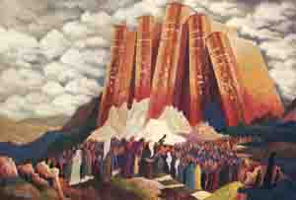
The dawn of the third day broke amid thunder and lightning that filled the air. Heavy clouds hung over the mountain, and the steadily growing sounds of the Shofar made the people shake and tremble with fear.
Moses led the children of Israel out of the camp and placed them at the foot of Mount Sinai, which was all covered by smoke and was quaking, for G-d had descended upon it in fire.
The sound of the Shofar grew louder, but suddenly all sounds ceased, and an absolute silence ensued; and then G-d proclaimed the Ten Commandments as follows:

The First of the Commandments
1. "I am the Lord your G-d, Who brought you out of the land of Egypt, out of the house of bondage.
2. "You shall have no other gods before Me. You shall not make for yourself a graven image, nor any manner of likeness of any thing that is in heaven above, that is in the earth beneath, or that is in the water under the earth. You shall not bow down to them, nor serve them. For I the Lord your G-d am a jealous G-d, visiting the iniquity of the fathers upon the children of the third and fourth generation of them that hate Me; and showing mercy unto the thousandth generation of them that love Me and keep My commandments.
3. "You shall not take the name of the Lord your G-d in vain; for the Lord will not hold him guiltless that takes His name in vain.
4. "Remember the Sabbath Day, to keep it holy. Six days you shall labor and do all your work; but the seventh day is a Sabbath unto the Lord your G-d. On it you shall not do any manner of work -- you, your son, your daughter, your man-servant, your maid-servant, your cattle, and your stranger that is within your gates. For in six days the Lord made heaven and earth, the sea and all that in them is, and rested on the seventh day; wherefore the Lord blessed the Sabbath Day, and hallowed it.

An Opportunity for Long Days Upon the Land
5. "Honor your father and mother, so that your days may be long upon the land which the Lord your G-d gives you.
6. "You shall not murder.
7. "You shall not commit adultery.
8. "You shall not steal.
9. "You shall not bear false witness against your neighbor.
10. "You shall not covet your neighbor's house; you shall not covet your neighbor's wife, his manservant, his maid-servant, his ox, his ass, nor anything that is your neighbor's."

Reprinted from the website of Chabad.org. “The Revelation at Sinai” was originally published in “Our Story” by the Kehot Publication Society in 1946-1948.

Chasidic Story #756

Thunder and Lightning
From the Desk of Yerachmiel Tilles

A few days before the festival of Shavuot, Rabbi Baruch of Medzibush went to pray at the resting place of his holy grandfather, the Baal Shem Tov.
One year, as was his custom, just a few days before the holy festival of Shavuot - the time of the receiving of the holy Torah - the Rebbe Reb Baruch, then living in Tulchin, traveled to Medzibush to pray at the holy resting place of his grandfather, the holy Baal Shem Tov, whose yahrzeit was on the holiday.
Reb Baruch completed his prayers at the Baal Shem Tov's gravesite, but he did not also pay a visit as he usually did to his brother, Rabbi Moshe Chaim Ephraim, the rabbi of Sudylkov for several decades and famous as the author of the Degel Machaneh Ephraim, who then, at the end of his life, lived in Medzibuz. Instead, he returned directly home to spend Shavuot with his chasidim and his family.
Immediately after Shavuot, Reb Baruch again traveled to pray at the grave of the Baal Shem Tov. But this time, he did stop to visit his brother, Reb Moshe Chaim Ephraim.

Questioning His Brother
During their conversation, the Baal HaDegel asked his brother: "Tulchiner Rebbe, when you came to our grandfather's holy gravesite before the festival, why did you not call on me as usual? And why did you return again so soon after Yom Tov?"
Reb Baruch answered: "I was told from Above that if I so desired, I could receive the revelation of Torah on Shavuot with thunder and lightning, just as Moshe Rabbeinu (Moses our teacher) and the whole Jewish nation received the Torah at Mt. Sinai. This lightning and thunder was a physical revelation of G-dliness, and I wished to also experience it."

Requesting a Grandfatherly Intercession in Heaven
"And so," he continued, "before Shavuot, I went to the graveside and asked our holy grandfather to intercede in heaven so that I be granted the merit and the strength to receive the Torah in such a manner. When I returned to Tulchin, I did indeed receive the Torah on Shavuot with thunder and lightning. But afterwards, I soon found to my sorrow that I did not have the strength to bear such a revelation. Each Jew has his own unique strengths and abilities, unlike any other individual's, and mine, it seems, are in other areas, where I can serve the Creator to the best of my potential."
"So I returned and asked our grandfather to intercede again and have the revelation removed!"

Source: Adapted and supplemented by Yerachmiel Tilles from the rendition of Tzvi-Meir Cohn posted on //baalshemtov.com, based on a story in "A Treasury of Chassidic Tales On the Festivals" by Rabbi S. Y. Zevin.
Biographical notes:
Rabbi Boruch of Mezhibuz [1753 - 18 Kislev, 1811] was the son of R. Yechiel Ashkenazi and Adel, the daughter of the Baal Shem Tov. He moved from Tulchin to assume the Chasidic leadership in Mezhibuz, the town of his holy grandfather. He was one of the pre-eminent Rebbes in the generation of the disciples of the Maggid of Mezritch and had thousands of Chassidim.
Rabbi Moshe Chaim Ephraim of Sudylkov [1748 - 17 Iyar 1800 was the son of R. Yechiel Ashkenazi and Adel, the daughter of the Baal Shem Tov. He authored one of the first primers of Chasidic thought, Degel Machaneh Ephraim ("Banner of the Camp of Ephraim"), and thereafter was popularly known as "the Degel." His holy grandfather testified about him that he was a Talmudic genius. He served as the rabbi of Sudylkov for several decades, but then retired to Medzibuz, the town of the Besht, at the end of his life, where he passed away and is buried.

The “Master of the Good Name”
Rabbi Yisrael, the Baal Shem Tov ["master of the good Name"], a unique and seminal figure in Jewish history, revealed the Chassidic movement and his own identity as an exceptionally holy person, on his 36th birthday, 18 Elul 1734. He passed away on the festival of Shavuot in 1760. He wrote no books, although many claim to contain his teachings. One available in English is the excellent annotated translation of Tzava'at Harivash, published by Kehos. Also, translations from Sefer Baal Shem Tov and Kesser Shem Tov can be found on //baalshemtov.com.
Editor's note: Another version of this story reverses the roles of the two brothers.

Reprinted from this week’s email of Kabbalahonline, a project of the Ascent Institute in Safat, Israel.
Akiva Abramowitz of Flatbush Wins
Diaspora International Bible Contest
By Daniel Keren

Akiva Abramowitz who will graduate from the Yeshiva of Flatbush Joel Braverman High School next month as his Class’s Salutatorian was the winner of this year’s Diaspora Hidon HaTanach (49th International Bible Contest for Jewish Youth) Competition and Runner-up in the International Hidon HaTanach Tournament that was held last month in Yerushalayim, Israel. It was the first time since 1984 that a non-Israeli competitor had finished so high in the International division which is usually dominated by Israeli contestants. The finals of the highly touted Bible Quiz were televised live in Israel.

Akiva Abramowitz of Flatbush with Israeli Prime Minister Binyamin
Netanyahu at the 49th International Bible Contest for Jewish Youth.

Won National Bible Quiz Last Year
His recent journey to the international Hidon HaTanach competitions began last year when he won the National Bible Contest in the United States Hebrew High School division that was conducted in Manhattan among the 15 – 20 high school finalists from across the United States. Akiva had advanced to this final round after having prevailed in three earlier regional tournaments that were held last year.
As a result of triumphing in the National Tanach Contest, Akiva had almost a year to prepare for this year’s International tournament in Jerusalem. In addition to Rabbi Taler’s assistance, he benefited from being able to access questions given to previous Yeshiva of Flatbush contestants who had made it to the international finals in Yerushalayim.

Practicing a Few Hours a Day
For the International Tournament
From the time he won the National Hidon HaTanach Championship last spring and knew he was going to the International finals last month in Israel, Akiva began practicing by studying the Tanach for an hour a day. As the international finals came closer that time period increased to two, than three and four hours a day.
His expenses for the International Tanach Contest finals were paid by the Jewish Agency and the Jewish National Fund. Akiva was accompanied to the Holy Land by his proud mother and two younger brothers.

Bible Competition Began with Written Questions
The competition began with all 56 finalists taking written tests on various aspects of Tanach on the first day of the competition. As a result of his scores, he advanced to the finals of both the Diaspora Division and the International Competition. He had the third best score of all contestants on the written competition.
Akiva’s total points accumulated in the Diaspora competition helped him to win the Diaspora title in a tie with another Canadian competitor. Advancing to the international competition, the first round began with written questions plus a two-part question on a pasuk of Tanach. As a result of his correct answers he was moved to the top eight finalists and had to answer additional questions with a time limit of 60 seconds in which to respond.

Quizzed by Prime Minister Binyamin Netanyahu
In the third round of competition for the International Hidon HaTanach Championships, Akiva and other contestants were quizzed by Israeli Prime Minister Binyamin Netanyahu whose then 15-year-old son Avner Netanyahu had won the 2010 Israeli Bible Contest and finished in third place in that year’s International Hidon HaTanach competition.
As a result of his outstanding educational achievement, Akiva Abramowitz, has been awarded a full four-year scholarship including room and board at Machon Lev, a top-rated technology college in Israel. The Flatbush Jewish Journal joins all of Akiva’s family, friends, classmates, teachers and neighbors in congratulating the Yeshiva of Flatbush student on an outstanding performance in the International Bible Quiz and much success in all his future endeavors.

Reprinted from last week’s edition of the Flatbush Jewish Journal.

The Yiddish Speaking
Latino Cop
By Rabbi Moshe Greene

Working to protect Rabbi Teitelbaum, he gained
Insight into the essence of the Jewish people.

Living in New York City is tough on cars. Pot holes and sharp debris on the road leads to bent rims and punctured tires.
One day while driving near my home in Queens, the inevitable happened. My tire went flat. I pulled over, took out my cell phone, called AAA, gave my location to the dispatcher, and waited.
About half an hour later a Latino man in his mid-60s pulled his truck behind me. He got out, looked at the car and then looked at me. "Hello, my name is Donny," he said as he extended his hand. He then began speaking in Yiddish.
"Are you Jewish?" I asked.
He shook his head smiled and said, "No."
I laughed and asked the obvious question. "So where did you learn Yiddish?"
"I picked it up many years ago when I was hanging out with one of your buddies," he said teasingly. "Rabbi Yoel Teitelbaum from Williamsburg. You heard of him?"
"The great chassidic leader?" I asked in disbelief.
"That's the one," he replied.
Donny explained that he was a retired NYPD cop. While on the force, his job was to protect Rabbi Teitelbaum – not only from outsiders but also the throngs of chassidim that push to get near him. Donny was assigned as the rabbi's bodyguard – at home, in shul and at public gatherings.
Donny described how he would dress like a chassid – a Latino with beard and sidelocks (peyos), scanning the crowds, looking for infiltrators.
"How could you tell a real chassid from an impersonator?" I asked.
"You guys are always hunched over your books," he explained. "If someone was standing a little too straight I kept my eye on him. He was either an outsider... or someone who ain't serious about his studies," he laughed.
Donny reminisced about the kindness of the rabbi's wife, and how she supplied him with a steady stream of cholent and kugel.
Donny then asked if I knew the expression "Yiddishe kup."
"Of course'" I replied. "It refers to Jews as a smart and clever people."
Donny became serious, knowing he had me where he wanted. "I heard you guys used to live in Israel with your capital in Jerusalem. I heard that you had a Temple – a beautiful place where you all got together for the holidays – right?"
I nodded.
"I also heard that about 2,000 years ago you were exiled because you guys didn't get along with each other. True?"
I nodded again.
"I also heard that if you guys could just learn to get along with each other, G-d will move you back to Jerusalem and rebuild the Temple."
Donny then leaned toward me, looked me straight in the eye and said, "So if you guys are so smart, how is it that in 2,000 years you haven't figured out how to get along?"
I had no answer.
The Torah tells us that unity of the Jewish people was a prerequisite for the revelation at Mount Sinai. The verse describes the encampment of the Jews by the mountain, united as “one person with one heart.”
It all starts with the realization that while Jews many be different from one another, we are all one family. We are part of the same unit, connected at the core, sharing the goal of Tikkun Olam, making the world a better place.
The upcoming holiday of Shavuot celebrates the giving of Torah at Mount Sinai. Now is an ideal time to work on attaining this consciousness and unite as a people.
Let’s make Donny’s question no longer a question.

Reprinted from the Parshas Bamidbar 5776 email of Aish.com website.

Lubavitchers Print First Edition Of Tanya on Mount Everest.
By COLlive

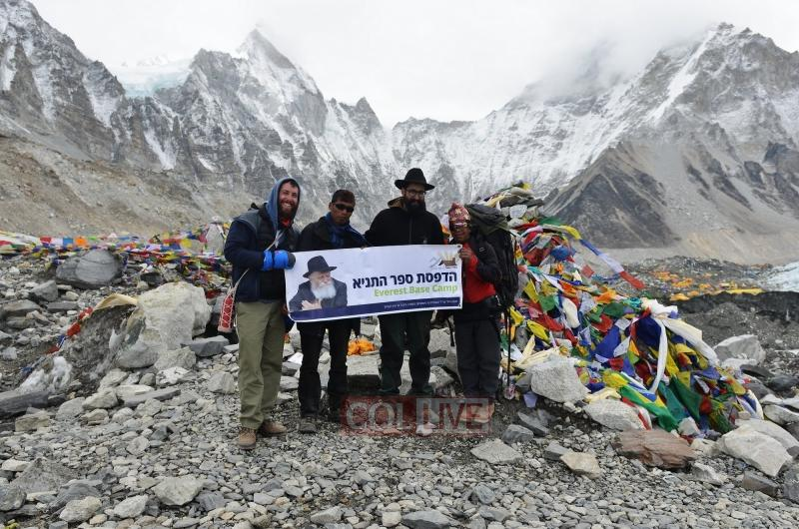

A pair of Lubavitchers trekked for days on a dangerous and cold path to be titled the first ones to print Chabad's foundational book, the Tanya, on Mount Everest.
Meir Alfasi of Rechovot, Israel, and Shmuly Levitin of Brooklyn's Crown Heights climbed 17,598 feet to reach the Everest Base Camp in Nepal.
"The Lubavitcher Rebbe instructed us to print 'The Tanya' in every place where there are Jews, one Jew," Alfasi, 30, told Israel Hayom newspaper.
With no vehicle access to the rudimentary campsite, Alfasi and Levitin took with them 10 cans of tuna, Matzah, a package of paper and a printer.
They were accompanied for the 2-week adventure by two Sherpas (local inhabitants) and bundled up in thermal clothes.
Alfasi also took with him a Chassidic fedora, saying that he wanted fellow Jewish trekkers to identify him. "We got to put on Tefillin on a few of them," he told COLlive.com.

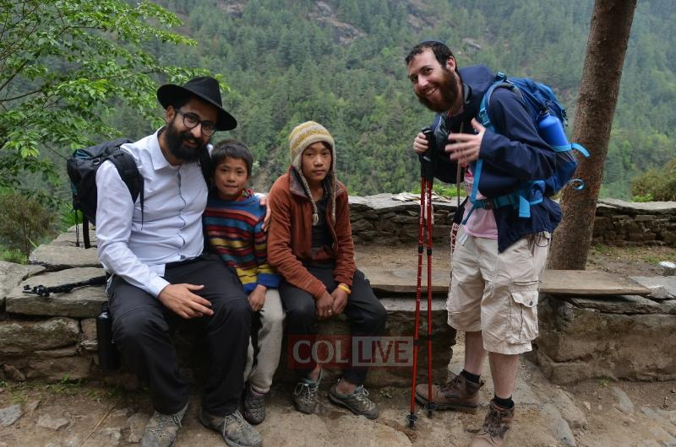

Nepal's Chabad Rabbi Chezki Lifshitz provided the hiking team with a satellite phone to locate their position throughout the challenging journey. Some four hikers died there just this past week.
"You walk 18 hours a day," Alfasi said. "I lost 22 pounds during the trek, so now I need to switch out my entire wardrobe."
These Lubavitchers ended up accomplishing what they set out to do: Printing the Tanya on the highest mountain in the world.
"When we came to the base camp, we asked them for electricity," Alfasi said. "We told them we're printing an ancient and holy book so they agreed and helped us print the Tanya on the most powerful mountain on earth.

Reprinted from the June 3, 2016 website of COLlive.com, the Community News Service of Crown Heights, Brooklyn.

Shavuot Without the Cheese
By Deborah A. Beverly

(Photo by Tablet)
As Shavuot approaches, I can almost taste the cheese blintzes. But I can’t actuallytaste them, because I’m allergic to dairy.
And that’s just the beginning. I also can’t eat wheat. This means the traditional Jewish foods for a lot of holidays are forbidden to me. No cheesecake for Shavuot. No sufganiyot for Hanukkah. No breaking the Yom Kippur fast with bagels and cream cheese. No challah for Shabbat.
My food issues began at birth. As a child, my favorite meal was “cheese soup” poured over toast; I often felt slightly ill after eating it, but it never occurred to me that feeling sick after eating wasn’t normal. Other foods gave me painful rashes, ear infections, hives, but doctors never connected these symptoms to allergies; one told me I’d outgrow these problems by age 13, while another suggested I avoid hazelnuts. It wasn’t until I was in my thirties that I discovered my extensive food allergies, including an allergy to dairy. I was not surprised, but I was crushed.
What about the holidays? Having to change my diet—and eliminate foods that had once been staples of my life and Jewish celebrations—meant I had to find a new way to celebrate the Jewish holidays, and doing so would challenge my relationship with Judaism. Every event at my temple centered on food—Shabbat dinners, bread and juice at Shabbat services, the oneg on Friday nights, fundraising dinners, or special programs to learn to make challah or blintzes.
What saddened me the most was losing the connection formed with others over food. My food restrictions made it challenging to be part of my Jewish community. At Shabbat services, I can’t eat the challah everyone else eats. At temple potlucks, I can only eat the food I’ve brought, since the foods people bring aren’t ingredient-labeled. I stopped attending those potlucks, but this cost me the chance to meet people and form new connections. These allergies have high costs.
***
I had lived for decades with health problems before my diagnosis, but a crisis finally prodded me to find some solutions: When my father nearly collapsed on me after a friend’s brunch in late 2015, I drove him to the ER thinking he had the flu. A doctor diagnosed him with sepsis. He nearly died. The stress of his subsequent hospitalizations, rehab, and doctor’s appointments over a six-month period marked a turning point in my own health, too. I felt run down and exhausted by near-daily hospital visits, by poring over lists of his medications, by ensuring the hospital actually fed him (they didn’t, not always), and by researching his diagnoses so I could speak intelligently to doctors about them.
Once my father’s health stabilized, I turned to investigating my own health. I found the process like peeling an onion. As soon as I peeled one layer and unearthed a problem, I would think that was the one issue to address. However, again and again I found one problem connected to another. This slow process led me to an allergist, where tests revealed allergies to milk, wheat, corn, peanuts, soybeans, beef, eggs, and chocolate.
Since I didn’t believe the test results, I ignored them. I had eaten many of these foods—corn, peanuts, beef, eggs, and chocolate—quite often for years and never noticed a bad reaction to them. It turns out that the body can mask allergies so that you don’t realize a food you eat every day is the culprit in causing your health issues. When I did finally give them up, my ear infections subsided. Surprisingly, my non-food allergies also eased. The cat no longer caused me to have itchy skin. Pollen season came and went without causing me fits of sneezing. Although I’d once been diagnosed with asthma and gone to the ER for it, my lungs were now clear, and my breathing troubles disappeared.
Over the past year, I’ve come to terms with my situation. I’m hardly a gourmet, but I’d picked up some basic cooking skills and a willingness to try new foods to expand my choices. I shifted my focus from eliminating foods to seeking out foods to add to my diet: dandelion greens, lamb jerky, oysters. After finding no gluten-free bread in local Jewish bakeries, I searched for gluten-free challah recipes and found one that my wheat-eating family found acceptable. Since bread without gluten can’t be braided well, I bought a special challah pan to at least give the appearance of braids.
When a challenge came my way, I figured out how to address it and gained a little power back over my life and its food challenges. I bring my own food to dinner for my book group. My husband has adapted to cooking breakfasts and dinners I can eat. But I still felt alone in my struggles with food, and I felt like I’d always be fighting with myself over the right way to handle the food-oriented Jewish holidays when the safe-for-me foods were not considered religiously correct.
Shavuot still leaves me in a quandary: I haven’t discovered an acceptable replacement for the traditional dairy foods. I’ll make blintzes for my family, but I can’t eat them myself since I can’t have eggs, wheat, or dairy. Instead, I’ll makepumpkin pie bites and zucchini lemon sorbet for myself to celebrate the holiday. These foods are not traditionally connected to Shavuot, but I pretend they are—because they are, now, for me.
Community forms around food, and I haven’t figured out a way to connect during the holidays that doesn’t include food at all. Instead, I connect with my family and the community despite the foods. Occasionally, my 10-year-old daughter runs up to me at an oneg to show me a pastry that delights her. I share her delight at the treat, and she runs off, happy I’ve listened; what she really wants, I’ve learned, is my attention. At a Purim carnival, my daughter and I filled hamantashen with fruit filling. Even though I couldn’t eat them because they contain wheat, I enjoyed connecting with my daughter and creating something with her. Both of these are happy memories for me, and I hope they are for her, too.
But even as I’ve tried as best I can to maintain my connection to other Jews around food, I’ve made new connections along the way—with other people who have food allergies. We form our own underground community at events. We help each other find the gluten-free dessert someone brought or warn each other away from a salad laced with dairy. So, even as I’ve learned to not let my food allergies hinder my social and spiritual life, I’ve built new connections and found an additional community that understands exactly why there’s more to Shavuot than cheese blintzes.

Reprinted from the June 9, 2016 email of Tablet Magazine.

Receiving Our Precious Torah on Shavuoth
By Savta Kops

The festival of Shavuoth is in Sivan, which was a crowning event
The Revelation took place on Mt. Sinai, before all eyes present.
It marked the greatest spiritual occurrence in our Jewish history
Receiving the Torah, the life of the Jewish nation, is no mystery.

Living the words of the Torah, gives you emotional security
The thoughts are gentle and soothing, creating a feeling of purity.
With inner peace your spiritual connection to Hashem allows you to see
The serenity and joy His world has to offer, is all yours, and all free.

Moshe, the receiver of the Torah, has 10 different names that we use
Yered was one because he “brought down” the Torah to the Jews.
Another was Cheber “to attach” us to the Torah, and obey the laws
That Hashem gave us and appreciate with significance, its cause.

On the festival of Shavuoth we decorate our synagogue with flowers
In memory of Mt. Sinai and the Revelation during those precious hours.
There were beautiful leaves, branches and flowers growing on the Mount
We remember with eternal memory to celebrate after the 49th Sefira count.

On the first day of Shavuoth, before the Torah reading, we recite
A most inspiring poem called Akdamos, a hymn of glory to sight.
The beauty to Hashem and His Torah with expressions of praise
And Israel’s unbounded love for it pending the ending of our days.

The second day of Shavuoth, traditionally, was the death of David our king
We continuously read all the beautiful hymns in Tehillim we say and sing.
David was the descended of the converted noble Moabite woman, and her fate
So we read the Book of Ruth understanding Hashem’s matching Boaz her mate.

Reprinted from last year’s Shavuos edition of The Jewish Connection.
additional Stories for
yom tov Shavuous

A Kiss is Not Enough
By Rabbi N. Reich

Every time we read the story of Ruth we are once again inspired by the extraordinary loyalty and noble spirit of this former Moabite princess. Naomi, a Jewish woman living in Moab, decides to return to Eretz Yisrael after losing her husband, her two sons and all her wealth.
Her two widowed daughters-in-law, Arpah and Ruth, both of them Moabite princesses, want to accompany her, but Naomi insists that they return. Arpah accedes to her mother-in-law’s wishes, but Ruth is steadfast in her loyalty. Together, Naomi and Ruth return to Eretz Yisrael, where Ruth ultimately marries Boaz and becomes the ancestress of the Davidic dynasty. Arpah returns to Moab and becomes the ancestress of Goliath.
How and when was Ruth’s loyalty expressed? Her famous words immediately come to mind: “Do not press me to abandon you, to turn back and leave you behind. Wherever you go I shall go. Wherever you sleep I shall sleep. Your people are my people, your L-rd is my L-rd.”
But if we look into the Book of Ruth we find that Ruth’s loyalty had already become evident even before she spoke these famous words. We read: “And Arpah kissed her mother-in-law, and Ruth embraced her. And [Naomi] said, “Behold, your sister-in-law is returning to her people and her gods. Follow your sister-in-law.” And Ruth said, “Do not press me to abandon you…”
How did Naomi know Arpah had decided to return but not Ruth? The clue seems to have been in their different reactions to Naomi’s appeal that they return home. Arpah kissed her, but Ruth embraced her. The Talmud (Sotah 42b) tells us that Goliath was vanquished by David because the Holy Blessed One said, “Let the child of the one who kissed be vanquished by the one who embraced!” Clearly, there was a great difference between Arpah’s kiss and Ruth’s embrace, a difference with important ramifications for the future.
How can we define this difference between a kiss and an embrace, which instantly told Naomi that Arpah had decided to return but Ruth was determined to remain?
Perhaps we can answer this question with another question. The Talmud tells us that when the Jewish people assembled at Mount Sinai to receive the Torah, Hashem uprooted the mountain and held it over their heads. “If you accept the Torah, all is well,” He said, “but if you don’t, this will be your burial place.” The question immediately arises: Why did He find it necessary to do this? The Jewish people had just accepted the Torah unconditionally with the immortal declaration of “Naaseh venishma! We will do, and we will hear!” Why was it necessary to force them to do something they had already agreed to do?
The commentators explain that Hashem was teaching the Jewish people a critical lesson that would carry them through all future generations. If the Torah had been accepted only because of an emotional impulse, there would always have been a danger that, at some future time, the emotion would dissipate - and the commitment along with it.
Therefore, Hashem wanted to impress upon the Jewish people that Torah was the very breath of life, that without it they were as good as in a “burial place.” The tremendous inspiration of the moment was to their everlasting credit, of course, but the perpetual bond to the Torah could only be forged by a strong fundamental attachment based on need in addition to emotion.
This is where a kiss differs from an embrace. A kiss is a glancing touch, an incomplete physical contact which expresses strong inner emotion but from a slight distance; a kiss does not show the fusion of two souls. An embrace, however, is an expression of total attachment, of two hearts that beat as one, that cannot live without each other.
When Arpah kissed Naomi, she showed that her feelings for her mother-in-law were purely emotional, and Naomi immediately understood that these tender emotions would not lead her to accept the sacrifices that lay ahead. But Ruth hugged her mother-in-law, showing a close attachment, a dependency, and Naomi understood she would not be so easily persuaded to return home. Nevertheless, she tried to send her away, and Ruth responded with her celebrated declaration of undying loyalty.
In our own lives, we sometimes find our observances lacking in zeal and enthusiasm. But if we reflect on the awesome power of the Torah to transform, elevate and give meaning to our lives, we can recapture that enthusiasm. As we prepare to receive the Torah this Shavuos, let us do more than pay lip service to the Torah. Let us recognize that our lives have lasting, eternal value only through the Torah. And if we embrace the Torah with all the devotion and dedication in our hearts, we will surely be rewarded with a feeling of total connection and fulfillment.

Reprinted from the Bamidbar/Shavuos 5776 email of Shabbos Candle Lighting

Preparing for Shavous
By Rabbi Y. Ciner

Life is just so busy. Traveling to work, back home, family responsibilities, household responsibilities; the days seem to go by in a blur-like fashion. My wife and I find this pace to be the most difficult adjustment of living in the States.
The Ramcha"l explains that Paroah's plan to keep the Jews as slaves was to keep them as busy as possible. This wouldn't allow for the introspection and growth which would render them worthy of redemption. Life in Israel seemed to go at a much slower pace. There was more time to focus on what was being accomplished without having to spend so much time and energy on just getting there.
We read the parsha of Bamidbar as we are making our final preparations for Shavuos. As such, Bamidbar must reveal some sort of a game-plan to make our Kabalas HaTorah a greater reality on Shavuos itself and one that will last throughout the year.
"And Hashem spoke to Moshe in Midbar {the wilderness of} Sinai. [1:1]" According to the Medrash [Rabbah 1:7], the passuk is stressing that the Torah was given in the Midbar. Many different explanations are offered but an idea that struck me is the hushed, serene, solitude of a midbar. Time for thoughts. Time for self-awareness, self-understanding, self- assessment. That is what enabled a Kabalas HaTorah.
And us? Our already busy, hectic lives are incessantly invaded by our cellphones, beepers and all the myriad electronic, multi-tasking devices that provide us with "all noise, all the time." I longingly recall the summers I spent running a sleep-away camp in Israel without a phone in our bungalow. The sweet sounds of silence...
When Eliyahu HaNavi witnessed Hashem's presence, we are told that at first a stone-shattering wind passed, but Hashem's presence was not manifested in that wind. That was followed by a clamorous din and then by a blaze but Hashem's presence wasn't found in either of those. Finally, Hashem's awesome presence was evident--in the guise of a soft, gentle voice.
As we prepare for Shavuos, we need to find or create that environment and those moments when that soft, gentle, resonating voice of Hashem can be heard and felt, enabling us to shift our focus from the clutter of our lives to the purpose of our existence.
Reprinted from the Bamidbar/Shavuos 5776 email of Shabbos Candle Lighting.
Shavuos: Kashrus
Cheese Facts
By Rabbi Avrohom Gordimer

Legend has it that cheese was first discovered by accident. Thousands of years ago, an Arabian nomad was carrying milk in a container made from the lining of an animal’s stomach. Upon reaching his destination, the nomad opened the container and noticed that the milk had hardened into something else—something we now call cheese. (The enzymatic properties of the stomach lining must have interacted with the milk to produce cheese.)

Whey to Go: How Cheese Is Made
Technically, cheese is broken down into two distinct categories: acid-set cheese and rennet-set cheese. Acidset cheese (“soft cheese” ) refers to cream cheese, cottage cheese, farmer cheese and other cheeses produced by adding bacterial cultures to milk. This results in the formation of soft cheese curds and whey.
Rennet-set cheese (“hard cheese” ) generally refers to cheeses such as cheddar, mozzarella, provolone and hundreds of other types. These cheeses are produced by adding rennet enzymes to milk, whereupon somewhat firm cheese curds form, accompanied by liquid whey.
All cheese production involves gathering the curds together and removing the whey. The curds are then either kept loose or molded tightly. Subsequently, they are processed in a multitude of ways.
In addition to milk and rennet, various other ingredients are used in most cheese making. Cream (milk fat) and non-fat milk powder are often added to modify the product’s fat ratio; vinegar may be added to adjust the pH of the milk prior to conversion into cheese, and additional cultures and enzymes are commonly added to achieve various flavors as well as to prepare the milk for interacting with the rennet. All of these ingredients help explain how there can be over one thousand varieties of cheese in the world today.

Hard Facts about Hard Cheese
While all hard cheeses include rennet, they vary greatly in how they are manufactured. Parmesan cheese is produced by adding rennet to scalding hot milk and then aging the cheese for over a year until it is quite firm. Mozzarella cheese is cooked and stretched in a large tub after it is formed, resulting in a unique elastic texture, ideal for pizza and lasagna. Mozzarella and many other cheeses are brined, that is, submerged into a salt-water solution to protect the cheese from spoilage. Cheddar cheese is manufactured at cool temperatures and is often aged.
Aside from creating a firm texture, aging provides for a uniquely sharp taste. The more cheese is aged, the more powerful its flavor. (Just compare sixmonth- old cheddar to its two-year-old counterpart; they are worlds apart in taste.)
Nearly every country in the world has its own varieties of cheese, developed over hundreds, if not thousands, of years. Cheese connoisseurs regard European cheeses as the finest. France boasts Camembert; Switzerland has Swiss cheese (Emmentaler); England gave birth to cheddar, double Gloucester and Cheshire cheeses, and Greece is known for feta cheese. (America has not developed any cheeses of its own. American cheese is not pure cheese; rather it is a blend of already-made cheeses—mostly cheddar—which is melted, hardened and sliced. Think of the hot dog—a collection of various scraps of meat that is mixed together with added spices and molded into a new piece of meat; American cheese is the United States dairy industry’s equivalent.)

FAQ: Most Frequently Asked Questions about Kosher Cheese
How is cheese made kosher?
As with any food, all of the ingredients in the cheese as well as the equipment used during the manufacturing process must be kosher. However, a special prohibition makes kosher certification of cheese a bit more challenging: the ban on gevinat akum, which means that cheese not made under special rabbinical supervision is not kosher.

What is the source for gevinat Akum?
The Talmud (Avodah Zarah 29b, 35a-35b) states that the sages of the Mishnaic period forbade eating cheese without special rabbinical supervision. Although the Talmud offers various reasons for this prohibition, most halachic authorities maintain that the ban was made because of the use of rennet in cheese making. Since rennet was traditionally derived from the lining of a calf ’s stomach,Chazal forbade cheeses without rabbinical onsite supervision because of the likelihood that they contained rennet from calves that had not been slaughtered in accordance with halachah.
It is important to note that the prohibition against gevinat Akum is not at all related to the kosher regulations regarding milk (chalav stam and chalav Yisrael—unsupervised milk and milk under onsite rabbinical supervision). Those who consume chalav stam are fully bound to adhere to the prohibition against eating gevinat Akum. Gevinat Akum is deemed non-kosher under all conditions, rendering the utensils and cookware used in making and serving it non-kosher as well.

Can the miniscule amounts of rennet used
in hard cheese render the product nonkosher?
A product containing a minuscule amount of a non-kosher ingredient is often regarded as kosher, as the non-kosher substance is batel, or nullified. However, rennet used in hard cheese cannot bebatel because of the halachic axiom that a non-kosher ingredient that gives a product its form—called a davar hama’amid—is never nullified (Yoreh Deah 87:11). Even trace amounts of such an ingredient can affect the kosher status of a product. Rennet is one of the most potent food enzymes, and it is therefore used in hard cheese in minute amounts; nevertheless, it cannot bebatel.

Aren’t some cheeses made from non-animal derived rennet?
In today’s world of advanced food technology, much of the rennet used is microbial, that is, artificial. Nevertheless, mainstream halachic literature posits that Chazal banned all cheese not made under onsite rabbinical supervison, irrespective of the presence of animal rennet, as a precaution against the consumption of actual non-kosher animal rennetbased cheese (Rambam,Hilchot Ma’achalot Asurot 3:14 and Shulchan Aruch ibid., 115:2). Thus, cheese made from artificial rennet (as well as Portuguese hard cheese made from thistleflower rennet) is not kosher when manufactured without special rabbinic supervision.
It should be noted that the bulk of today’s cheese manufactured in mainland Europe does contain animal rennet. Furthermore, lipase—an enzyme added to some cheeses to hasten the breakdown of fat and endow a more powerful flavor—is almost always animal-derived (lipase is extracted from the tongues of domesticated animals), although artificial lipase substitutes are becoming more widespread. Romano cheese is usually treated with goat, lamb or kid lipase, and blue cheese often contains calf lipase.
Animal rennet and lipase can be kosher, however. If the kosher source animal is slaughtered, de-veined, salted and processed according to kosher law, its rennet and lipase are fine for kosher use. (There is no halachic problem with using animal-derived enzymes in cheese [mixing meat and milk] since the amounts used are miniscule. Moreover, the enzymes are not cooked with the milk, and they are flavorless. Also, the davar hama’amid principle cited earlier only applies to non-kosher substances, and the enzymes are actually kosher.) Still, even cheese made with glatt kosher animal rennet and lipase is considered gevinat Akum when manufactured by without special rabbinic supervision, as the sages created a general ban on such cheese.

How does one make gevinat Yisrael?
Some halachic authorities rule that to satisfy the gevinat Yisrael requirement, a rabbinical supervisor must be present to supervise the cheese making and ensure that only kosher rennet is used; others hold that a rabbinical supervisor must personally add the rennet (similar to “bishul Yisrael ” and “pat Yisrael,” which are satisfied only if the rabbinical supervisor is actually involved with cooking or baking the food). The OU follows both halachic opinions and insists that rabbinic field representatives supervise all kosher cheese productions and add the rennet as well.
In modern cheese facilities, rennet is often not added manually. Rather, it is dosed into cheese vats via automated rennet feeders. In such cases, the rabbinic field representatives activate the rennet feeders for each vat of cheese produced. Cheese made in specially supervised plants is automatically considered gevinat Yisrael, thereby alleviating the need for full-time rabbinic supervision or involvement (Shach on Yoreh Deah 115, s.k. 20).
Does gevinat Yisrael also apply to soft cheeses?
This, too, is a point of dispute. Some halachic authorities maintain that gevinat Yisrael applies to all cheeses. Others contend that only cheeses with rennet are subject to this rule. The OU and most of the other kosher certifying agencies adopt the latter position, and on-site full-time supervision is thus not required for acid-set cheeses. (Of course, the ingredients and equipment must be kosher nonetheless, and a reliable kosher symbol must be present on the package.)

Why is kosher hard cheese so expensive?
The cost of sending rabbinic field representatives to far-flung places to supervise hard-cheese production for days on end is significant. Kosher cheese manufacturers will naturally need to charge more for their products to cover the costs involved.
Furthermore, nearly all domestic and European hard-cheese plants are non-kosher when not doing special kosher cheese productions. These plants schedule kosher campaigns sporadically in the midst of their normal non-kosher activity. Thus, aside from supervising the cheese manufacturing process, the rabbinic field representatives often need to kasher (or supervise the kashering of ) each plant before every kosher production. This can take days to complete, and it is not simple work.
The kashrut rules for cheese are among the most mysterious to the average kosher consumer. Even otherwise scholarly and erudite members of our community are often “in the dark” as to what makes cheese kosher (and why they pay more for it!). It is hoped that the above discussion sheds light and unravels some of the mystery.

Reprinted from the June 10, 2016 website of Matzav.com This article first appeared at OU KOSHER and appears here with permission of the author. Rabbi Avrohom Gordimer is Rabbinic Coordinator at the Orthodox Union and expert in the kashrus of dairy products.

It’s Not About Winning
By Rav Aryeh Zev Ginzberg

Sitting in my car in rush-hour traffic, I turned on the radio to catch up on the news of the day, and heard an interview with two superstars on the teams that were about to go head-to-head in the NBA championship.
Any real interest I had in following professional sports ended decades ago, but one of the players’ responses to the reporter’s question caught my attention. He was asked, “Since you have lost in the past against this team, is winning everything?” He responded with the well-known sports mantra of “Winning isn’t everything—it’s the only thing.”
That caught my attention, as his attitude was totally at odds with the first Rashi in the parashah of that week (no surprise there). Rashi comments on the pasuk of “Im bechukosai teileichu” that one might think this refers to the fulfillment of the mitzvos, but actually it’s all in the ameilus, in the struggle and effort that one puts in to get there. It’s never about winning or completing—it’s about giving it all of your effort; that itself is the goal.
Upon finishing a mesechta, we say, “Anu ameilim u’mekablim s’char,” we get our reward just for the effort and toil that we put into our observance ofmitzvos and limud haTorah.
While the rest of the world is focused on the battle between these two superstars and their teams, Klal Yisrael is also focused, but on the upcomingyom tov of Shavuos, Z’man Mattan Toraseinu.
The Ran describes Shavuos as a yom ha’din, a day of judgment. We are being judged from above as to our commitment and accomplishment in limud haTorah. From last Shavuos to the one approaching, how has our learning developed? Did we learn more, did we learn better, and did our appreciation of what Torah means to Klal Yisrael grow as well?
If the answer to those questions is no, then we should ask ourselves, “Why not?” And if the answer is yes, we should be asking, “Could we have done even more?”
I see people sitting together in the same shul, sometimes even at the same table, and one person has completed a full-year regimen of Daf Yomi, and another a seder of mishnayos, but yet a third didn’t even keep to his resolution of Shnayim Mikra that he made on Yom Kippur and stopped at Parashas Noach.
Why does this happen? Obviously it has a lot to do with personal levels of commitment. However, I have observed that often it’s because some people just strive too high. We become motivated and inspired and commit to a task that we can never possibly keep, and then when we fall behind, we become disillusioned and give up completely.
We need to take baby steps. Rav Avrohom Pam, zt’l, once explained why Yaakov Avinu’s dream upon leaving his father’s house to go to Lavan was fixated on a ladder; why not on a flight of stairs? He explained that no matter how athletic you are, you cannot run up or skip up a ladder as you can with stairs. You need to climb one rung at a time, climbing steadily until you reach the top. This is a metaphor for avodas Hashem. Climbing one step at a time is the only way to succeed. Do not look at the finish line; just take one baby step after another.
I know many people who committed to learn a mishnah or two a day (our shul’s organized daily mishnayos quota, currently being followed by close to 5,000 people, is five mishnayos), and they finished Shishah Sidrei Mishnah multiple times.
We observe people who dedicate campuses for yeshivas, or pop out fabulous sefarim in record time, and we look at our seemingly small accomplishments as totally insignificant. Chazal beg to differ.
Rav Aharon Kotler, zt’l, made an insightful comment on a famous Chazal. The first Beis HaMikdash was destroyed by the powerful King Nevuchadnetzar. To be able to destroy the house of Hashem built by the hands of Dovid HaMelech and Shlomo HaMelech, he must have had some very special z’chuyos. What possible z’chus could this evil, despotic warmonger have to his credit that would give him the ability to destroy the first Beis HaMikdash?
Chazal tell us that when the Navi came to speak to him, Nevuchadnetzar walked three small steps for kvod Shamayim; he was about to take a fourth step, but a malach stopped him in his tracks, so he shouldn’t have an even greater z’chus. Those three small steps are what afforded him the ability to destroy the Beis HaMikdash.
If this is the reward for such a wicked person’s mere steps in the right direction, imagine how far—as members of “mamleches kohanim v’goy kadosh”—our small steps can take us on our journey to achieve the lofty goals of bringing additional kedushah into our lives.
• • • •
I have a dear friend who, as a young newlywed many years ago, decided to pay attention to the gentle prodding of his young wife to try to make tefillah b’tzibbur a priority. He realized that with the pressures of a full-time job and the new responsibilities of taking care of a young household, a huge commitment would never last. So he compiled lists of the neighborhood’s minyanim schedules for Minchah and started with that one tefillah.
This friend just recently celebrated his tenth anniversary of not missing even one tefillah with a minyan. That is three tefillos a day, times 365 days a year, times ten years. Do the math. This was not easy. To arrange and deal with vacations, business trips, children’s births, serious bouts of the flu, etc., making sure that not one time in ten years would he miss a tefillah b’tzibburwas a monumental task.
How did he do this? If, back when he started, he had thought that he must do it for a whole year, his commitment would not have lasted even ten days, let alone ten years. He was able to do it because he just focused on one day at a time, one tefillah at a time—and kept at it for the last ten years. The z’chus for his wife, who was the source of the inspiration and encouragement, is unimaginable.
Someone shared with me that he was never aware that one is not supposed to eat before davening (unless there is a medical need). This had been part of his daily routine, particularly on Shabbos, for years. Then recently he joined in the Dirshu daily Mishnah Berurah shiur that is given online by Rabbi Yudi Jeger for ten minutes each morning, and he learned hilchos tefillah. One particular halachah is that one should not eat before davening. He decided that if that’s the halachah, he would change his longstanding habit.
It wasn’t a commitment for life—just one day at a time. But it has been several months already and he has a new appreciation of kavod ha’tefillah.
These are examples of Yidden just like the rest of us who took on commitments that will not make headlines around the world or even on YeshivaWorldNews. But if the steps of the evil Nevuchadnetzar gave him such power from above, it’s safe to assume that these wonderful Yidden are accruing z’chuyos for themselves and Klal Yisrael that we will never comprehend.
Let the superstar athletes live to win. But as Shavuos approaches and we are again called to task on this yom ha’din, let us, the children of Avraham, Yitzchak, and Yaakov, be content to live our lives one day at a time, one step at a time, to bring more kvod Shamayim to the world.
Have a wonderful yom tov.

Reprinted from the June 10, 2015 edition of the 5 Towns Jewish Times. This article was written l’zecher nishmas Sarah Chaya, z’l, bas Rav Aryeh Zev.

Sinai-Filled Cheesecake
By Larry Gordon

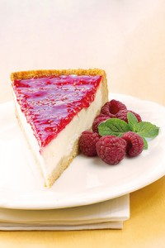

My father, a’h, liked to say that while he enjoyed all the yomim tovim, he had a special affinity for Shavuos. Quite often, he would say that on Sukkos you are able to eat whatever you want but not where you want to. On Pesach you can eat where you want to but not necessarily what you want to. But on Shavuos, he would say, you can eat what you want, where you want. And that, you will most likely agree, is one of the great truisms of Jewish life.
So I was thinking last week what subjects to write about in advance of this three-day version of Torah-mandated solitary confinement. This is it, this is what it is—three consecutive days of Shabbos andyom tov, from Friday evening until late Monday night. Just contemplate what it is about for a moment. Just think, for 72 hours you are not going to pull out your cell phone even one time.
I already have this feeling of courage and mesirus nefesh welling in my system as I think about how we are going to pull this thing off. That is, no Internet, no Facebook, no Twitter, no Instagram—no electronic communication whatsoever. And the fascinating thing is that even though some of us cannot get through Minchah during the week without checking our cell phones a few times, somehow we are going to survive three days without doing it even once.
But back for a moment to the food aspect of this holiday—and the aspect of eating “what we want, where we want to.” While that is generally true, it also contains within it a “not so fast, buddy” element stuffed somewhere into the equation.
To that end, I asked our chief copy editor, Shmuel Gerber, to find an article that I wrote on this subject more than a decade ago and that I updated for the Shavuos issue in 2011. The headline, a few of you may recall, was “Cheesecake, Soufflé, Blintzes, and Kugel at Mount Sinai.” That is a long headline; we must have had a different design in those days, because I don’t know how we fit such a wordy title on the front page of the paper, but somehow we did.
The focus of that article was the relationship between us—the Jewish people—and the events surrounding the giving of the Torah at Sinai that we commemorate over this yom tov, and how having all these cheese and other dairy dishes have snuck their way into and become an almost principal objective of the holiday.
While I am not rerunning the full essay now, I have it here beside me on my desk. I am enjoying reading it and will share updated aspects of that piece with you.
Firstly, where did this obsession with cheese on this yom tov come from? There are many good answers, but I believe the one that is most logical is also the most human and practical. This was the scenario: The Jewish nation was receiving the Torah at Sinai. There were myriad laws and regulations that they were now obligated to follow for the first time. It took time to learn and absorb all these rules and regulations.
One of the key laws was that of ritual slaughter, that is the halachos ofshechitah. At the time of the reception of Torah at Sinai, the intricacies of how to properly slaughter an animal so that it would be fit for consumption were possibly not clear to us yet. Therefore, some explain, since the people’skashrus observance for meat dishes could not be trusted with assurance, the fledgling nation resorted to eating dairy products.
And here we are today, over 3,000 years later—with all the kosher meat in the world at our disposal just for the buying or the taking—but no: they ate dairy then and, dedicated traditionalists that we are, we remain steadfast in our commitment and unity with our ancestors to eat dairy, just as they did all those years ago.
Just take a supermarket ad in this newspaper last week. The ad featured an attractive crusted cheesecake with copy that said, “When cheese cake looks this good, you almost don’t want to eat it.” But then the next line says, “Good luck with that.”
Still, it is not serious or necessarily proper to state that cheesecake or cheese dishes are the centerpiece of this yom tov. For that matter, cheesecake on Shavuos is not on the same plane as eating in the sukkah or the matzos on Pesach—which are vital to the mitzvos of those holidays—or even the apple dipped in honey that we eat on Rosh Hashanah.
But you would not know that from the record number of cheese blintzes and other creamy dishes being prepared this week. And then there is the matter of the next big thing for Shavuos beyond the cheese doodles and cheese curls. That is the matter of being up all night on the first night of yom tov to study Torah.
Frankly, it’s a nice departure from our usual yom tov schedule—that is, instead of going to sleep after dinner, going to shul or the local beis midrash to observe and celebrate the giving of the Torah to the Jewish people by staying awake until sunrise, studying Torah and invigorating that special relationship that exists between us and G-d’s words that are directed to us.
And, by the way, this idea of staying awake all night learning is also a throwback to that Sinaitic experience of more than 3,300 years ago. As I wrote in that piece of a decade ago, we stay up through the night because the Jewish nation, which was selected to receive Torah at Sinai, made the apparently wrong but nevertheless conscious decision to go to sleep that night of the giving of the Torah.
You see, they thought then—as possibly many still do today—that Torah, its laws and dictates, is a spiritual pursuit more appropriately received when in an altered state of consciousness most akin to our condition when we are asleep. So what better way to receive the Torah from G-d than to get under the covers and snore our way into a nice deep sleep?
But we have since been made to understand that this was a colossal miscalculation. The message of that day was that Torah is not strictly a cerebral or intellectual pursuit. The idea is to live it in our everyday lives in whatever we do and whatever we think, how we do business and how we treat our friends. Torah is not something out there designed for another planet, nor does it have a switch that allows it to be turned on or off.
Here’s an explanation of this event from that earlier article:
“Chassidic thought explains that the Jews’ oversleeping on Shavuos morning was not because their alarm clocks didn’t ring or the roosters didn’t cock-a-doodle-do. The Jews slept because they understood that they were souls in physical bodies and that the soul in this world is restricted by being enclosed in a finite body. To receive Torah, they wanted to have their souls—which ascend to Heaven during sleep—to receive the Torah unencumbered.
“We have learned many times that some of our greatest tzaddikim throughout the ages have had high aspects of Torah revealed to them while they were asleep. Our forefather Yaakov saw the entire future of the Jewish people, from beginning until the coming of Mashiach—but only when he was asleep. And this is what the Jews desired in unity as they slept so soundly on the morning ofMattan Torah.
“So if that’s the case and if this is such a beautiful thing, why do we in this day and age have to rectify this alleged faux pas by desisting from sleep on Shavuos night?
“And the answer is that Hashem admired the beauty of the Jewish intent to receive Torah from Him at the highest level possible. But this was not G-d’s purpose of creation. Hashem created us and gave us Torah and mitzvos so that we can perform them here with our bodies in a physical world, thereby transforming mundane physicality into great and high holiness. Our function as flesh-and-blood humans is to take the physical things that this world has to offer and turn them against their nature, making them holy and fulfilling Hashem’s intent of creating a lower worldly environment suitable for Hashem to dwell in and amongst us, which was the intent at Creation.”
That leads to a greater understanding of the purpose of our creation and the challenges of these modern times. In other words, nothing that we do or indulge in is disconnected in any way from our attachment to Torah. That means if you are not eating steak or flanken on that first night of yom tov, that conduct is for a purpose. And all those cheesecake recipes you found yourself perusing over the last few weeks—that too might be a part of the process of receiving the Torah. Now chocolate cheesecake? That might be a level of highness beyond our grasp.
Chag sameiach.

Reprinted from the June 10, 2015 edition of the 5 Towns Jewish Times.

A Fascinating Shavos Concept
From the Facebuker Rebbe’s Vault of Wisdom

I heard a fascinating insight over Shavuos..... The Rabbi gave a series of classes on the topic of "a sin that was done with the right intentions". Without going too deep here, I wanted to share one insight from the three hours of classes. When Lot and his daughters emerged from the apocalypse that destroyed the city of Sodom, we learn that the daughters seduced their father because the thought mankind was completely destroyed. Their intent was pure despite the presumed impropriety of their actions. Take a look at who their aunt and uncle were. Uncle Abraham and Aunt Sarah were world-famous as righteous people. Their nephew Lot had many redeeming qualities to the point where he and his daughters merited being saved from the fiery end of their city.
While the daughters may have been justified in committing their incestuous act (and this post is not discussing that here; it was 3 hours of classes and you should have been there) they could have hid the act when they realized the world was not destroyed by playing off their reputation and that of their illustrious family. They could have claimed Immaculate Conception and no one would have ever suspected that anything was improper between father and daughter.
Let us look, instead, to the Torah to see the name given one of the children: Moav. Moav means Mai’Av - From my father! Lot's daughter chose to let the entire world know that, despite her pure intentions, her son was the product of two humans, a male and female, and not through immaculate conception.
As a reward for not claiming Divine status for her son and teaching the world that offspring comes from male and female humans, she was rewarded that the real Moshiach/Messiah will descend from her. Ruth, whose story we read in shul on the second day of Shavuos, was a Moavite princess, a descendant of this relationship from Lot and his daughter. From Ruth came King David and the Moshiach will descend from the Davidic line.

Reprinted from the Bamidbar – Shavuos 5776 email of the Faceburker Shabbos Table Talk email published in memory of Rabbi Dovid Winiarz of blessed memory.

Story #968

Simple Sincere
Singers of Psalms
From the desk of Yerachmiel Tilles
editor@ascentofsafed.com

The Baal Shem Tov (an honored title: "Master of the Good Name") showed a particular fondness for simple, pious folk. His approach was widely known and was a major reason for the tremendous number of simple Jews who quickly became his devotees, as many accounts attest.
His greatest disciples, however, although outstanding in purity and Torah scholarship, could not grasp this perspective. True, the Baal Shem Tov (sometimes abbreviated as "Besht") frequently sent them to learn traits such as sincerity, trust, simple faith, faith in sages, faith in tzadikim. love of one's fellow Jew, and the like from unlettered Jews. Yet, these distinguished disciples could not appreciate the Besht's affection for ordinary people, and certainly could not emulate him.
Customarily, guests ate the night and morning Shabbat meals at the Besht's table. Participation at the third meal in the late afternoon was restricted to the Besht's scholarly disciples, students of the inner circle. No guests were admitted - not even to observe from a distance. One summer Shabbat, in 5514/1754 C.E. (or perhaps a year earlier or later), an incident took place that thoroughly perplexed and bewildered the disciples, a group which then included brilliant and illustrious men like the Mezritcher Maggid and the Rav of Polnoye.
A large number of visitors had come for that Shabbat, including many undistinguished people such as farmers, artisans, cobblers, tailors, vintners, gardeners, stockmen, poultry-men, and small-time merchants. At the Friday evening meal, the Baal Shem Tov showed these people extraordinary affection. Into the cup of one man, he poured the remains of his Kiddush. To another, he gave his own kiddush cup to recite Kiddush; to several others, he gave pieces of the loaves of challah that he blessed upon. And to yet others he shared a little of the meat and fish on his own plate. He showed other gestures of friendship and affection for these guests, leaving his disciples confounded.
Knowing that they could not attend the third Shabbat meal that was reserved for the inner circle, the guests, after their repast, found their way back to the shul of the Besht. Since they were totally uneducated, incapable of anything more than simply reading Chumash ("Five Books of Moses") and Tehillim (Psalms), they all started chanting Tehillim.
After the Besht took his place at the head of the table for the third meal, he seated each of the disciples in a particular place, characteristic of the meticulous approach that governed everything he did. After a short while, he began to share with his students selected Torah insights. The disciples felt a tremendous divine delight in their Rebbe's teachings.
As was customary, they sang at the table, and when they saw the obvious joyous mood of the Besht, they were even more pleased, filled with a sense of gratitude and happiness for G-d's favor to them, granting them the privilege of being counted among the disciples of the holy Baal Shem Tov.
Some of them mused that is was so delightful, without the presence of the simple people who wouldn't have the faintest idea of what the Master was discussing. Why does our Rebbe show such marks of favor to these people, pouring from his cup into theirs, and even giving his cup to one of them to use?
While these thoughts still flitted through their minds, the Besht's face suddenly changed. He became serious, immersed in his thoughts. Without a shift in this mood he addressed his students: "Peace, peace, to the far and the near".
Our Sages observe, "Where the baalei teshuvah (penitents) stand the perfect saints cannot,"stressing perfect saints. He explained that there are two paths in divine service - the saint's and the penitent's. The service of simple folk belongs to the second level, the loftier level of the penitent - for they are lowly of spirit, regretting their imperfect past and determined to improve the future.
As soon as the Besht concluded his words, they resumed their melody. Those disciples, who had harbored doubts as to their Rebbe's conduct, realized that he had sensed what they had been thinking. His exposition of the qualities of the simple, equating them with the superiority of the penitent over the saint, was obviously addressed to them.
During the singing the Baal Shem Tov was still in his deep meditation, but when they finished he opened his eyes, intently examining each disciple. Then he told them each to rest their right hand on the shoulder of their neighbor, linking the disciples sitting around the table.
While in this position, he told them to sing certain melodies, and after the songs he instructed them to close their eyes and not open them until told to do so. Then he closed the circle by resting his right hand on the shoulder of the disciple seated at his right, and his left hand on the shoulder of the disciple seated at his left.
Suddenly the disciples heard songs and sweet melodies, interlaced with moving pleas, touching their inner soul. One voice sang, "O, Ribbono shel olam (Master of the World)," and launched into a verse of Tehillim, "The sayings of G-d are pure sayingsâ€¦" Another sang - "Ai, Ribbono shel olam," and another verse, "Test me G-d, prove me, purify my heart." A third introduced his verse with a spontaneous cry in Yiddish - "Tatte hartiziger (Feeling father), be gracious to me; I trust in You and I take shelter in the shadow of Your wings".
A fourth voice burst out, "Ai gevald, zisser fotter in himmel (sweet Father in Heaven)," followed by the verse, "let G-d arise; His foes will scatter; His enemies will flee." Another voice was anguished, "Ty'erer tatte (Dear Father), a bird has a home; a swallow a nest," Still another pleaded, "Leiber fotter ,derebarmdiger tatte (Sweet father, merciful Father, bring us back, G-d who helps, erase Your anger against us."
Hearing these precious words of Tehilim in a way they never had before, the holy brotherhood of learned chasidim trembled. Their eyes were still closed yet tears coursed down their cheeks. Their hearts were shattered by the songs. Each of the disciples fervently wished that G-d help him to serve Him in such a manner.
The Baal Shem Tov lifted his hands from the shoulders of the disciples sitting to his right and to his left, and the music vanished from their ears. The Baal Shem Tov then instructed them all to open their eyes and to sing a number of particular songs.
"When I heard those songs of Tehillim," the Maggid later told Rabbi Shneur Zalman, his youngest disciple and subsequently the first Chabad Rebbe, "my soul spilled forth. I felt such longing, such a deep love for G-d that I had never previously been privileged to feel. My boots were soaked with the perspiration and tears of teshuvah from the inwardness and depths of my heart."
When the Baal Shem Tov stopped singing, a hush fell over the group. He sat in deep meditation for some time, then opened his eyes and said, "The songs you heard were the songs of the simple Jews saying Tehilim with sincerity, from the recesses of their hearts and with simple faith, as they are heard in Heaven."
Source: Edited by Yerachmiel Tilles from an appendix in "Psalms - Ohel Yosef Yitzchak" (Kehot)
Editor's note: I am aware that many of you knew this story already, but I couldn't resist the Shavuot connections (see below).
Biographic note: Rabbi Yisrael ben Eliezer (18 Elul 1698 - 6 Sivan 1760), the Baal Shem Tov ["master of the good Name"], a unique and seminal figure in Jewish history, revealed the Chassidic movement and his own identity as an exceptionally holy person, on his 36th birthday, 18 Elul 1734. He wrote no books, although many claim to contain his teachings. One available in English is the excellent annotated translation of Tzava'at Harivash, published by Kehos.
Connections: Seasonal -- This week began with the Festival of SHAVUOT. Besides its biblical significances, it is also the yahrzeit of the Baal Shem Tov and of King David, author/compiler of the Book of Psalms.

Reprinted from the Parashat Nasso 5776 email of KabbalaOnline.org, a project of Ascent of Safed, www.ascentofsafed.com ascent@ascentofsafed.com

Gush Chalav – Tomb of
The Akdamut Author

One of the highlights of the Shavuot morning service is the melodic chanting of Akdamut, a lengthy, beautiful Aramaic poem that praises G-d and describes the reward for the righteous in the end of days. The author of Akdamut is Rabbi Meir ben Yitzchak, a twelfth century shaliach tzibur (prayer leader) for his German community, and his tomb is in Gush Chalav, about 2.5 miles north of the Meron Junction on Route 89.

Reprinted from the Shavuout 5776 email of OHRNET, the Ohr Somayach Torah Magazine of the Internet.

A Child’s Shavuous Bedtime Question to His Tatty
By Rabbi Yoseph Vigler

As I was putting my five year old to bed on Shavuos, he turned to me thoughtfully and said, "Tatty, Before Hashem gave the Torah to Am Yisroel, he first offered it to the nations of the world..." He went to the children of Esav and they asked what's written in the Torah. לא תרצח, He told them. "We can't keep that," they said, "We live on murder."
Then He went to the nations of Amon and Moav. When they heard that the Torah forbids adultery they refused to accept it. After all their very nation was founded on the adultery of their ancestor Lot and his daughters.
And the Yishmaelites couldn't accept not to steal.
"...But Tatty," he inquired with the simplicity and innocence of a five year old, "Did Hashem seriously plan to give Torah to the goyim if they would have accepted it??"
It's an exciting chinuch experience when you can come back to your child and say, 'I researched your amazing question and I found a Kedushas Levi, where the Bardichever Rebbe addresses it and answers it!'
There he explains that G-d foresaw that one day the Jews would be scattered amongst the nations and would be affected by their host countries. He wanted the host nations of the world to respect and admire the Jew who keeps Torah; even if it was deep down in their souls, so that they would not hamper the Torah of the Jew and on the contrary, would do all they could to help him.
And so He showed the Torah to each nation individually. Each of them found one particular commandment impossible for them to keep. There are those amongst the nations who thrive on gunning people down, there are those who can't help themselves with immorality, and still others who thrive on theft.
And yes, the other 612 commandments of the Torah they actually were impressed by. This touched a deep cord within them and a residue of their admiration and respect was maintained.
Deep down, the goy wants you to fulfill your 613 mitzvahs.
In order for a Jew to be respected by a goy in the long run, everyone in the office should know that this Jew wears a skullcap to work, leaves early friday, doesn't come on yom tov, doesn't eat at office parties and is super trustworthy.
612 out of 613 they appreciated, and ALL the obstacles the nations of the world try to erect, they don't really mean it.
Our goal is to carry the message of the Torah we just received into the world.

Reprinted from the Parshos Nasso 5776 email of the Mayan Yisroel Center in Flatbush.

The 2nd Day
By Rabbi Yoseph Vigler

The 2nd day of Shavuos is the most special day on the calendar...Because it makes no sense why we keep it!
Every other second day of Yom Tov is what we call sfeika deyoma. In the times of the Bais hamikdash, the Sanhedrin in Yerushalayim would determine each month when Rosh Chodesh was based on testimony of witnesses. They would communicate their decision to the Jews all over the world by sending emissaries riding on horse back. This process could take a number of weeks and by Pesach or Succos the far flung communities may not necessarily know what day was declared as Rosh Chodesh and what day would be Yom Tov. So they kept 2 days... just in case....and thus we maintain the custom of 2 days Yom Tov in the diaspora.
But Shavuos is different, because Shavuos is not on a particular date. The Torah tells us to keep Shavuos on the 50th day from Pesach. By Shavuos, there was thus sufficient time for every community to know what day was Yom Tov. So one day should have sufficed!
Chazal explain that לא פלוג. The Rabbis wished to have one uniform system that outside Eretz Yisroel you always keep two days, regardless.
What this means then is that the second day of Shavuos should really not have been Yom Tov but the Rabbis declared that a mundane weekday assume a special holiness!
Why specifically on Shavuos? Because when we received the Torah, G-dliness penetrated the world. Suddenly our simple actions can become holy Mitzvahs and the entire physical world can be transformed into a home for G-d.
If our goal is to draw the G-dliness of Matan Torah into the mundane world then the second day of Shavuos is precisely that! We take an otherwise regular weekday and with the power of Matan Torah, we make it holy!
And then everyday out there we continue to draw the power of Shavuos, through our Torah learning and Mitzvah observance, until the entire world gets the message and becomes a home for the Divine.
Wishing you a קבלת התורה בשמחה ופנימיות

Reprinted from the Shavuos 5776 email of the Mayan Yisroel Center in Flatbush.

